The Grady Lab’s
Functional MRI Analysis with PLS
Step-by-Step Guide
for use with Matlab and PLSNPAIRS

updated August 2013

Contents

Introduction 3
Prelude: Preparations 3
Preparing the files for PLS 3
Organizing Files and Folders 3
Starting PLS 3
Chapter 1: Creating Sessiondata Profiles 3
Blocked fMRI Design 3
FOR MATLAB USERS 3
Creating Sessiondata Profiles 3
FOR PSLNPAIRS JAVA USERS 3
Session and Datamat Files 3
Event-Related (E.R.) fMRI Design 3
FOR MATLAB USERS 3
Sessiondata Files 3
FOR PLSNPAIRS JAVA USERS 3
Session and Datamat Files 3
Event-Related (E.R.) fMRI Design with User Defined HRF 3
FOR MATLAB USERS 3
Sessiondata Files 3
Chapter 2: Running PLS Analysis 3
Mean-Centering Task PLS 3
FOR MATLAB USERS 3
FOR PLSNPAIRS JAVA USERS 3
Contrast Analysis (Non-Rotated Task PLS) 3
FOR MATLAB USERS 3
FOR PLSNPAIRS JAVA USERS 3
Regular Behavioral PLS 3
FOR MATLAB USERS 3
FOR PLSNPAIRS JAVA USERS 3
Non-Rotated Behavioral PLS 3
FOR MATLAB USERS 3
FOR PLSNPAIRS JAVA USERS 3
Seed PLS 3
Chapter 3: Looking at PLS Results 3
FOR MATLAB USERS 3
For Blocked fMRI Design 3
Singular Values Plot 3
Design Score and LV Plots 3
Task PLS Brain Scores with CI 3
Voxel Intensity Response 3
Multiple Voxels Extraction 3
Cluster Reports 3
Mean-centering Type 3
Splithalf Option 3
For E.R. fMRI Design 3
Response Function Plot 3
Temporal Brain Scores 3
For Non-Rotated PLS analysis 3
For Behavioral PLS Results 3
Temporal Brain Correlation Plot 3
Datamat Correlations Response 3
Datamat Correlations Plot 3
For Seed PLS Results 3
FOR PLSNPAIRS JAVA USERS 3
For Blocked fMRI Design 3
Singular Value Plot 3
Design Score and LV Plots 3
Task PLS Brain Scores with CI 3
Voxel Intensity Response 3
Structural PLS with MATLAB 3
Troubleshooting 3
Appendix 3
Batch Parameters for Creating Session Profiles (for MATLAB) 3
References 3

Introduction

Partial Least Square (PLS) has been shown to be a robust method for describing the relationship between signal changes in brain and a set of exogenous variables (i.e. task demands, performance, or activity in other brain regions). PLS is a MATLAB program with a graphic user interface (GUI). It works with preprocessed data, and is compatible with both ANALYZE and NIFTI format images. We begin by outlining the steps to prepare your files.

Outline

- Prelude: Preparing the files

- Chapter 1: Creating SessionData files
  - Blocked Design
  - Event-related (E.R.) Design
  - Event-Related (E.R.) fMRI Design with User Defined HRF
PLS Pipeline
- Chapter 2: Running PLS Analysis
  - Mean-Centering Task PLS
Motion Correction
Spatial Normalization
Smoothing
  - Non-Rotated Task PLS
  - Regular Behavioral PLS
  - Non-Regular Behavioral PLS
  - Seed PLS

- Chapter 3: PLS Results
  - For Blocked fMRI design
    - Design Scores
    - Brain Scores
    - Voxel Intensity Plot
De-nosing (optinal)
Includes regressing out WM, CSF, Vessel, motion, and detrending

    - Multiple Voxels Extractions
    - Cluster Report
    - Mean-centering Type
    - Splithalf Option
  - For E.R. fMRI design
    - Response Function Plot
    - Temporal Brain Scores
PLSGUI
Signal Normalization
Masking
Singular Value Decomposition (SVD)

  - For Non-Rotated PLS
  - For Behavioral PLS
    - Temporal Brain Correlations
    - Datamat Correlations Response
    - Datamat Correlations Plot
  - For Seed PLS

- Structural PLS

- Troubleshooting

- References

Prelude: Preparations

Preparing the files for PLS

Before using PLS you will need to prepare the files using AFNI…

Before you begin, please make sure your data is reconstructed, physio-corrected, and motion-corrected. Data must be in 3D NIfTI (.nii) or ANALYZE-7.5 format (.img).

Step 1: Spatial normalization of anatomical images into standard space (Transformation)

Using files created using AFNI after motion correction, i.e. Rrun1+orig, you will need to perform spatial normalization of anatomical images into standardized space. That is, you are aligning your images into some standard space.

Anatomical brain transformation requires a built-in standard template as references. In AFNI, you should use TT_EPI+tlrc. Go into the folder containing the Rrun files (usually located within the subject folder)

Please note that the @auto_tlrc means normalize to standard space, the space depends on your base template. That is, if you are using TT_EPI+tlrc (this template is actually in MNI space), the resulting file will also be normalized in MNI space (not Talairach!). Why the confusion? ANFI was created before MNI, thus, afni only assigns +orig and +tlrc extensions.
Bug in system, doesn’t do anything but you will need to include it

For Run 1:
Name of output dataset, with suffix ‘Ref4mm’

- For specifying landmarks:

@auto_tlrc –base TT_EPI+tlrc –input ‘Rrun1+orig[20]’ –dxyz 4 –ok_notice –suffix REF

Base template, here we are using the functional MNI template
Function to transform the dataset to match the template
Input file, motion corrected files. Here we are using sub-brick 20 as a reference scan. So, all scans are aligned to this sub-brick. This number may be different for your dataset. It might be useful to use 1dplot command in AFNI to determine the reference sub-brick (the middle point of the motion plots).
Cubic voxel size of output dataset in TLRC space, here it’s 4x4x4
>

Creates: Rrun1_20REF+tlrc

- Applying the above specified landmarks to the new image…

@auto_tlrc –apar Rrun1_20REF+tlrc –input Rrun1+orig –dxyz 4 –suffix TT

Name of output dataset, this time with subject ID, 2891
Input file, the original anatomical volume (derived from reconstruction)
To apply the specified landmarks, use the output from above, to the input file.

Creates: Rrun1TT+tlrc
Now, we need to do the same thing for each functional run.

For Run2:
(same as run1, except changes in file names)

@auto_tlrc –base TT_EPI+tlrc –input ‘Rrun2+orig[20]’ –dxyz 4 –ok_notice –suffix REF
@auto_tlrc –apar Rrun2_20REF+tlrc –input Rrun2+orig –dxyz 4 –suffix TT

Creates: Rrun2TT+tlrc

Step 2: Smooth the images

Smoothing increases sensitivity by averaging out uncorrelated noise across voxels, but reduces spatial resolution by blurring small areas of activity. A positive side effect of blurring is that the subject averaging is less affected by inter-subject anatomical variability.

Do this by applying the 8mm full-width-at-half-maximum (FWHM) Gaussian filter to all images in each run. Rule-of-thumb is to use a kernel size 1.5-2.5 voxel size.

For Run1:
For all images in run1

3dmerge –doall –prefix s2891run1TT -1blur_fwhm 8 Rrun1TT+tlrc
Input file, the normalized file (from Step 1) for run 1
Apply Gaussian blur with FWHM, here we stated 8, for 8mm
Function to transform the dataset to match a template in standard space
Output file, with prefix ‘s2891run1TT’
Note: The naming convention includes the subject number (e.g. 2891).

For Run2:
(same as run1, except changes in file names)

3dmerge –doall –prefix s2891run2TT -1blur_fwhm 8 Rrun2TT+tlrc

Creates: s2891run1TT+tlrc, s2891run2TT+tlrc

You have a choice whether to convert the AFNI files to ANALYZE or NIFTI format.

Step 3a: Convert the AFNI files to NIFTI

Do this for each of the runs. You will need to do this because PLS can only read ANALYZE and NIFTI files (but not AFNI).
Input files the smoothed files, from Step 2
3dAFNItoNIFTI s2891run1TT+tlrc
3dAFNItoNIFTI s2891run2TT+tlrc
Function to convert AFNI to NIFTI

Creates: s2891run1TT.nii, s2891run2TT.nii
Step 3b: Convert the AFNI files to ANALZE format

Do this for each of the runs. You will need to do this because PLS can only read ANALYZE and NIFTI files (but not AFNI).
Input files the smoothed files, from Step 2
3dAFNItoANALYZE s2891run1TT+tlrc
3dAFNItoANALYZE s2891run2TT+tlrc
Function to convert AFNI to ANALYZE files

That’s it for preparing the files. Creates: s2891run1TT_0000.img-s2891runTT_0152.img, s2891run2TT_0000.img-s2891run2TT_0152.img

That’s it for preparing the files.

Script

The following is the script for the above procedures:

cd young/2891;
@auto_tlrc –base TT_EPI+tlrc –input ‘Rrun1+orig[20]’ –dxyz 4 –ok_notice –suffix REF;
@auto_tlrc –apar Rrun1_20REF+tlrc –input Rrun1+orig –dxyz 4 –suffix TT;
@auto_tlrc –base TT_EPI+tlrc –input ‘Rrun2+orig[20]’ –dxyz 4 –ok_notice –suffix REF;
@auto_tlrc –apar Rrun2_20REF+tlrc –input Rrun2+orig –dxyz 4 –suffix TT;
3dmerge –doall –prefix s2891run1TT -1blur_fwhm 8 Rrun1TT+tlrc;
3dmerge –doall –prefix s2891run2TT -1blur_fwhm 8 Rrun2TT+tlrc;

3dAFNItoNIFTI s2891run1TT+tlrc;
3dAFNItoNIFTI s2891run2TT+tlrc;
or
3dAFNItoANALYZE s2891run1TT+tlrc;
3dAFNItoANALYZE s2891run2TT+tlrc;

A script is basically a string of command separated by ‘;’ that tells the program what to do next after completing the previous command. Just copy and paste the above script onto a text editor. In UNIX, this would be emacs. To create a new script:
>emacs newscript.sh

You can name your script whatever you like. For this example, I named the file ‘newscript’. You need to save the file with .sh extension, so the program knows this is a script. Other than the extension, this file behaves the same way as a .txt file. Make sure you change the parameters in the text to reflect your own data. Depending on how you organize your folders and file name, the above script will change. Make sure you save the script before running it. When you made changes to your script and don’t save it, when you run it the previously saved script will run.

To run your script:
>sh newscript.sh

Organizing Files and Folders

You will need pre-processed image files in order to create sessiondata files. That is, data should be motion corrected, spatial normalized (to MNI template), and smoothed.

Create a separate folder in the main directory named something like “PLS” or “plsdir” (>mkdir plsdir). This will contain all the files you will produce. These include sessiondata files, PLS results from all task, behavior, and seed analyses, contrast files, LV images extracted from PLS results, etc. We need sessiondata file to run a PLS analysis and to display fMRI PLS results, so it is a good idea to keep all your PLS related files in one folder. Avoid moving individual result files around (or to separate directories).

Note: You do not need to move the nifti files into the newly created PLS folder. When we run the analysis, we can specify the path where the data files are located.

Starting PLS
MATLAB USERS:

Outside Rotman-Baycrest server:

Go to http://www.rotman-baycrest.on.ca/index.php?section=345
Download the latest PLSgui file.

Start MATLAB
- Go into your PLS analysis folder (e.g. plsdir)
- addpath C:\Users\My Directory\Documents\MATLAB\plsgui [change this data path to where your plsgui folder is stored]
- plsgui

Within Rotman-Baycrest Server:

- Go into your PLS analysis folder (e.g. plsdir)
- Start MATLAB
  - matlab [This will bring up the default version of matlab in a separate window. The remaining commands are typed in the matlab window.]
- Then type in the following command in your MATLAB window
  - addpath /software/jimmy/plsgui/
  - plsgui

PLSNPAIRS JAVA USERS:

Go to http://code.google.com/p/plsnpairs/downloads/list
Download the latest executable jar file.

Simply, double-click the plsnpairs.jar file to start the program.

The default heap size (memory allocation) when you run the plsnpairs program via Java Web Start is 1024M (1G). You will probably need more especially if you have event-related data.

In order to allocate more memory, you will need to run the program via command line.

Window Users: Open up a command prompt console by going to your Start menu and selecting Program Accessories Command Prompt. Then type in the following command line (in blue), changing the data path to where your jar file is stored.

All Platform: You must either run the program from the directory containing the plsnpairs.jar file or else include the path of the jar file on the command line.

If there are spaces in your directory names, you will have to enclose the jar file reference in quotation marks, e.g.:

- java –Xmx 2G –jar “\Documents and Settings\my Directory\jarfiles\plsnpairs.jar”

Please go to http://code.google.com/p/plsnpairs/wiki/HowToRunPLSNPAIRS for more information.

Chapter 1: Creating SessionData Profiles

Creating SessionData Profiles:

Information you will need to know before running plsgui:
  - Number and name of conditions
  - Number of runs
  - Onset (& length, for block design) for each condition within a run

PLS requires both the session and datamat files in order to perform analyses. In the new version of PLS released in March 2013, session.mat / datamat.mat files are combined into a single sessiondata.mat file. This file contains information about the runs, the structure of the data, the number of conditions, block information, the concatenated data matrix and tells PLS what session profile fits with what run. It also contains information about the mask of the brain and the reference scan in block design. To provide seamless upgrade, a new program “session2sessiondata.m” is included in PLSgui to convert old session / datamat files to new sessiondata file, either for a single session or for entire folder. For example: session2sessiondata(‘.’) will convert all the old session / datamat files in the current folder to new sessiondata files. Note: old session / datamat files will NOT be removed or modified. For more information, please type: help session2sessiondata

Blocked fMRI Design

At this point, you are done preprocessing your data and have nifti files for each subject. We are going to create a sessiondata file. First, you will need information on how we obtained this dataset.

The Distractor Study

Studies have shown that older adults are less able to inhibit unwanted distractions, leading to poorer cognitive performance on tasks. In this study, we were interested in the extent to which an irrelevant stimulus is processed by older and younger adults. In this part of the study (run1), participants were shown letter strings (consisted of words and non-words) that were superimposed on pictures and were told only to attend to the pictures. The task is to press a button when the picture repeated.
Block

Words
Words
Non-Words
Non-Words

7TR
7TR
7TR
length
12TR
12TR
12TR
12TR

onsets
119TR
131TR
157TR
150TR
138TR
0TR
5TR
24TR
17TR

Baseline
Baseline
Baseline
Baseline
Run 1

There are 3 conditions (baseline, words, non-words). Participants are to perform 8 blocks of task (4 block per condition), and in between there are blocks of baseline. In PLS, the unit measure for time is in TRs (usually 1 TR = 2 sec, but your TR may be different). The task blocks are 12 TR long (i.e., length) and the rests in-between are 7 TR long.

The first block begins 10 sec (5 TR) after the start of the run. We will drop the first 10 sec of the run due to scanner instability at start of the run. At 5 TR, participants performed the task (non-words condition), rest, task (words condition), rest, task (non-words condition), etc.

Using the information we have so far, we can calculate the onset of each task and rest conditions. For example, block 1 starts at 5 TR and is 12 TR long (5 TR + 12 TR = 17 TR), so the first rest occurs at 17 TR.

Usually an experiment contains multiple runs. In run 2 of this experiment (YA_subj1_run2.nii), participants were asked to attend to letters rather than pictures. Letter strings (words/non-words) again were superimposed on pictures and participants were asked to press a button when the letters repeat. The structure of the runs is the same between run 1 and 2.

When I am creating the sessiondata files, I will be labeling the conditions in run 1 and run 2. There are a total of 5 conditions:

Conditions | Labeled
Attending to pictures, non-words shown | AP_NW
Attending to pictures, words shown | AP_W
Attending to letters, non-words shown | AL_NW
Attending to letters, words shown | AL_W
Baseline | Baseline

Notice that the AP_NW and AP_W conditions only appear in run1. Meanwhile, the AL_NW and AL_W conditions only appear in run2. However, we need to include all conditions across all runs when creating the sessiondata files. This will give us one sessiondata profile for each subject.

Of course there are exceptions. How you create your sessiondata profiles depend entirely on the type of analyses you would like to run. Generally, we would like to look at group differences or condition differences within a single group. In these cases, it’s a good idea to create a single session profile for each subject.

Okay, we are now going to create the sessiondata files.
Let’s load PLS.

FOR MATLAB USERS

Creating Sessiondata Profiles for blocked fMRI

There are two ways you can create sessiondata profiles in matlab, via 1) PLSgui or 2) command line

Using the GUI

Step 1: Choose the data type

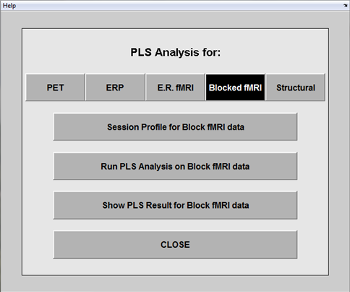
Select “Session Profile” to put together individual subjects’ sessiondata profiles.

You will need to make a sessiondata file for EACH subject.
Select the kind of data you will be working with. In our case, it will be fMRI data with block design.

Step 2: Sessiondata profile
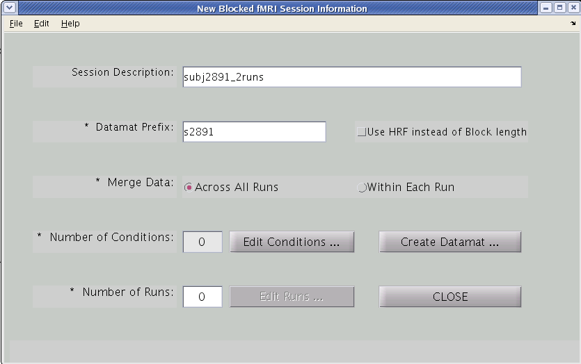

Check this box then your sessiondata file is for E.R.fMRI with user defined HRF; otherwise, your sessiondata file is for Blocked fMRI. Once you make the decision, it can not be changed unless you make a new sessiondata file.
Describe subject data. Important when you want to analyze the same subject(s) in more than one way.
Step 3: Edit conditions
Filename of the datamat files.
PLS will add the suffix _fMRIsession.mat.
(E.g. YA_subj1_BfMRIsession.mat).
You might also want to indicate the group for each subject in the session and datamat names if you have more than one group (e.g., yng_s2891, old_s4523, etc). This will make it easier to enter the data when you run an analysis.
Specify the names of each condition and click “Add”.

Make sure you click Add! You will notice a blank row at the end, this is correct.

Mandatory input field. *

Across All Runs: If you want the same conditions across the runs to be averaged (E.g. Condition A, for run 1 and 2 will be averaged)
Within Each Run: if the conditions within each run are unique. So, Condition A in run1 is considered separately from Condition A in run 2.

This option does not make a difference if you only have a single run.

Usually, you leave these as default.

Relative Ref. Scan Onset refers to the reference scan used for normalization (standardization). PLS by default uses the first scan of each block. Normalization is needed so you can compare signals between blocks. If you are dropping out transitions between the blocks, you will need to move the reference scan for normalizing back to the last TR in the preceding block (value ‘-1’).

Number of Reference refers to how many scans after the first reference scan will be averaged together to become a reference scan. So, a value of 2 means two scans after the reference scan (specified above) are averaged and used as reference.
However, if you want to use a single reference scan for all data (rather than the first scan of each block, you can specify that later in the create datamat step.

Click “Done”
Click the “Edit Conditions” button.
Now, we need to specify all the conditions across runs (at group analysis you can always omit some of these conditions, but you cannot add any additional conditions or collapse them).
Click the “Edit Conditions” button.
Now, we need to specify all the conditions across runs (at group analysis you can always omit some of these conditions, but you cannot add any additional conditions or collapse them).
Click the “Edit Conditions” button.
Now, we need to specify all the conditions across runs (at group analysis you can always omit some of these conditions, but you cannot add any additional conditions or collapse them).
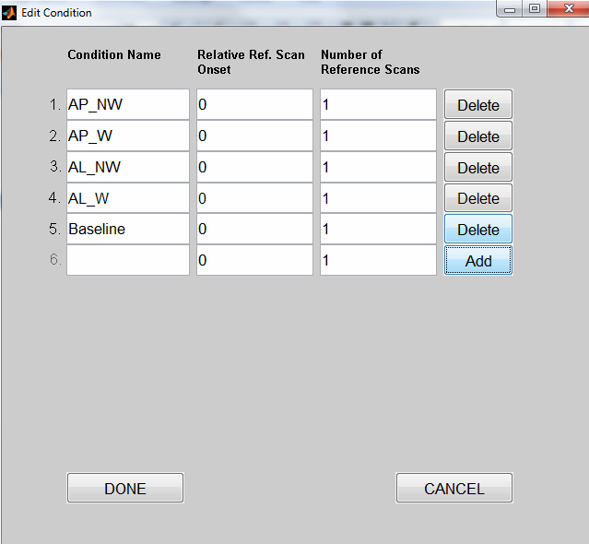

Step 4: Edit the run conditions

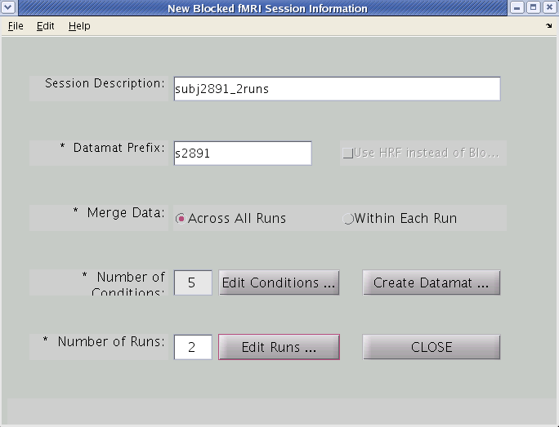
Note that PLS is zero-indexed, meaning that counting starts at 0, not 1.

The first several scans in this run to be skipped
For Run 1:
Onsets and length information is provided in onsetsLength.txt within the distractor_study folder

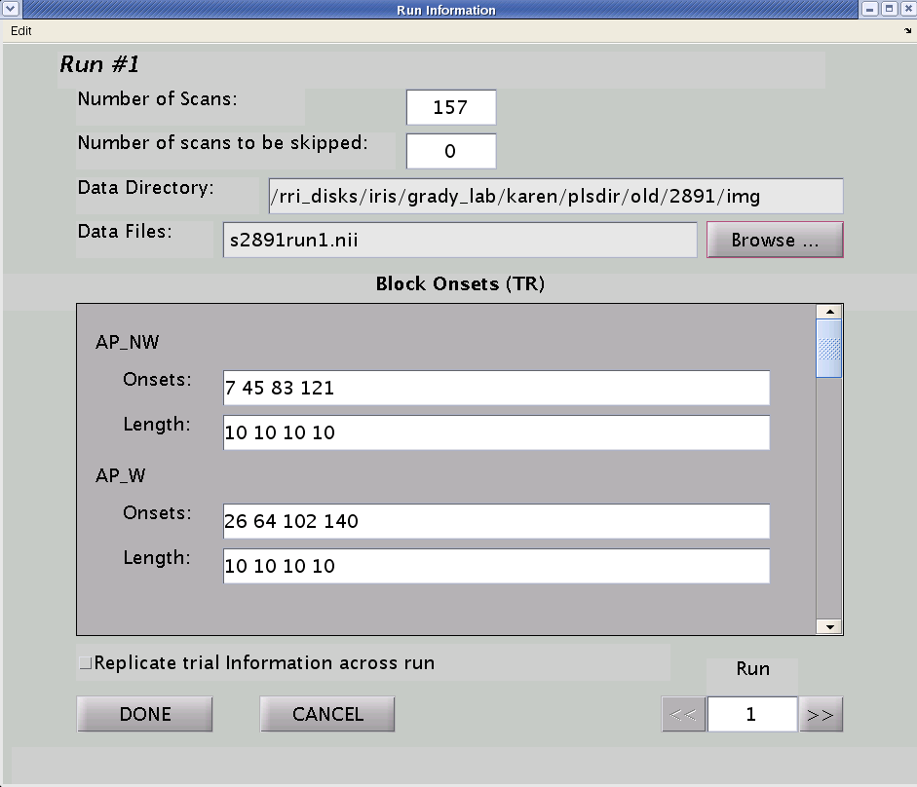

Specify the Number of runs. This will enable the edit runs option

Now, click “Edit Runs”

Number of TR in the run
This is for information pertaining to Run 1
Click “Done”
Select this if you have the same onset/length values for all your runs
Information for Run 1. If you have more than 1 run, you can scroll to edit onset/lengths of other runs.
Data path where the data files are located (automatic if you click browse)
Click “Browse” to locate your data files for run1 (.nii or *.img) [see below]
Enter the onset TR for each condition. Note that the non-words condition appeared 4 times (4 blocks), so there will be 4 onset values with space in between.

If this condition is not in the run, enter “-1” for onset and “0” length.

Specify length of each block. The number of length values equals the number of onset values. You can input one value, press tab, and it automatically fills in rest of the field for you.
For NIFTI files:
After clicking “Browse”, select the appropriate nifti file.
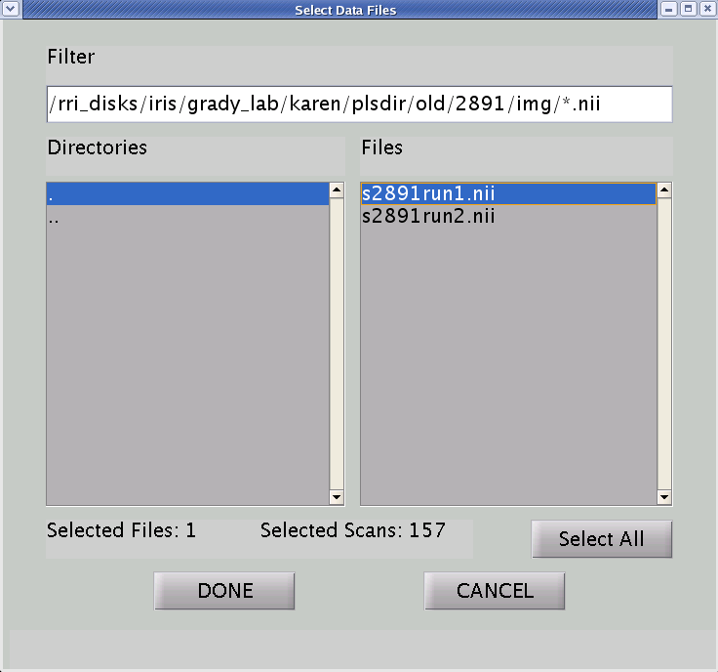
Change the filter to *.nii, to show the nifti files

Select the file

Click “Done”

For ANALYZE files:
Note that for Analyze files (with .img extension), the number of files for a particular run correspond to the number of TR in that run. In this case, it’s all the .img files containing run1 (157 TR in run1 = 157 files, s2891run1*.img). Note
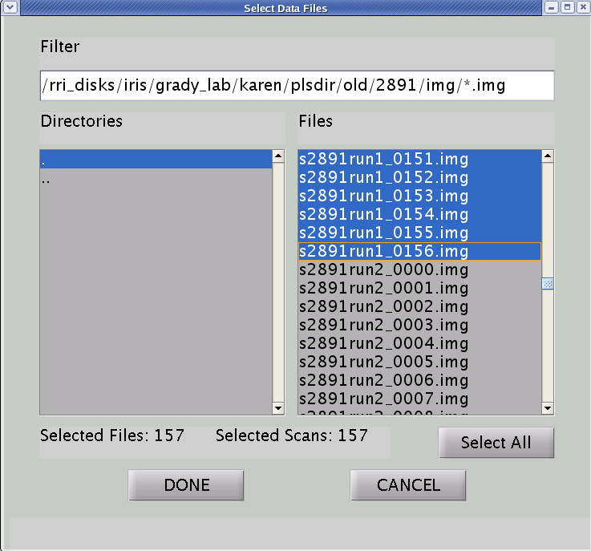

Change the filter to *.img, to show the analyze files

Select all files with the prefix s2891run1*

You should have 157 files selected.

Notice that the Number of Scans is the same regardless if the file is in nifty or analyze format.

Click “Done”

For Run 2:
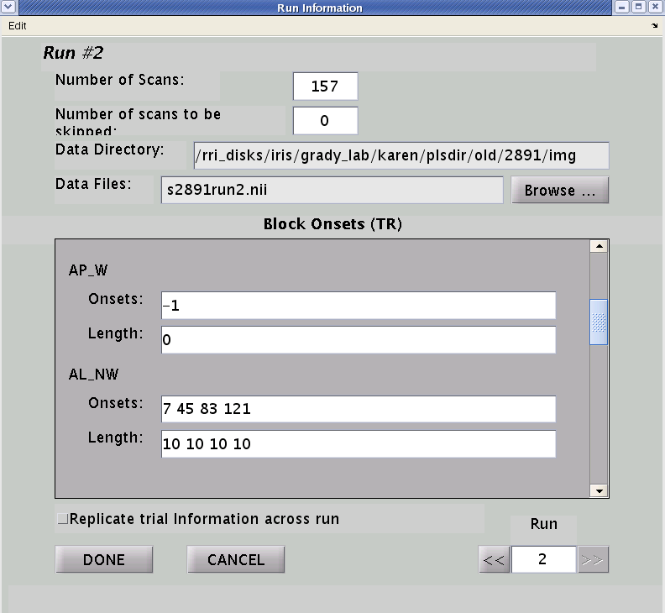

Again, if you would like to exclude a specific condition, enter “-1” for onset and “0” length.

Click “Done”

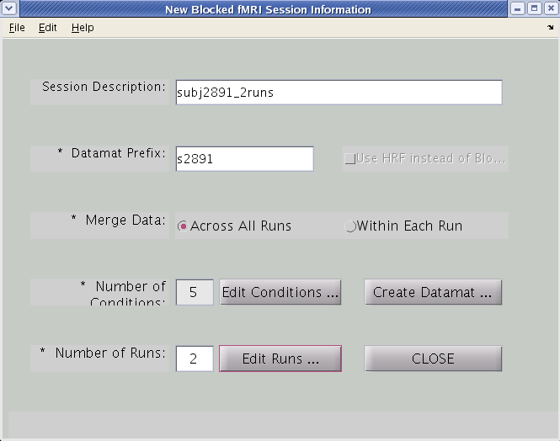

Click “Create Datamat”

Step 5: Generate and save the sessiondata file
By default, the threshold for defining the brain region is set to 0.15. Unless specified by the researcher, do not change this

You can also use a binary brain mask (field above), or use all voxels as brain.
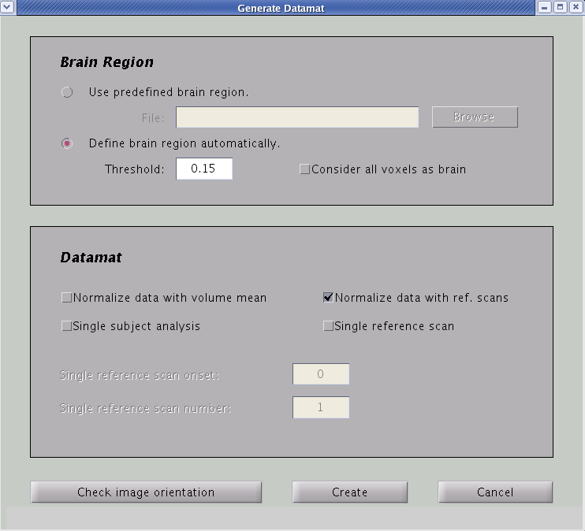

You can (in addition to normalizing it to reference scan), normalize the data to the volume mean

By default, we want to normalize the data to the specified reference scan (usually the first scan of each block). That is, each block is averaged and normalized to the first scan

If you want to use a single reference scan for all data, select this instead.

Note that if you select this option, it ignores what you specified as your ref scans (in the edit condition section)

To check the image orientation, click here

Select “Create”
You will be prompted that file has been saved, click “OK”

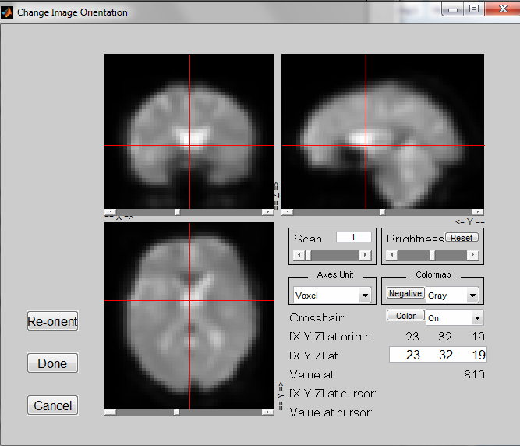To check your image orientation:
Note that the crosshair should be at the center of the anterior commissure. If this is not the case, the coordinates displayed are incorrect (usually happens when you are switching between multiple programs).

Re-orient the x, y, and z axes, using drop down menus

To change scan number (157 scans)

To change Brightness

Enter Coordinates to change crosshair

Click “Done” if you want changes to saved, or “Cancel” to return to the previous screen without saving.

You have successfully created your sessiondata files!

Step 6: Repeat the same procedure for all participants
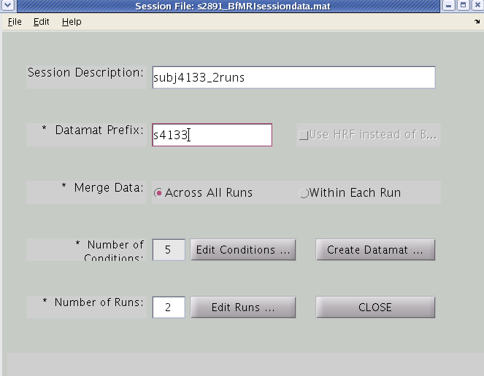

If the conditions, length, and onset are the same for all your participants and all your runs, you can just change the session description and datamat prefix.

Important: you will need to click on “edit runs” and select the appropriate nifti file.

Select “Create Datamat”

2. Batch PLS (with text files) –Recommended

You can create multiple sessiondata files using the batch_plsgui command on text files containing conditions and runs information (e.g. onsets and length). The advantage of using the batch command is that once you have all your files PLS will create the sessiondata profiles consecutively.

This may look confusing but it is the best way to create sessiondata files because it ensures you have labeled your conditions consistently and that you are using the same parameters for each participant.

PLS will only recognize information presented in a certain way. Use the following template to create your own text file. Note that one text file is needed per sessiondata files. So, you will need to create a text file for each subject.

The complete list of batch parameters is provided in Appendix A.

Step1: Create text files

To create the text file, open Notepad, and copy and paste everything in the following textbox (on the next page) into Notepad.

Note that there are additional options in the General Section Start (again, see section Batch Parameters in Appendix A for more detail).

Save the text file as ‘s2891.txt’ (or any other name, usually subject ID). Remember the file needs to be saved with a .txt extension, otherwise the batch command won’t run. Once you have a template with the correct values, you can copy and paste the text files and change the parameters accordingly.

Sample Template
%------------------------------------------------------------------------
%%%%%%%%%%%%%%%%%%%%%%%%%%%
% General Section Start %
%%%%%%%%%%%%%%%%%%%%%%%%%%%

prefix s2891 % prefix for session file and datamat file
brain_region 0.15 % threshold or file name for brain region
across_run 1 % 1 for merge data across all run, 0 for within each run
single_subj 0 % 1 for single subject analysis, 0 for normal analysis

%------------------------------------------------------------------------
%%%%%%%%%%%%%%%%%%%%%%%%%%%%%
% Condition Section Start %
%%%%%%%%%%%%%%%%%%%%%%%%%%%%%

cond_name AP_NW % condition 1 name
ref_scan_onset 0 % reference scan onset for condition 1
num_ref_scan 1 % number of reference scan for condition 1

cond_name AP_W
ref_scan_onset 0
num_ref_scan 1

cond_name AL_NW
ref_scan_onset 0
num_ref_scan 1

cond_name AL_W
ref_scan_onset 0
num_ref_scan 1
Notice the “-1” values for the conditions you would like to void from the run. When you run batch_plsgui, you will get an error message saying ““Scan -01 for the conditional 4 of run1 are not included due to out of bound”, this is okay since we don’t want the AL conditions included in run1.

cond_name Baseline
ref_scan_onset 0
num_ref_scan 1

%------------------------------------------------------------------------
%%%%%%%%%%%%%%%%%%%%%%%
% Run Section Start %
%%%%%%%%%%%%%%%%%%%%%%%

data_files C:\Users\Charisa\Desktop\plsTestData\Chp1_Session_Profile\distractor_study\nifti\s2891run1.nii

block_onsets 7 45 83 121
block_onsets 26 64 102 140
block_onsets -1
block_onsets -1
block_onsets 19 38 57 76 95 114 133 152

block_length 10 10 10 10
block_length 10 10 10 10
block_length 0
block_length 0
block_length 5 5 5 5 5 5 5 5

data_files C:\Users\Charisa\Desktop\plsTestData\Chp1_Session_Profile\distractor_study\nifti\s2891run2.nii

block_onsets -1
block_onsets -1
block_onsets 7 45 83 121
block_onsets 26 64 102 140
block_onsets 19 38 57 76 95 114 133 152

block_length 0
block_length 0
block_length 10 10 10 10
block_length 10 10 10 10
block_length 5 5 5 5 5 5 5 5
%------------------------------------------------------------------------
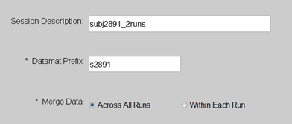Now, let’s take a closer look what everything means:
%------------------------------------------------------------------------
%%%%%%%%%%%%%%%%%%%%%%%%%%%
% General Section Start %
%%%%%%%%%%%%%%%%%%%%%%%%%%%

prefix s2891
brain_region 0.15
across_run 1
single_subj 0

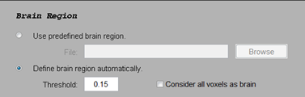%------------------------------------------------------------------------
%%%%%%%%%%%%%%%%%%%%%%%%%%%%%
% Condition Section Start %
%%%%%%%%%%%%%%%%%%%%%%%%%%%%%

cond_name AP_NW
ref_scan_onset 0
num_ref_scan 1

cond_name AP_W
ref_scan_onset 0
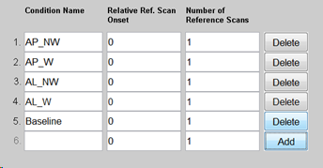num_ref_scan 1

cond_name AL_NW
ref_scan_onset 0
num_ref_scan 1

cond_name AL_W
ref_scan_onset 0
num_ref_scan 1

cond_name Baseline
ref_scan_onset 0
num_ref_scan 1

%------------------------------------------------------------------------
%%%%%%%%%%%%%%%%%%%%%%%
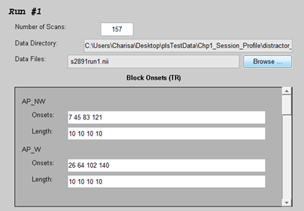 % Run Section Start %
%%%%%%%%%%%%%%%%%%%%%%%

data_files C:\Users\Charisa\Desktop\plsTestData\Chp1_Session_Profile\distractor_study\nifti\s2891run1.nii

block_onsets 7 45 83 121
block_onsets 26 64 102 140
block_onsets -1
block_onsets -1
block_onsets 19 38 57 76 95 114 133 152

block_length 10 10 10 10
block_length 10 10 10 10
block_length 0
block_length 0
block_length 5 5 5 5 5 5 5 5

data_files C:\Users\Charisa\Desktop\plsTestData\Chp1_Session_Profile\distractor_study\nifti\s2891run2.nii

block_onsets -1
block_onsets -1
block_onsets 7 45 83 121
Note: please change the values and parameters according to your experiment. For more parameter options, please see Batch parameters for more detail.

Note: the number of rows of ‘block_onsets’ and ‘block_length’ corresponds to the number of conditions in your run.
block_onsets 26 64 102 140
block_onsets 19 38 57 76 95 114 133 152

block_length -1
block_length -1
block_length 10 10 10 10
block_length 10 10 10 10
block_length 5 5 5 5 5 5 5 5
%------------------------------------------------------------------------
Step 2: FTP your files to the pls folder
After you have created all your text files, transfer (FTP) all the text file to the PLS folder.

Step 3: Run batch_pls

- Go into your PLS analysis folder
- Start MATLAB:
  - matlab
  - addpath /software/jimmy/plsgui/
  - batch_plsgui s2891.txt s4133.txt s4246.txt …

After the batch_plsgui command, just enter the text filenames with a space in between. Then hit “ENTER”.

FOR PSLNPAIRS JAVA USERS

Session and Datamat Files

Step 1: Choose the data type
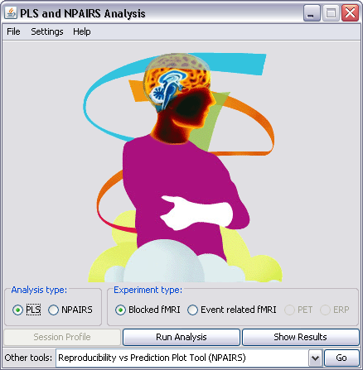

Select “PLS” and “Session Profile” to put together individual subjects’ session profiles.

You will need to make a session profile and datamat for EACH subject.
Select the kind of data you will be working with. In this case, it will be Blocked fMRI data.

Step 2: Session profile
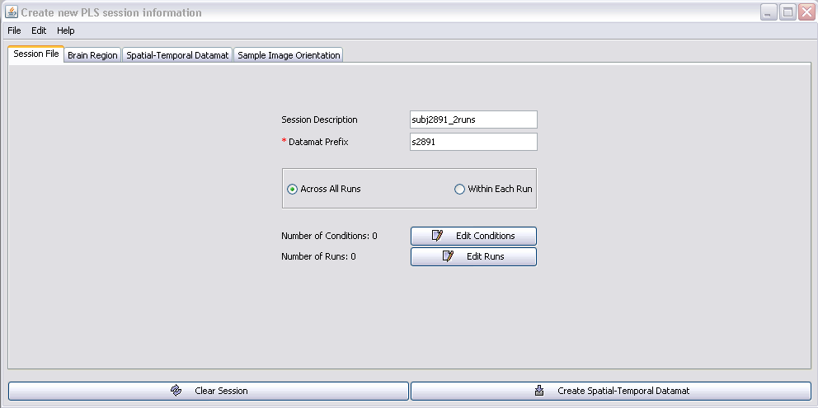

Describe subject data. Important when you want to analyze the same subject(s) in more than one way.
Mandatory input field.

Across All Runs: If you want the same conditions across the runs to be averaged (E.g. Condition A, for run 1 and 2 will be averaged)
Within Each Run: if the conditions within each run are unique. So, Condition A in run1 is considered separately from Condition A in run 2.

This option does not make a difference if you only have a single run.
Filename of the datamat files. PLS will add the suffix _BfMRIsession.mat.
(E.g. s2891_BfMRIsession.mat).
You might also want to indicate the group for each subject in the session and datamat names if you have more than one group (e.g., yng_s2891, old_s4523, etc). This will make it easier to enter the data when you run an analysis.

Click the “Edit Conditions” button.
Now, we need to specify the conditions…

Step 3: Edit conditions

Specify the names of each condition. Make sure you don’t skip a line.
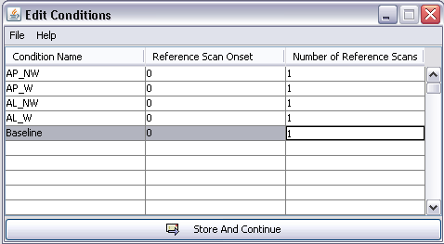

Usually, you leave these as default.

Relative Ref. Scan Onset refers to the reference scan used for normalization (standardization). PLS by default uses the first scan of each block. Normalization is needed so you can compare signals between blocks.

Number of Reference refers to how many scans after the first reference scan will be averaged together to become a reference scan. So, a value of 2 means two scans after the reference scan (specified above) are averaged and used as reference.
However, if you want to use a single reference scan for all data (rather than the first scan of each block), you can specify that later in the create datamat step.

Note that you can only specify default values (0 for ref scan and 1 for number of ref scan) in the current version of Java.

Click “Store And Continue”

Step 4: Edit the run conditions

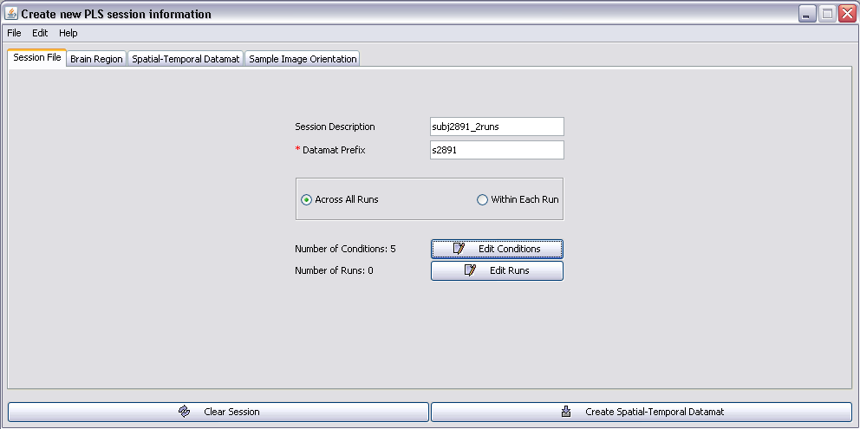

Notice that now the Number of Conditions is set to 5.

Now, click “Edit Runs”

For Run 1:
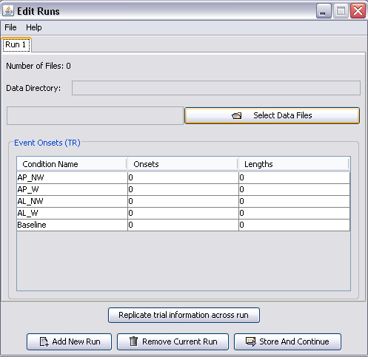

Click “Select Data Files”

After clicking “Select Data Files”, navigate to the folder where you store the image file for the Run1, and select the appreciate image files.

Note that for Analyze files (with .img extension), the number of files for a particular run correspond to the number of TR in that run. In this case, it’s all the .img files containing run1 (157 TR in run1 = 157 files, wmr2891run1*.img).

Note that for NIfTI files (with .nii extension), you will only have 1 file per run (e.g. s2891run1.nii).

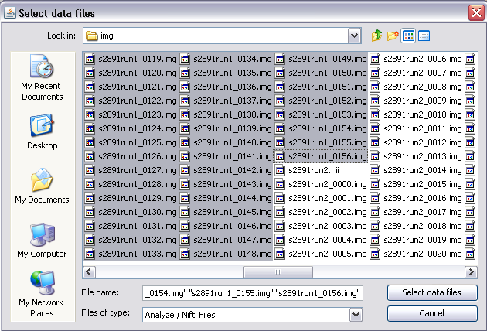
Select all the files containing run1 and click “Select data files”

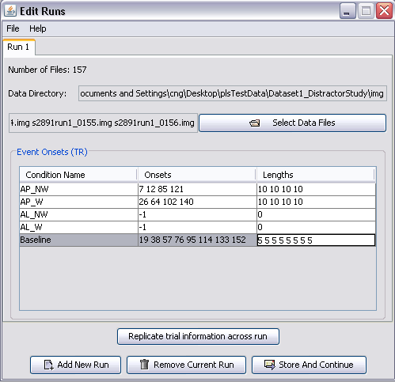

This is for information pertaining to Run 1

Notice that the Data Directory field is automatically filled in for you.

Make sure you have selected all the files for run1 by checking the Number of Files. For Analyze files (.img), this should correspond to the number of TR/scans in that run.

Specify length of each block.
Make sure the number of lengths matches the number of onsets.
Enter the onset TR for each condition.
If this condition is not in the run, enter “-1” or any negative values for onset.

Select this if you have the same onset/length values for all your runs

Click “Add New Run” to add run information for Run 2.

For Run 2:
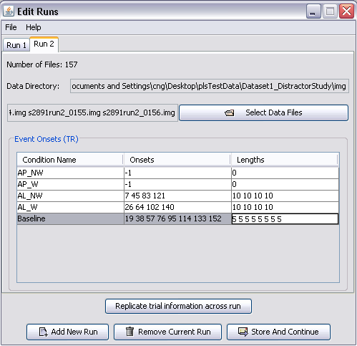

Do the same for Run 2.

Make sure you select the files corresponding to run2.

However, notice the onset and length values are different.

Click “Store And Continue”

Step 5: Creating and Saving the Session File

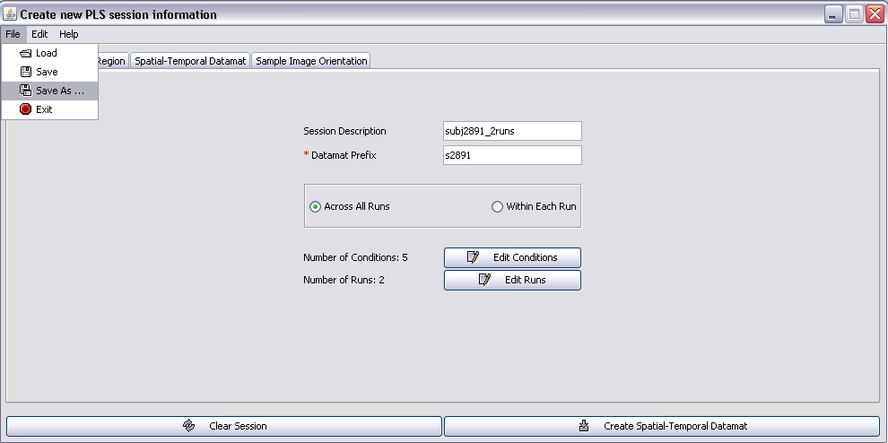

This step is IMPORTANT
Go to File Save As. Then navigate to your JavaPLS folder.

Name the file the same as your Datamat Prefix.

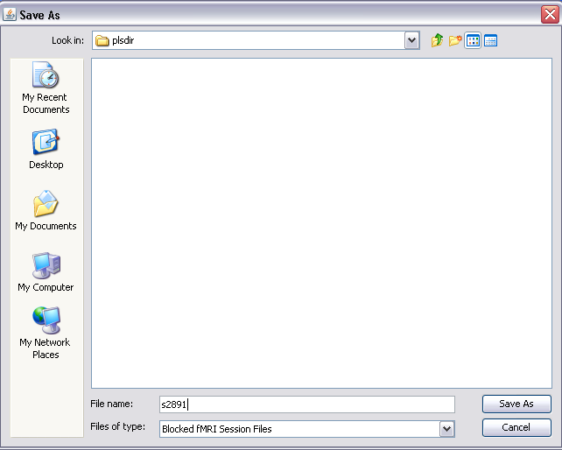

Step 6: Generating the Datamat file
Click on the “Brain Region” tab.

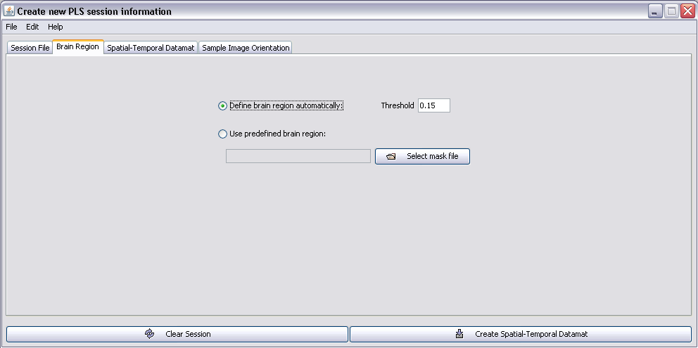

By default, the threshold for defining the brain region is set to 0.15.

Unless specified by the researcher, do not change this

Click on the “Spatial-Temporal Datamat” tab.

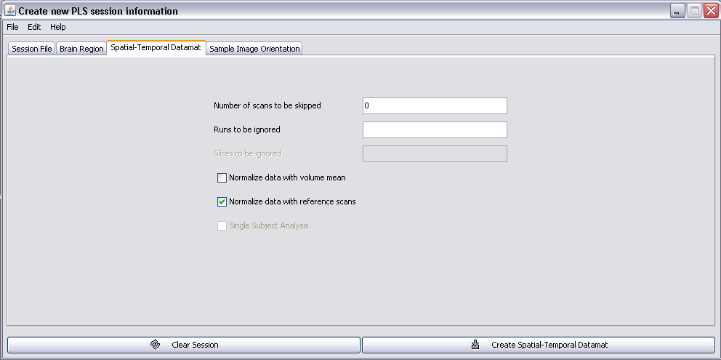

Again, you usually do not want to skip any scans, so leave this at ‘0’.

Runs to be ignored –used if you want to ignore certain runs. Usually we want to include all our runs, so leave this blank.

Usually, we want to normalize the data to the first scan. The default for PLS.

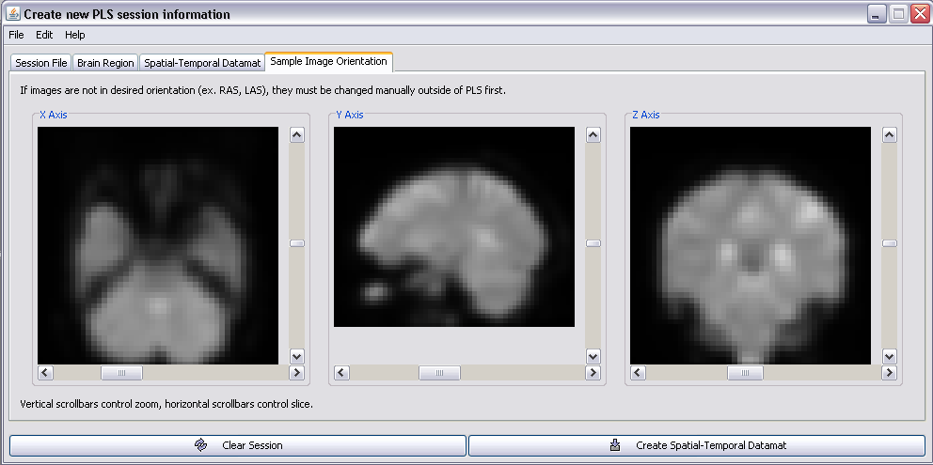
Click on the “Sample Image Orientation” tab.

Everything looks good!

Now click “Create Spatial-Temporal Datamat”

You will notice a Progress Window appears.
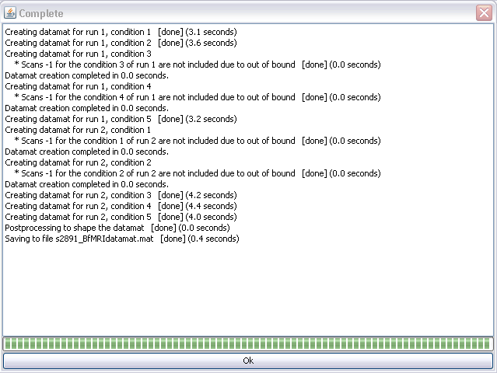

You will know you have successfully created your datamat file once “Saving to file s2891run1_BfMRIdatamat.mat” is [done].

Click “OK”.

Step 7: Repeat the same procedure for all subjects

Event-Related (E.R.) fMRI Design

In event-related fMRI, the changes in signal activity are associated with specific presentation of events (i.e., stimulus onset). In some cases, successive images are acquired after the stimulus onset to determine pattern of changes over time. Basically in event-related design, you want to model the hemodynamic response after the presentation of the stimulus. Thus, the results will be presented in terms of the number of TRs (or lag) after the stimulus presentation.

The Bilingual-Cognitive Control Study

As an example, Gigi was interested in whether bilingualism has an effect on the neural recruitment needed for cognitive and motion inhibition. Specifically, past studies have shown a bilingual advantage in cognitive control tasks, but not in motor control tasks. In addition, neuroimaging studies have shown different neural networks involved in cognitive and motor inhibition.

Using the Flanker task (which involves cognitive control) and a No-go task (which involves motor inhibition), we can compare the brain activity between monolinguals and bilinguals. For simplicity, we are only going to go over the details of run 2. The flanker task consists of 5 conditions (baseline, congruent, incongruent, no-go, and neutral).

Instructions: “Respond to direction of red arrows as fast as possible (< = left response key & > = right response key), but do not respond if you see X’s surrounding the red arrow”.

Congruent
Incongruent
Baseline
Neutral
Nogo

The experiment consisted of 5 task blocks (40 trials within each block, 6 sec rest between each block). The five conditions were randomly presented within each block. As mentioned above, in PLS, the unit measure for time is in TR (for this experiment, 1 TR = 3 sec). Each trial is 1 TR long (3 seconds).
208TR
0TR
Run 2

Block 1
Block 2
Block 3
Block 4
Block 5

2TR (6 sec) rest

40 trials

Trial 1 consists of:
1000 ms

>>><>

300 ms

blank

1700 ms

+

<100 ms, buffer

blank

Total trial duration: ~ 3000 ms (1 TR = 3 sec)
In E.R. design, we only need the onsets to create the sessiondata files. The onset corresponds to the TR when the stimulus was presented. In this case, a stimulus is shown at every TR within a block. The onsets for each condition in run 2 are shown below (remember the conditions were presented randomly so the onsets does not follow any particular pattern and number of times each condition appeared are not the same):

Condition | Onsets
Baseline | 1 2 45 49 52 92 126 128 137 142 147 148 149 194 202
Congruent | 6 7 17 18 19 26 27 28 30 35 36  37 41 50 51 55 60 61 62 65 67 70  80 85 89 90 93 104 105 109 114 115 116  117 131 134 136 138 146 151 152 159 163 164  167 169 170 171 173 174 175 177 181 183 185  190 191 207
Incongruent | 8 9 13 14 16 29 38 42 43 44 53  54 57 58 64 84 87 99 107 110 120 129  130 135 145 157 158 160 162 168 179 180 182  184 186 192 193 197 198
Neutral | 4 5 10 12 31 32 33 34 46 47 56  66 68 69 74 79 86 95 97 98 102 106  111 112 113 119 122 125 132 133 139 141 150  153 154 155 156 172 196 200 203 204 205
Nogo | 0 3 11 15 20 21 22 23 24 25 48  59 63 71 72 73 83 88 91 94 96 100  101 103 108 118 121 127 140 143 144 161 176  178 187 189 195 199 201

The formats for the other runs, i.e., run 1 and 3, are very similar, with the exception in run 1 the first block is a fixation block, and in run 3 the last block is a fixation block. That is, run 2 consists of 5 task blocks, while run 1 and 3 consists of only 4 task blocks. Otherwise, the structure (e.g. # of blocks, trials, TRs) is analogous to run 2. We are not interested in the fixation block, so we will not include it as a condition.
Run 1
208TR
0TR

Block 5
Block 4
Block 3
Block 2
Block 1

Task Blocks
Fixation Block

208TR
0TR
Run 3

Block 5
Block 4
Block 3
Block 2
Block 1

Task Blocks
Fixation Block

FOR MATLAB USERS

SessionData Files for E.R.fMRI

Using the information we have so far, let’s create the sessiondata files for this experiment:
Again, there are two ways you can create sessiondata files:

1. PLSGUI

Starting PLSGUI
- Go into your PLS analysis folder
- Start MATLAB:
  - matlab
  - addpath /software/jimmy/plsgui/
  - plsgui

Step 1: Choose the data type

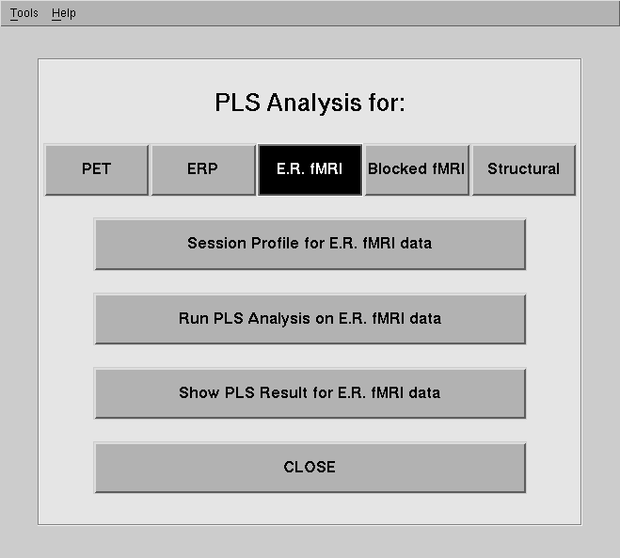
Select the kind of data you will be working with. In this case, it will be E.R. fMRI
Select “Session Profile” to put together individual subjects’ sessiondata profiles.

You will need to make a sessiondata file for EACH subject.

Step 2: Sessiondata profile
Describe subject data. Important when you want to analyze the same subject(s) in more than one way.

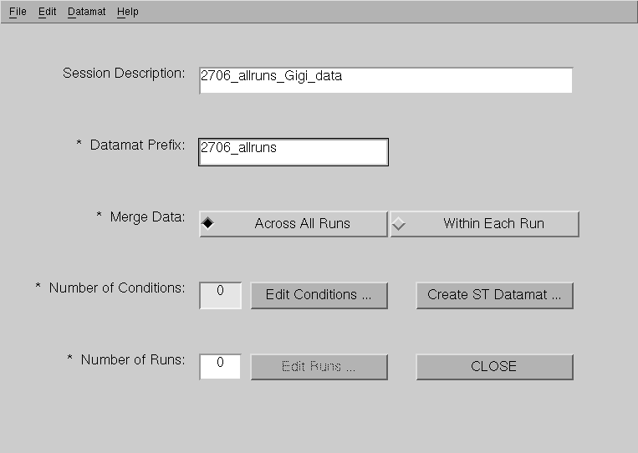

Mandatory input field.
Filename of the datamat files. PLS will add the suffix _fMRIsession.mat.
(E.g. s2891run1_fMRIsession.mat).

Across All Runs: If you want the same conditions across the runs to be averaged (E.g. Condition A, for run 1 and 2 will be averaged)
Within Each Run: if the conditions within each run are unique. So, Condition A in run1 is considered separately from Condition A in run 2.

Again, this option does not make a difference if you only have a single run.

Click the “Edit Conditions” button.

Now, we need to specify the conditions…

Step 3: Edit conditions
Specify the names of each condition and click “Add”.

Make sure you click Add! You will notice a blank row, this is correct.
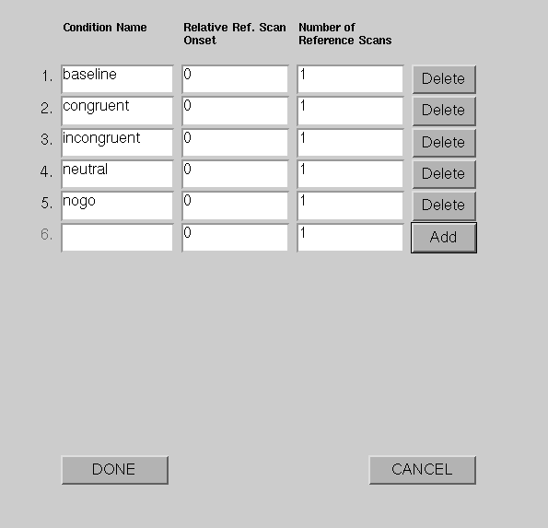
Specify the names of each condition and click “Add”.

Make sure you click Add! You will notice a blank row at the end, this is correct.

Usually, you leave these as default.

Relative Ref. Scan Onset refers to the reference scan used for normalization (standardization). PLS by default uses the first scan of each block. Normalization is needed so you can compare signals between blocks. If you are dropping out transitions between the blocks, you will need to move the reference scan for normalizing back to the last TR in the preceding block (value ‘-1’).

Number of Reference refers to how many scans after the first reference scan will be averaged together to become a reference scan. So, a value of 2 means two scans after the reference scan (specified above) are averaged and used as reference.

Click “Done”

Step 4: Edit the run conditions
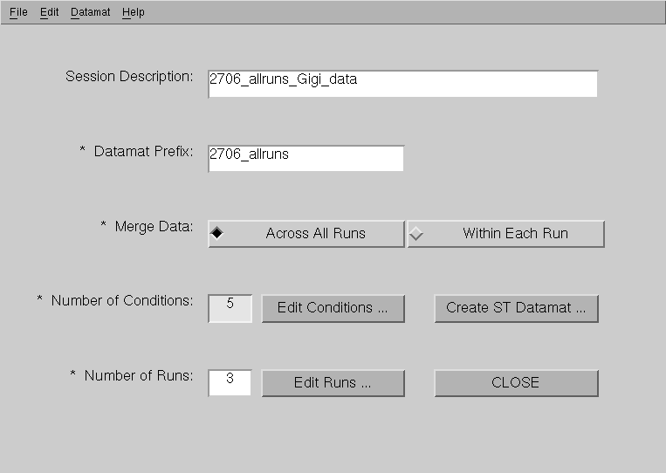

Specify the Number of runs. This will enable the edit runs option

Now, click “Edit Runs”

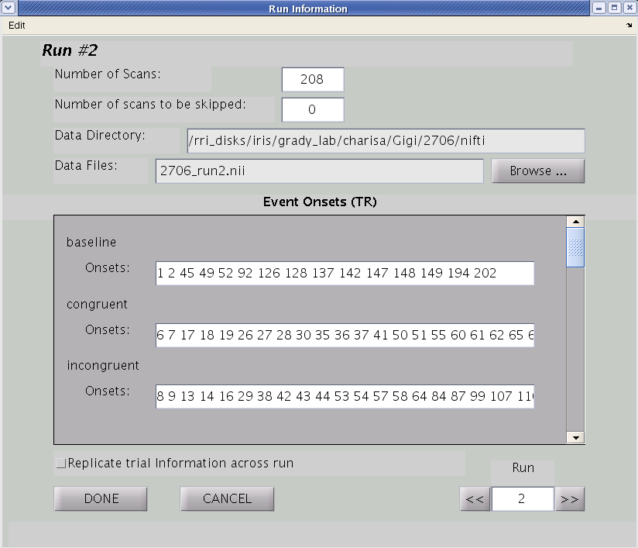
Number of TR in the run

Path where the nifti files are located

Click “Browse” to locate your nifti files (.nii) [see below]

Enter the onset TR for each condition. Notice the onsets are the same as the onsets listed above

Select this if you have the same onset values for all your runs

Information for Run 2. Scroll to edit onsets for Run 1 and Run 3.

Once all run information is filled, Click “Done”

Remember to fill in all the above information for ALL RUNS!

After clicking “Browse”, select the appropriate nifti file.

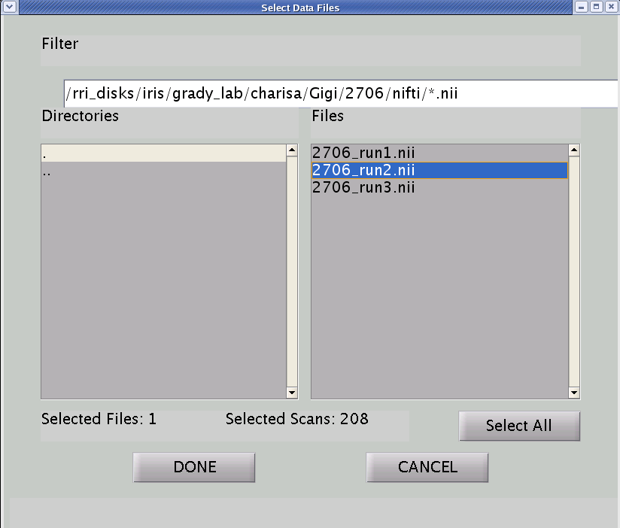
Change the filter to *.nii, to show the nifti files

Select the file

Click “Done”

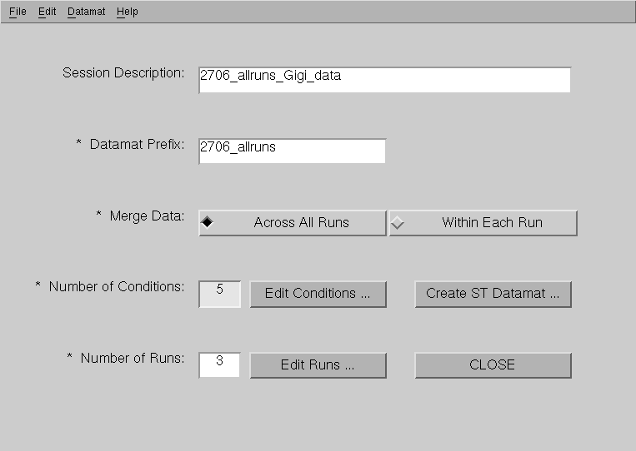

Click “Create ST Datamat”

Step 5: Generate and save the sessiondata file
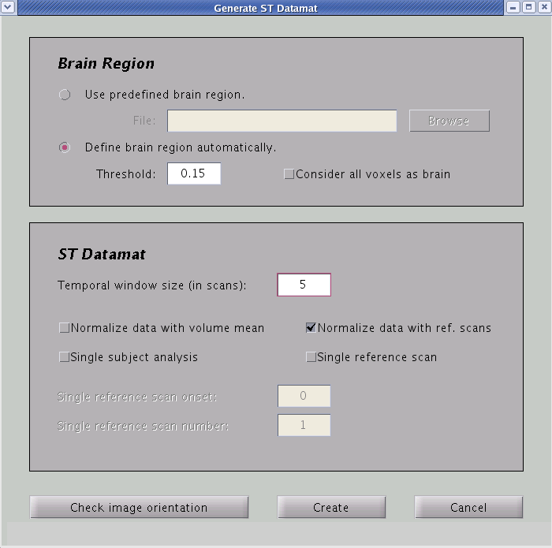

By default, the threshold for defining the brain region is set to 0.15. Unless specified by the researcher, do not change this

Length of hemodynamic period (in TRs). The default is 8 TRs. If your TR=2 sec this will give you a 16 sec analysis window, which should be adequate. The example here uses 5 TRs (15 sec, with TR = 3)
[ONLY for E.R. fMRI]

To check the image /nifti file orientation

Usually, we want to normalize the data to the first volume (TR) in each event. The default for event-related PLS

Select “Create”
You will be prompted that file has been saved, click “OK”

To check your image orientation:
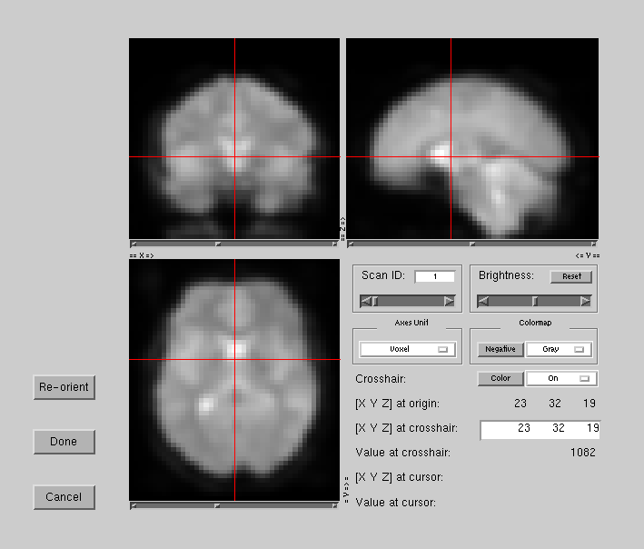
Re-orient the x, y, and z axes, using drop down menus

Click “Done” if you want changes to saved, or “Cancel” to return to the previous screen without saving.

Enter Coordinates to change crosshair

Change Brightness

Change Contrast

You have successfully created your sessiondata files!

Note: If you get a warning message saying that ‘scan 207 was not included due to out of bound’, this is okay. This is because a hemodynamic response lasts around 16 seconds (5 TR, temporal window). If you add 5TR to the onsets near the end of the run (e.g. 207 + 5 = 212), they will be out-of-bound. The incomplete hemodynamic responses are dropped from analysis.

Step 6: Repeat the same procedure for all participants
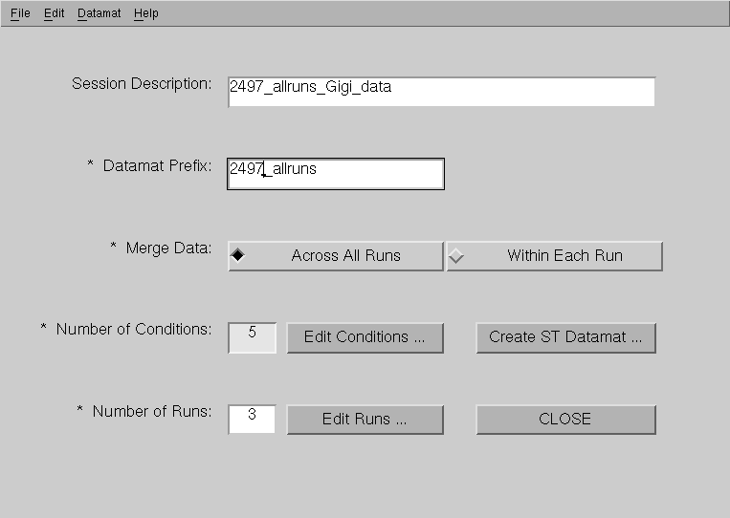

Rename for each participant

2. Batch PLS (with text files) –Recommended

You can create multiple sessiondata files using the batch_plsgui command on text files containing conditions and runs information (e.g. onsets). PLS will only recognize information presented in a certain way. Use the following template to create your own text file.

Note that 1 textfile is needed per sessiondata file. So, you will need to create textfile for each subject.

Step1: Create text files
To create the text file, open Notepad, and copy and paste everything in the following textbox into Notepad.
Template for E.R. fMRI
%------------------------------------------------------------------------
%%%%%%%%%%%%%%%%%%%%%%%%%%%
% General Section Start %
%%%%%%%%%%%%%%%%%%%%%%%%%%%

prefix 2706_allruns % prefix for session file and datamat file
brain_region 0.15 % threshold or file name for brain region
win_size 5 % number of scans in one hemodynamic period
across_run 1 % 1 for merge data across all run, 0 for within each run
single_subj 0 % 1 for single subject analysis, 0 for normal analysis

%%%%%%%%%%%%%%%%%%%%%%%%%
% General Section End %
%%%%%%%%%%%%%%%%%%%%%%%%%
%------------------------------------------------------------------------
%%%%%%%%%%%%%%%%%%%%%%%%%%%%%
% Condition Section Start %
%%%%%%%%%%%%%%%%%%%%%%%%%%%%%
cond_name baseline % condition 1 name
ref_scan_onset 0 % reference scan onset for condition 1
num_ref_scan 1 % number of reference scan for condition 1

cond_name congruent % condition 2 name
ref_scan_onset 0 % reference scan onset for condition 2
num_ref_scan 1 % number of reference scan for condition 2

cond_name incongruent % condition 3 name
ref_scan_onset 0 % reference scan onset for condition 3
num_ref_scan 1 % number of reference scan for condition 3

cond_name neutral % condition 4 name
ref_scan_onset 0 % reference scan onset for condition 4
num_ref_scan 1 % number of reference scan for condition 4

cond_name nogo % condition 5 name
ref_scan_onset 0 % reference scan onset for condition 5
num_ref_scan 1 % number of reference scan for condition 5

%%%%%%%%%%%%%%%%%%%%%%%%%%%
% Condition Section End %
%%%%%%%%%%%%%%%%%%%%%%%%%%%
Continue on next page…

%------------------------------------------------------------------------
%%%%%%%%%%%%%%%%%%%%%%%
% Run Section Start %
%%%%%%%%%%%%%%%%%%%%%%%

data_files /iris/grady_lab/charisa/pls_examples/event_related/2706_run1.nii % run 1 data pattern (must use wildcard)
event_onsets 46 76 91 105 116 130 133 134 153 184 186 200 201
% for allruns condition 1
event_onsets 45 49 50 51 54 55 60 63 65 73 84 96 97 104 108 109 127 129 141 146 150 151 152 160 161 167 168 173 174 185 187 188 189 190 191 196 199
% for allruns condition 2
event_onsets 41 43 44 48 53 61 62 64 66 67 68 78 92 93 98 101 103 117 140 147 148 149 158 162 164 172 176 178 180 182 197
% for allruns condition 3
event_onsets 42 74 75 77 79 80 94 95 100 106 110 112 113 114 115 118 119 120 128 132 137 143 156 159 177 192 193 195 198 207
% for allruns condition 4
event_onsets 47 52 56 57 58 59 69 83 85 86 87 88 89 90 99 102 107 111 121 122 125 126 131 135 136 142 144 145 154 155 157 163 169 170 171 175 179 181 183 194 202 203 204 205
% for allruns condition 5

data_files /iris/grady_lab/charisa/pls_examples/event_related/2706_run2.nii % run 2 data pattern (must use wildcard)
event_onsets 1 2 45 49 52 92 126 128 137 142 147 148 149 194 202 % for allruns condition 1
event_onsets 6 7 17 18 19 26 27 28 30 35 36 37 41 50 51 55 60 61 62 65 67 70 80 85 89 90 93 104 105 109 114 115 116 117 131 134 136 138 146 151 152 159 163 164 167 169 170 171 173 174 175 177 181 183 185 190 191 207 % for allruns condition 2
event_onsets 8 9 13 14 16 29 38 42 43 44 53 54 57 58 64 84 87 99 107 110 120 129 130 135 145 157 158 160 162 168 179 180 182 184 186 192 193 197 198 % for allruns condition 3
event_onsets 4 5 10 12 31 32 33 34 46 47 56 66 68 69 74 79 86 95 97 98 102 106 111 112 113 119 122 125 132 133 139 141 150 153 154 155 156 172 196 200 203 204 205 % for allruns condition 4
event_onsets 0 3 11 15 20 21 22 23 24 25 48 59 63 71 72 73 83 88 91 94 96 100 101 103 108 118 121 127 140 143 144 161 176 178 187 189 195 199 201 % for allruns condition 5

Continue on next page…

data_files /iris/grady_lab/charisa/pls_examples/event_related/2706_run3.nii % run 3 data pattern (must use wildcard)
event_onsets 6 23 24 26 30 34 56 57 86 104 105 139 % for allruns condition 1
event_onsets 14 36 41 44 45 46 48 49 58 59 63 64 68 71 83 87 91 95 112 120 125 127 128 132 133 151 153 162 % for allruns condition 2
event_onsets 2 4 7 12 13 18 22 33 43 54 55 60 62 66 67 76 77 78 82 89 90 92 93 102 103 106 107 109 110 114 115 119 124 129 130 131 137 138 143 147 148 154 156 157 158
% for allruns condition 3
event_onsets 5 8 15 16 25 27 28 29 37 38 42 47 50 51 52 61 74 75 84 85 94 96 97 101 108 111 116 117 121 126 134 136 140 141 150 155 160 161 163
% for allruns condition 4
event_onsets 0 1 3 9 10 11 17 21 31 32 35 53 65 69 70 72 73 79 88 98 99 100 113 118 135 142 144 145 146 149 152 159 % for allruns condition 5

%%%%%%%%%%%%%%%%%%%%%
% Run Section End %
%%%%%%%%%%%%%%%%%%%%%

%------------------------------------------------------------------------

Now, let’s take a closer look what everything means:
%------------------------------------------------------------------------

%%%%%%%%%%%%%%%%%%%%%%%%%%%
% General Section Start %
%%%%%%%%%%%%%%%%%%%%%%%%%%%

prefix 2706 % prefix for session file and datamat file
brain_region 0.15 % threshold or file name for brain region
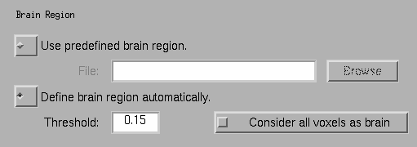win_size 5 % number of scans in one hemodynamic period
across_run 1 % 1 for merge data across all run, 0 for within each run
single_subj 0 % 1 for single subject analysis, 0 for normal analysis

%%%%%%%%%%%%%%%%%%%%%%%%%
% General Section End %
%%%%%%%%%%%%%%%%%%%%%%%%%

%------------------------------------------------------------------------

%%%%%%%%%%%%%%%%%%%%%%%%%%%%%
% Condition Section Start %
%%%%%%%%%%%%%%%%%%%%%%%%%%%%%
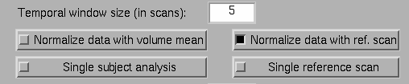

cond_name baseline % condition 1 name
ref_scan_onset 0 % reference scan onset for condition 1
num_ref_scan 1 % number of reference scan for condition 1

cond_name congruent % condition 2 name
ref_scan_onset 0 % reference scan onset for condition 2
num_ref_scan 1 % number of reference scan for condition 2

cond_name incongruent % condition 3 name
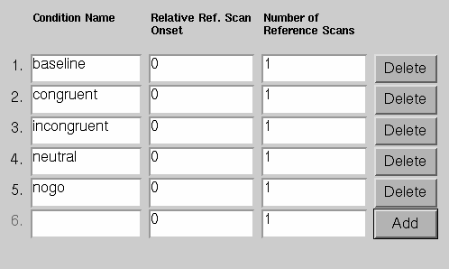ref_scan_onset 0 % reference scan onset for condition 3
num_ref_scan 1 % number of reference scan for condition 3

cond_name neutral % condition 4 name
ref_scan_onset 0 % reference scan onset for condition 4
num_ref_scan 1 % number of reference scan for condition 4

cond_name nogo % condition 5 name
ref_scan_onset 0 % reference scan onset for condition 5
num_ref_scan 1 % number of reference scan for condition 5

%%%%%%%%%%%%%%%%%%%%%%%%%%%
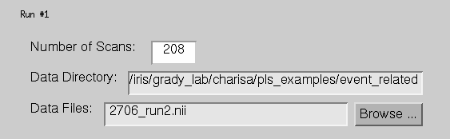 % Condition Section End %
%%%%%%%%%%%%%%%%%%%%%%%%%%%

%------------------------------------------------------------------------

%%%%%%%%%%%%%%%%%%%%%%%
% Run Section Start %
%%%%%%%%%%%%%%%%%%%%%%%
[Same for Run 1]
.
.
data_files /iris/grady_lab/charisa/pls_examples/event_related/2706_run2.nii % run 1 data pattern (must use wildcard)

event_onsets 1 2 45 49 52 92 126 128 137 142 147 148 149 194 202 % for allruns condition 1

event_onsets 6 7 17 18 19 26 27 28 30 35 36 37 41 50 51 55 60 61 62 65 67 70 80 85 89 90 93 104 105 109 114 115 116 117 131 134 136 138 146 151 152 159 163 164 167 169 170 171 173 174 175 177 181 183 185 190 191 207 % for allruns condition 2

event_onsets 8 9 13 14 16 29 38 42 43 44 53 54 57 58 64 84 87 99 107 110 120 129 130 135 145 157 158 160 162 168 179 180 182 184 186 192 193 197 198 % for allruns condition 3

event_onsets 4 5 10 12 31 32 33 34 46 47 56 66 68 69 74 79 86 95 97 98 102 106 111 112 113 119 122 125 132 133 139 141 150 153 154 155 156 172 196 200 203 204 205 % for allruns condition 4

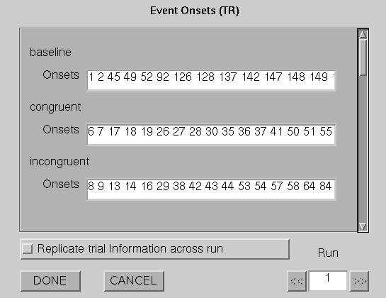event_onsets 0 3 11 15 20 21 22 23 24 25 48 59 63 71 72 73 83 88 91 94 96 100 101 103 108 118 121 127 140 143 144 161 176 178 187 189 195 199 201 % for allruns condition 5

[Same for Run 3]
.
.
.
%%%%%%%%%%%%%%%%%%%%%
% Run Section End %
%%%%%%%%%%%%%%%%%%%%%

%------------------------------------------------------------------------

Note: everything in bold font should be changed to match your experiment.

Note: the number of rows of ‘block_onsets’ corresponds to the number of condition in your run.

Save the text file as ‘2706_example.txt’. Remember the file needs to be saved with a .txt extension, otherwise the batch command won’t run. Once you have a template with the correct values, you can copy and paste the text files and change the ‘prefix’ and ‘data_files’.

Step 2: FTP your files to the pls folder
After you have created all your text files, FTP all the text file to the PLS folder.

Step 3: Run batch_pls

- Go into your PLS analysis folder
- Start MATLAB:
  - matlab
  - addpath /software/jimmy/plsgui/
  - batch_plsgui 2706_allruns.txt …

After the batch_plsgui command, just enter the text filenames with a space in between. Then hit “ENTER”.

FOR PLSNPAIRS JAVA USERS

Session and Datamat Files

Using the information we have so far, let’s create the session/datamat files for this experiment:

Step 1: Choose the data type

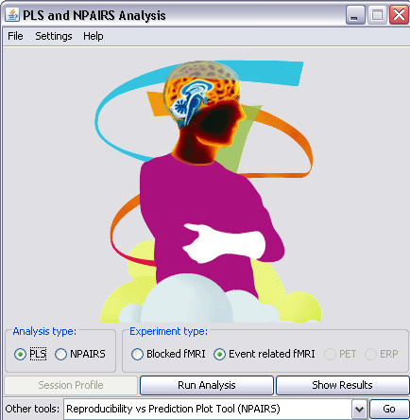
Select the kind of data you will be working with. In this case, it will be Event-related fMRI data.

Select “PLS” and “Session Profile” to put together individual subjects’ session profiles.

You will need to make a session profile and datamat for EACH subject.

Step 2: Session profile
Describe subject data. Important when you want to analyze the same subject(s) in more than one way.

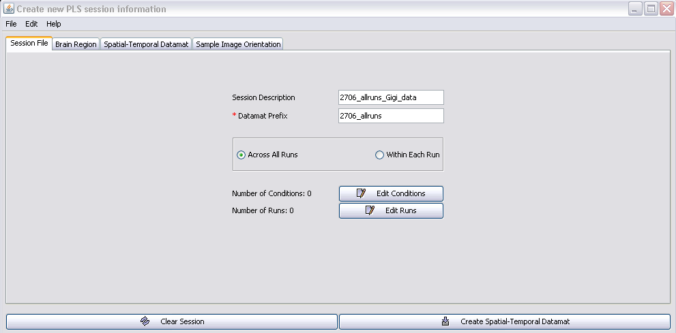

Filename of the datamat files.
PLS will add the suffix _fMRIsession.mat.
(E.g. 2706_allruns_fMRIsession.mat).
Mandatory input field.

Across All Runs: If you want the same conditions across the runs to be averaged (E.g. Condition A, for run 1 and 2 will be averaged)
Within Each Run: if the conditions within each run are unique. So, Condition A in run1 is considered separately from Condition A in run 2.

Again, this option does not make a difference if you only have a single run.

Click the “Edit Conditions” button.

Now, we need to specify the conditions…

Step 3: Edit conditions
Specify the names of each condition. Make sure you don’t skip a line.
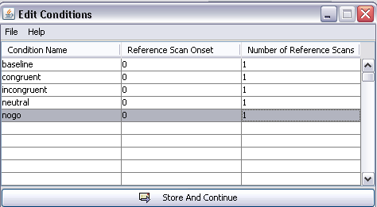

Usually, you leave these as default.

Relative Ref. Scan Onset refers to the reference scan used for normalization (standardization). PLS by default uses the first scan of each block. Normalization is needed so you can compare signals between blocks. If you are dropping out transitions between the blocks, you will need to move the reference scan for normalizing back to the last TR in the preceding block (value ‘-1’).

Number of Reference refers to how many scans after the first reference scan will be averaged together to become a reference scan. So, a value of 2 means two scans after the reference scan (specified above) are averaged and used as reference.

Click “Store And Continue”

Step 4: Edit the run conditions

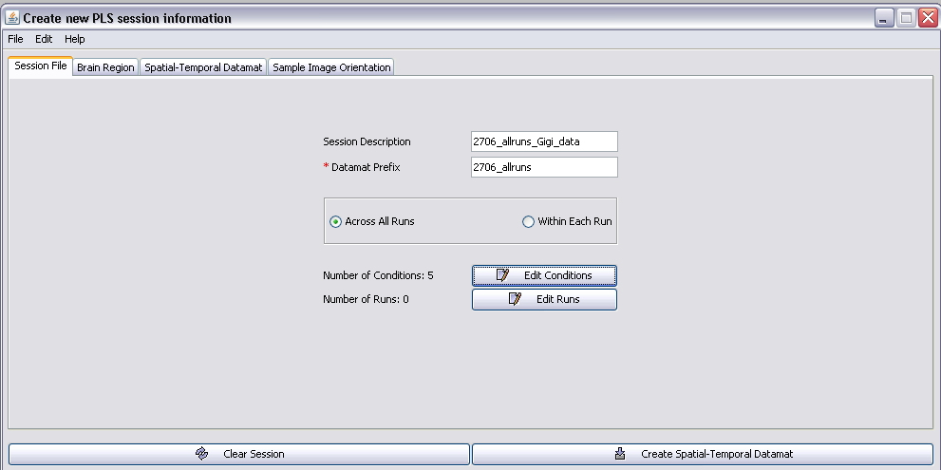
Now, click “Edit Runs”
Notice that now the Number of Conditions is set to 5.

For Run 1:
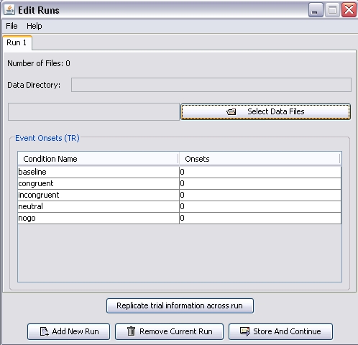

Click “Select Data Files”

After clicking “Select Data Files”, navigate to the folder where you store the image file for the Run1, and select the appreciate image files.

Note that for Analyze files (with .img extension), the number of files for a particular run correspond to the number of TR in that run. In this case, it’s all the .img files containing run1 (208 TR in run1 = 208 files).

Note that for NIfTI files (with .nii extension), you will only have 1 file per run (e.g. YA_subj1_run1.nii).

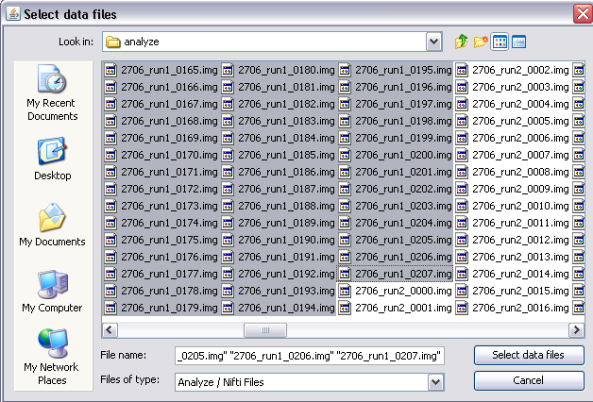
Select all the files containing run1 and click “Select data files”

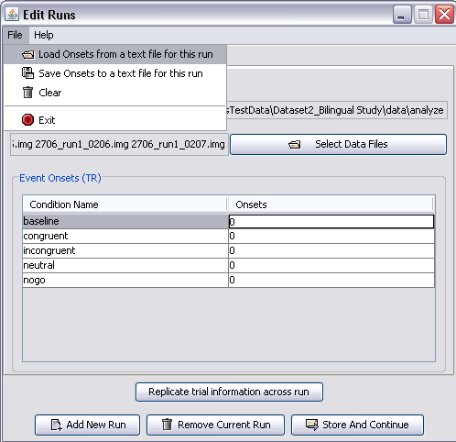
Rather than hand typing all the onsets onto the field, we are going to load the onsets from a text file.
Go to FILE Load Onsets from text file for this run.
Notice that the Data Directory field is automatically filled in for you.

Make sure you have selected all the files for run1 by checking the Number of Files. For Analyze files (.img), this should correspond to the number of TR/scans in that run.

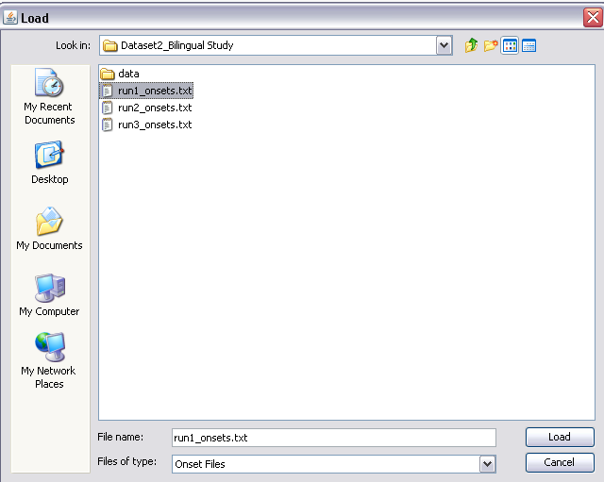

Navigate to your folder containing the onsets (text files are included into this sample test data).

Select ‘run1_onsets.txt’ and click ‘Load’

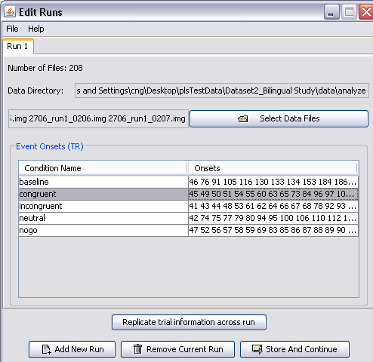

Notice that the onsets TR are automatically filled in. Note that there are no lengths –since this is an even-related dataset.

If this condition is not in the run, enter “-1” or any negative values for onset.

Select this if you have the same onset/length values for all your runs

Click “Add New Run” to add run information for Run 2.

Repeat the same procedure as above for Run 2 and 3 –make sure you select the data files corresponding to the run and load the correct text file since the event onsets are different for all runs.

Run 2:
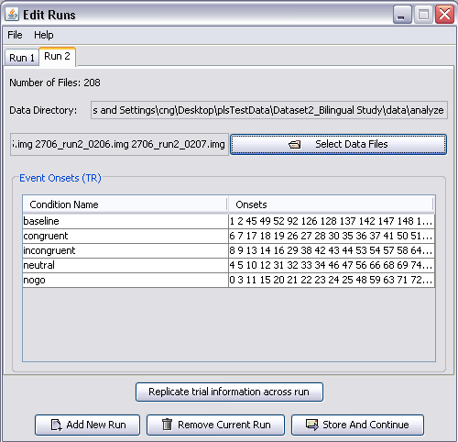

Run 3:
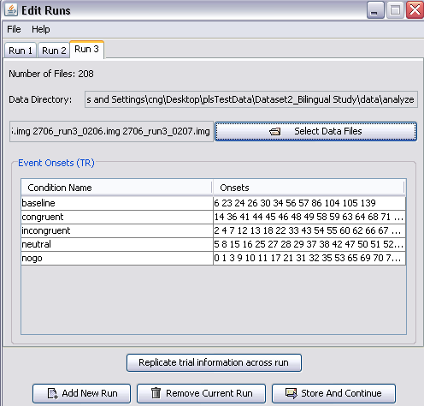

Once all run information is filled, Click “Store and Continue”

Step 5: Creating and Saving the Session File

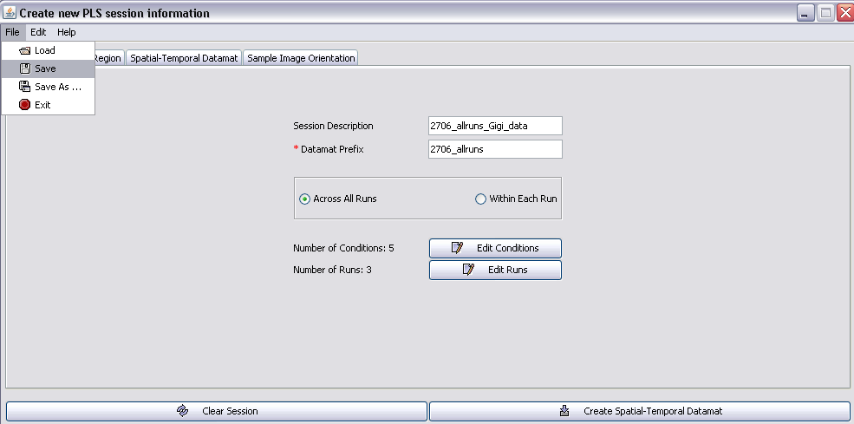

This step is IMPORTANT
Go to File Save As. Then navigate to your JavaPLS folder.

Name the file the same as your Datamat Prefix.

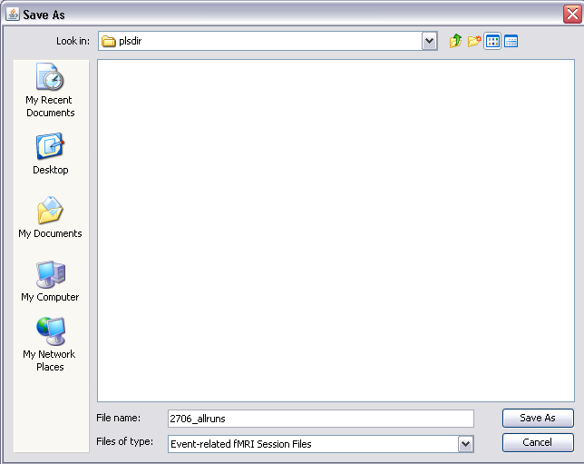

Step 6: Generating the Datamat file
Click on the “Brain Region” tab.

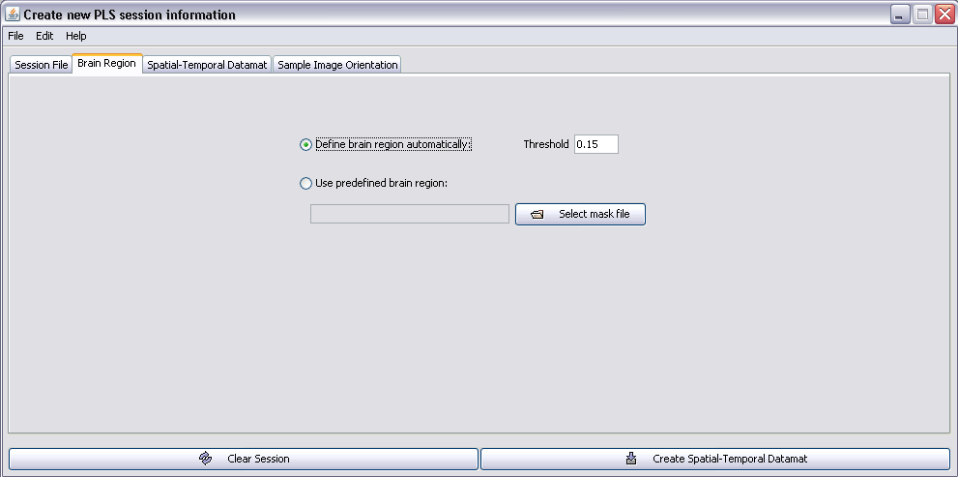

By default, the threshold for defining the brain region is set to 0.15.

Unless specified by the researcher, do not change this

Click on the “Spatial-Temporal Datamat” tab.

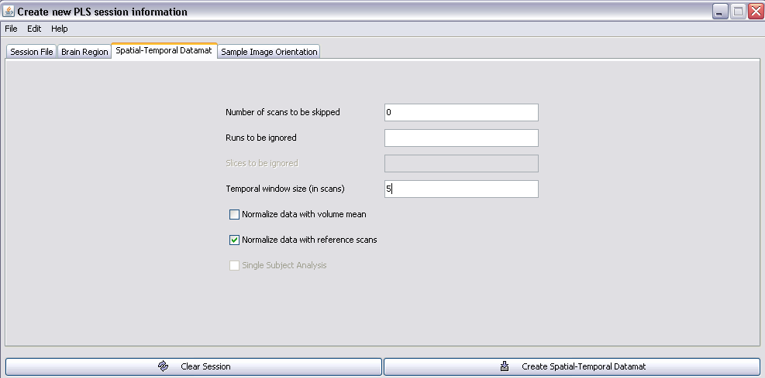

Again, you usually do not want to skip any scans, so leave this at ‘0’.

Length of hemodynamic period (in TRs). The default is 8 TRs. If your TR=2 sec this will give you a 16 sec analysis window, which should be adequate. The example here uses 5 TRs (15 sec, with TR = 3)
[ONLY for E.R. fMRI]
Runs to be ignored –used if you want to ignore certain runs. Usually we want to include all our runs, so leave this blank.

Usually, we want to normalize the data to the first scan. The default for PLS.

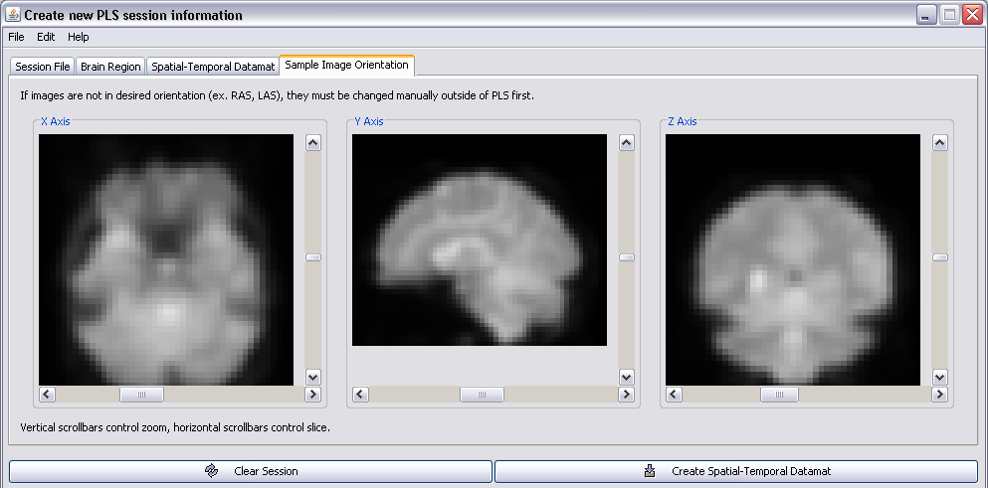
Click on the “Sample Image Orientation” tab.

Everything looks good!

Now click “Create Spatial-Temporal Datamat”

You will notice a Progress Window appears.
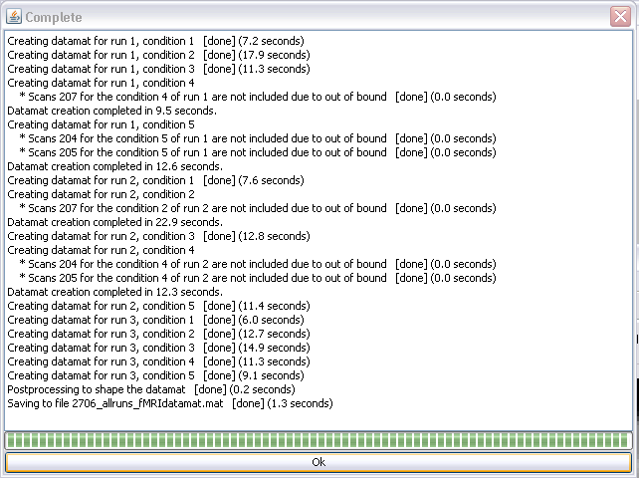

You will know you have successfully created your datamat file once “Saving to file s2706_allruns_fMRIdatamat.mat” is [done].

Click “OK”.

You have successfully created your session/datamat files!

Note: If you get a warning message saying that ‘scan 207 was not included due to out of bound’, this is okay. This is because a hemodynamic response lasts around 16 seconds (5 TR, temporal window). If you add 5TR to the onsets near the end of the run (e.g. 207 + 5 = 212), they will be out-of-bound. The incomplete hemodynmaic responses are dropped from analysis.

Step 7: Repeat the same procedure for all subjects

SessionData Files for E.R.fMRI with user defined HRF

Let’s create the sessiondata files for this experiment again with user defined HRF, using PLSGUI. Note that the option of user defined HRF is implemented on blocked fMRI platform:

Starting PLSGUI
- Go into your PLS analysis folder
- Start MATLAB:
  - matlab
  - addpath /software/jimmy/plsgui/
  - plsgui

Select “Session Profile” to put together individual subjects’ sessiondata profiles.

You will need to make a sessiondata file for EACH subject.
Select blocked fMRI to create sessiondata file for E.R.fMRI with user defined HRF.

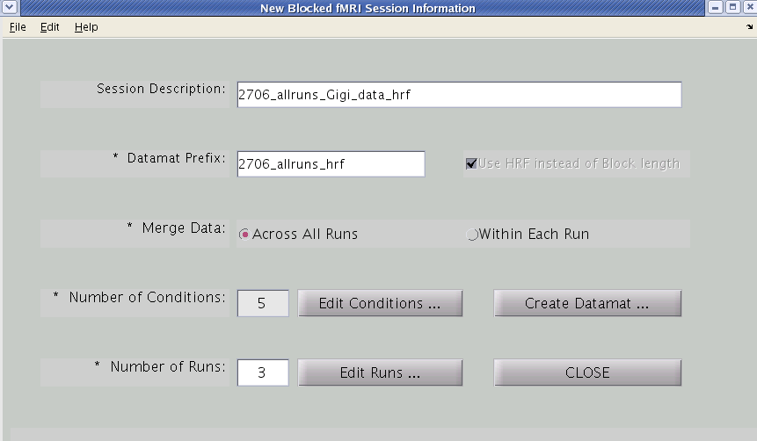

Check this box before you edit conditions and runs to make sessiondata file for E.R.fMRI with user defined HRF; otherwise, your sessiondata file is for Blocked fMRI. Once you make the decision, it can not be changed unless you make a new sessiondata file.

Click “Create Datamat” after you edit conditions and runs

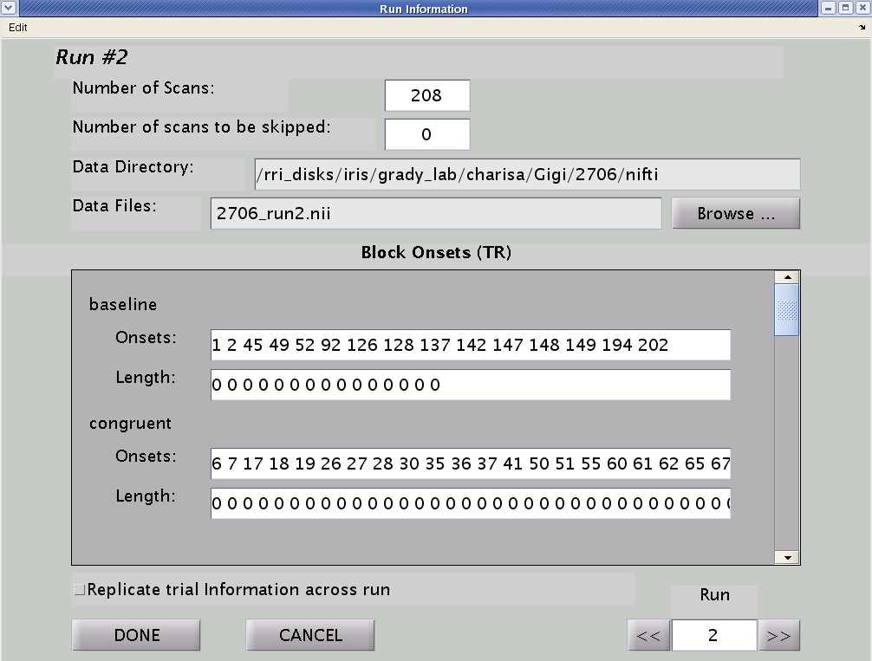

When editing run information, note that “Length” is 0 for event-related response

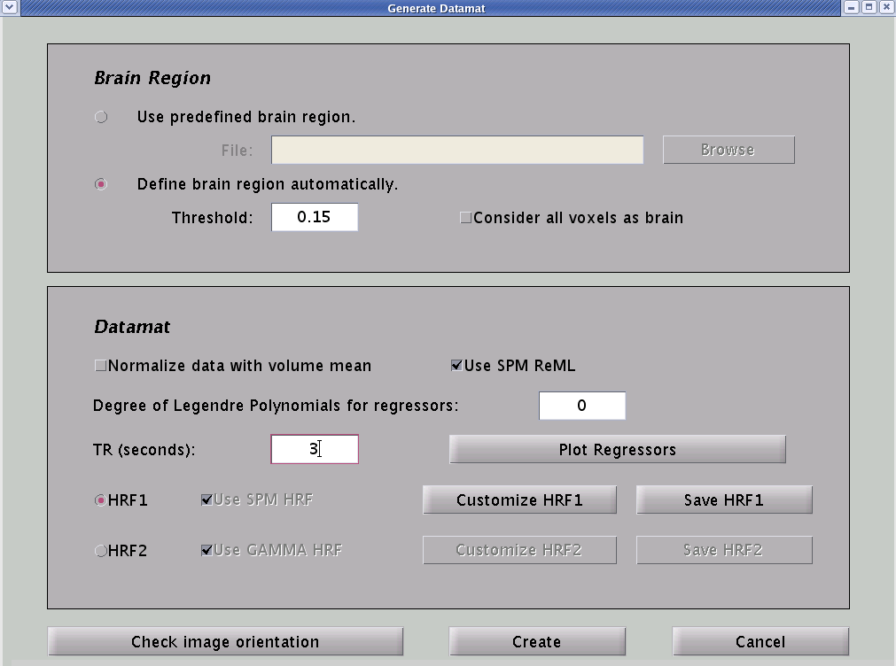

If this box is checked, datamat value will be the stacked volume intensity divided by the average intensity for each volume; otherwise, datamat value will just be the stacked volume intensity. By default, this box is NOT checked for both E.R.fMRI and Blocked fMRI data. Don’t select this box unless you have good reason to do so.

check this box to use the feature that is copied from SPM to remove the voxel outliers over the run. It is a temporal whitening function using restricted maximum likelihood estimation.

This is used to define the baseline regressor. By default, it is 0, which provides a single column of all ones.

You must enter the TR to define the HRF.

Plot Regressors would display the entire hemodynamic response across the run. This is the design matrix: convolution result between HRF and event (or epoch).

In HRF1, TR will be further divided when calculating design matrix. It uses HRF model from SPM by default. In HRF2, TR is always the smallest unit when calculating design matrix. By default, it uses GAMMA HRF from AFNI. In both cases, you can click Customize HRF to modify the model, and click Save HRF
to save the model.

Click “create” to generate E.R.fMRI sessiondata file with user define HRF.
You will be prompted that file has been saved, click “OK”

Chapter 2: Running PLS Analysis

PLS Analysis Options for fMRI Data

PLS offers 7 different analysis options.

- Mean-Centering Task PLS
- Non-Rotated Task PLS
- Regular Behavioral PLS
- Non-Rotated Behavioral PLS
- Seed PLS (Behavioral PLS)
- Multiblock PLS
- Non-Rotated Multiblock PLS

The term ‘partial least squares’ refers to the computational method of maintaining maximal covariances (and minimizing residuals) between the set of exogenous variable (i.e., conditions, behavior, seed activity) and the dependent measure (i.e., BOLD data). For all types of PLS, the data for all the subjects and tasks are combined into a single matrix. Thus, it is assumed that the image data (nifti or analyze files) have been standardized so they are the same shape and size. Task PLS is used to identify whole-brain patterns of activity that distinguish tasks.

Each analysis (except for multiblock PLS) will be discussed in detail in the following sections. Please consult the PLS user manual (available on the RRI website) for more information on multiblock PLS.

Mean-Centering Task PLS

If you choose the Mean-Centering Task PLS option, the data will be mean centered according to the mean-centering type you selected, and then decomposed with SVD to obtain singular values, singular vectors, etc.

In mean-centered PLS, you have the opportunities to choose different values for Mean-Centering Type. If you leave the default value (i.e. 0) unchanged, the conventional mean-centering algorithm will be applied.
Mean-Centering Type feature allows you to choose the kind of mean-centering of the data matrix before running Mean-Centering Task PLS, Non-Rotated Task PLS, Multiblock PLS, Non-Rotated Multiblock PLS. Depending on your scientific question, by selecting a specific type for mean-centering you can remove main effects that are not of interest and focus on those that are relevant. The options are as follows:
0 - (default) Within each group remove group means from condition means. Tells us how conditions are modulated by group membership, however it boosts condition differences, removes overall group differences. Select this option if you are interested in condition and condition- by-group effects.
1 - Remove grand condition means from each group condition mean. Tells us how conditions are modulated by group membership. However, it boosts group differences, removes overall condition differences. Select this option if you are interested in group and group-by-condition effects.
2 - Remove grand mean (over all subjects and conditions). It tells us full spectrum of condition and group effects (group, conditions and group-by-condition).
3 - Remove all main effects, subtract condition and group means (group by condition). This type of analysis will deal with pure group by condition interaction.

Singular value decomposition (SVD) is performed on the mean-centered data. SVD expresses the relationship between data and design as a set of orthogonal (independent) latent variables (LVs). The results of the SVD algorithm are three components:

1) Design LV (i.e., salience for the design), how well do the tasks/conditions relate to a given LV,

2) Singular Values, which represent the ‘importance’ of each LV (i.e., the proportion of variance that the LV accounts for). SVD always orders the SV in a descending fashion. Since each SV correspond to an LV, LV1 is always assigned with the highest SV, and therefore, accounts for the most variance.

3) Brain LV (i.e., salience/weights for each voxel), how well does each voxel contribute or relate to the overall pattern exhibited by a LV.

Permutation Test

The data matrix is then re-sampled using permutation procedure (via how many specified times, usually between 500-1000 depending on the researcher). In the permutation procedure, the order of the conditions for each subject is re-assigned without replacement. Then, the tasks are permutated across the groups without replacement.

Experimental Order  (for one subject) | Permutation 1 | Permutation 2 | Permutation 3
Condition A | B | C | B
Condition B | A | B | C
Condition C | C | A | A

The question this procedure addresses is whether shuffling the labels of the conditions makes a difference to the computed singular values (compared to the observed values). Singular values reflect the importance of the LV (the higher the value, the higher the covariance accounted for by that LV). It is important to note that higher singular values do not mean the particular LV will be significant. The significance of the LV is based on the permutation tests.

Once the data are re-sampled, the whole procedure (from calculating the task means) is repeated on the new permuted data set and SVD is performed on the new mean-centered data. The number of times the permuted singular values exceeded the observed singular values is calculated and expressed as a p-value (i.e., number of times SV exceed observed / number of permutation). If the probability of obtaining higher singular values is low, the latent variable is significant (i.e., unlikely due to chance). This gives the distribution under the null hypothesis, which is then used to compute the probability of each latent variable.

In order to run Permutation tests, you need to set values greater than 0 for Number of Permutation loops.

There is a new type of reliability testing using Splithalf Resampling which examines each latent variable for the reliability of association between brain and design patterns. In this case, plsgui will estimate two p-values, which reflect the reliability of the brain pattern (p_braincorr) and the design pattern (p_designcorr). Simulations have shown that this type of testing is less prone to false positives and may improve detection rate. However, this option is computationally more demanding. In order to use this option, choose both Number of Permutation and Number of Splits. Good rule of thumb is to choose 100 for both these values. If you have parallel computing toolbox for Matlab, it is a good idea to use it because it will considerably speed up this step. If you do not want to run Splithalf Resampling, simply leave the default value in the Number of Split edit box (i.e. 0), so the conventional permutation algorithm will be applied.

Bootstrap Estimate

The bootstrap procedure assesses the reliability of the brain saliences. In this case, subjects are re-sampled with replacement. In the bootstrap procedure you are re-sampling the dataset within condition for each voxel. That is, unlike the permutation procedure, the assignment of the subjects to conditions is maintained. The following example has 2 conditions, with 8 subjects per condition.
Note that in re-sampling with replacement, you can have duplicated values
 | Subject | Data | Bootstrap 1 | Bootstrap 2
Condition 1 | Subj 1  Subj 2  Subj 3  Subj 4  Subj 5  Subj 6  Subj 7  Subj 8 | 1  2  3  4  5  6  7  8 | 2  6  4  2  7  1  3  5 | 8  4  4  4  You can restrain the amount of duplication in PLS (you will be prompt to do so in the gui). The default value is 50%, meaning that the maximum number of times an observation can be duplicated within a condition is 50%, in this case, it’s 4 times (50% of 8).  In this example, even though the value ‘13’ appeared 5 times, this still meets the 50% criteria (4 duplications plus 1 ‘original’). If the value appears 6 times, then you will get an error message, and PLS will re-sample the data again.  3  2  1  6
Condition 2 | Subj 1 Subj 2  Subj 3 Subj 4 Subj 5 Subj 6 Subj 7 Subj 8 | 9  10  11  12  13  14  15  16 | 16  9  14  15  15  10  11  12 | 13  11  13  13  13  13  13  9

The bootstrap procedure gives an estimate of the standard error for each salience in all latent variables. If the ratio of salience over its standard error is greater than 2, the salience is considered reliable (i.e., salience of 2 ~ z-score of 2 in Gaussian distribution). This procedure assesses the contribution of each datapoint (or voxel) to the latent variable structure.

After the bootstrap re-sample, the whole procedure (from calculating the task means) is repeated on the new bootstrapped data set. SVD is performed on the new mean-centered data generating new salience (weights) values. The new salieces are then projected into the space of the original analysis to determine how much the voxels ‘move’ when reshuffled. This procedure is repeated 100 times (specified by the researcher) generating a standard error value.

The bootstrap ratio (BSR) is calculated for each voxel and/or timepoint by dividing the salience generated by the re-sampling procedure by the standard error.

BSR = Salience (original data matrix) / Standard Error of Salience

In order to run Bootstrap tests, you need to set values greater than 0 for Number of Bootstrap. However, make sure you have enough subjects. This is especially important in bootstrap test, because we reorder bootstrap data with replacement and it contains repeated subjects after reordering. If you choose to run bootstrap tests, the bootstrap result will also contain the upper and lower percentile of correlations in behavioral and multi-block analyses. It is determined by the value in Confidence Level field, which is 95 percent by default.

In bootstrap test, you can also choose different Bootstrap Type, however this is a feature for future development. Please leave the default value (i.e. strat) in Bootstrap Type pull-down menu, so the conventional bootstrap algorithm will be applied.

The conventional permutation and bootstrap tests include procrustes rotation of each SVD decomposition based on resampled datamats. However, if you are running splithalf resampling, this step is no longer used. Accordingly, single p-value associated with a singular value is equivalent to the non-rotated PLS method. And no procrustes is applied during bootstrap resampling either. Simulation shows that use of the procrustes rotation has a significant effect on p-value, but very little effect on bootstrap results.

A flow-chart summarizing the process of mean-centered PLS is shown below.

Permutations
Re-sampling) are done on the order of the conditions for each subject. This generates a new dataset.

Bootstrap
Re-sample are done for all subject within a condition for all voxels and/or timepoints generating a new dataset.
Data
Matrix
Condition 1 | Subject 1
 | Subject 2
Condition 2 | Subject 1
 | Subject 2

Condition 1 | Mean 1
Condition 2 | Mean 2
Task Means
Means for each condition across subjects
for each voxel and/or timepoint are calculated

Grand Mean
Task means are averaged
to obtain grand mean for each voxel

Mean-Centered
(According to the Mean-Centering Type)
Data Matrix is mean-centered for each voxel

SVD (Mean-Centered)
yields three components

Brain LV (salience/weights): How well each voxel relates to each LV (pattern)
Design LV (salience/weights):
How well the tasks relate to each LV (overall pattern)
Singular Values
(Each SV corresponds to each LV)

Iterations (whole process repeats for each permutation and bootstrap generating new Singular Values and Saliences)

FOR MATLAB USERS

We will begin by running the mean-centered task PLS. We are going to use the dataset from The Distractor Study. In this example, we are interested in the difference in brain activity between younger and older adults in all five conditions (baseline, AP_NW, AP_W, AL_NW, and AL_W). In order to run pls analyses, you have to navigate to the folder where your sessiondata files are located.

Load PLS.

Step 1: Choose the data type

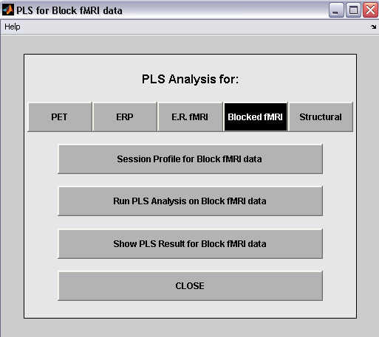
Select “Run PLS Analysis”
Select data type
‘Blocked fMRI’

Step 2: Create your groups
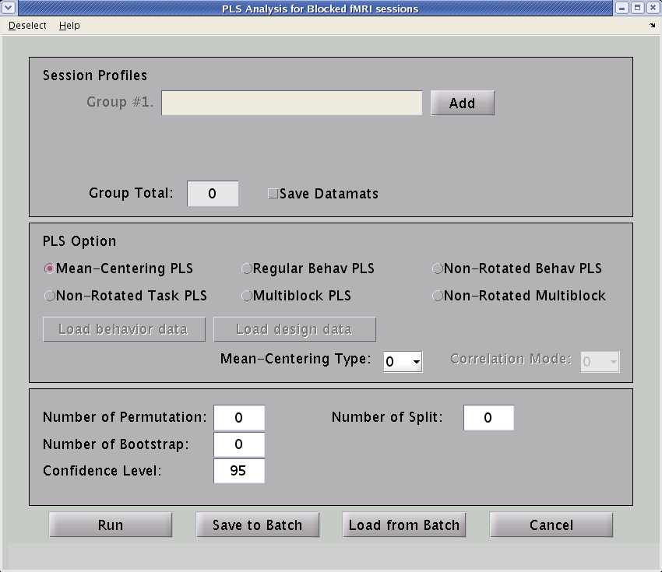
Specify groups. Click ‘Add’
For this dataset, we have 2 groups (i.e., young and old adults).

Navigate to the plsdir folder containing the session profiles.

[..] to go up a directory
[.] to go down a direcgtory

Go to File, “Save to a text file”, if you want to save the group. In future analysis, you can just go to “File” “Load from a text file” and select the group.
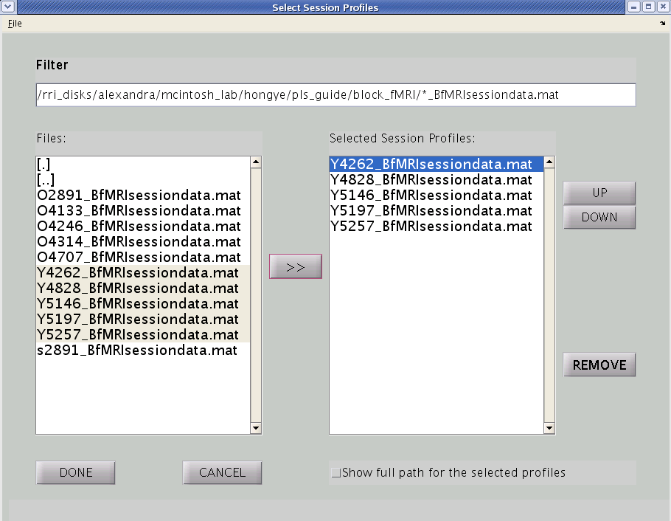

Select all the participants in the group and click on the “>>”

If you would like to change the order of the subjects, you can highlight that subject and click on the UP or DOWN keys.

Subject should be in alphabetic and numeric ascending order. This is important!

Keep a record of the order your subjects are entered. You can extract and examine individual subject time-courses once you have your results, but they are only labeled “Subject 1, 2, etc”.

Click “Done”

Repeat the above process for each group of subjects (prefix Y = young adults & O = older adults).
Step 3: Specify Options (type of PLS, permutation, bootstrap)
Check this box if you want to save the stacked datamat. This is not advised because the result file will be huge

If you wish to drop conditions from analysis go to Deselect (see below)
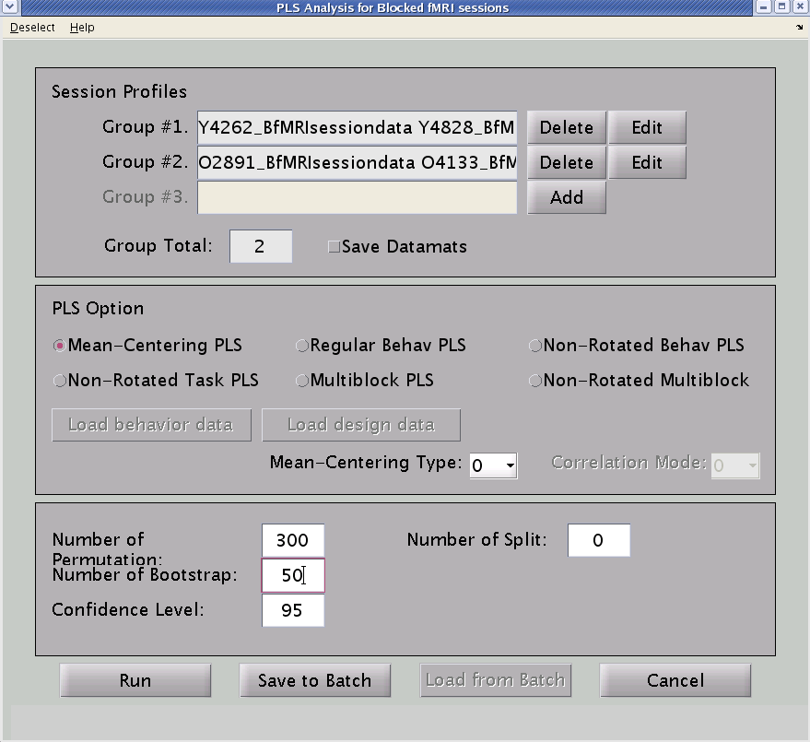

Click “Edit” if you like to edit the groups

Select the PLS option. In most cases, you will be using mean-centering PLS unless you are running contrast analysis or have behavioral data.

Number of permutation: gives the p-value for the LV (unless you are using splithalf resampling, see below)
Usually, we set this to 500 but since we only have 5 subjects per group; I am setting it to 300.
Note: This number can vary depending on researcher’s needs.
Select Mean-Centering Type depending on your scientific question. This parameter determines which main effects are removed by mean-centering of the datamat:

0 (default) - remove main group effects and focus on how conditions are modulated by group membership
1 – remove main condition effects and focus on group differences
2 – remove grand mean only and analyze the full spectrum of effects (group, conditions and group-by-condition)
3 – remove all main effects and focus on interactions

Number of bootstrap: gives you the bootstrap ratio and confidence intervals for mean brain scores.
Again, we usually set this to 500 but since we only have 5 subjects per group; I am setting it to 50 instead.
Note: This number can vary depending on researcher’s needs.

Click “Run” to run the analysis. However, you could also click “Save to batch”. This will create a text file documenting what you did in the analysis (similar to the text file used to create the sessiondatat files). The batch process allows you to run the analyses sequentially. There is a way of extracting information pertaining to your analysis if you just hit ‘Run’. However, this is just easier.

You can now also load batch files that you created previous by clicking “Load from Batch” and selecting the corresponding text file.

If you leave Number of Split as 0, you will be running a standard PLS with permutation based significance testing.
If, instead, you want to run the analysis with splithalf reliability testing, set this number to 100 or higher and also set Number of Permutations to 100 or higher.
Splithalf analysis examines each latent variable for the reliability of the association between brain and design patterns. In this case, plsgui will estimate two p-values: the reliability of the brain pattern (p_braincorr) and the design (p_designcorr). More specifically, for every LV we test the reliability of the brain pattern by randomly dividing subjects into two halves, projecting the design LV onto both halves and calculating the correlation between the projected brain patterns of the two halves. This procedure is repeated Number of Split times and the mean correlation is estimated. However, in order to determine whether the obtained mean correlation is higher than chance, we create a null distribution by making random permutations (mixing up conditions and group membership) and repeating the splithalf procedure for each permutation. P_braincorr is estimated as the probability that the mean correlation of the original, unpermuted datamat is higher compared to the null distribution.
P-designcorr is estimated analogously, only this time we project the brain LV onto split halves and correlate the projected design patterns of the two halves.
Note that the splithalf resampling requires considerably more computational time. If you have Matlab’s Parallel Toolbox installed – use it!

Deselecting Conditions
Go to Deselect -> Deselect conditions (before loading behavior data):
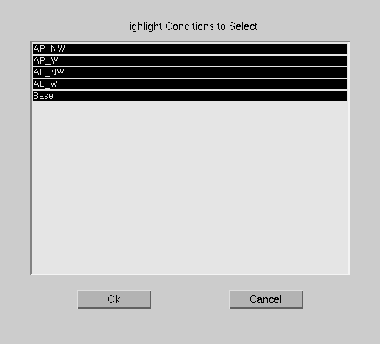
Deselect conditions you wish to take out. In our case, we are interested in all conditions

Run from GUI: Step 4a: Specify Results Filename
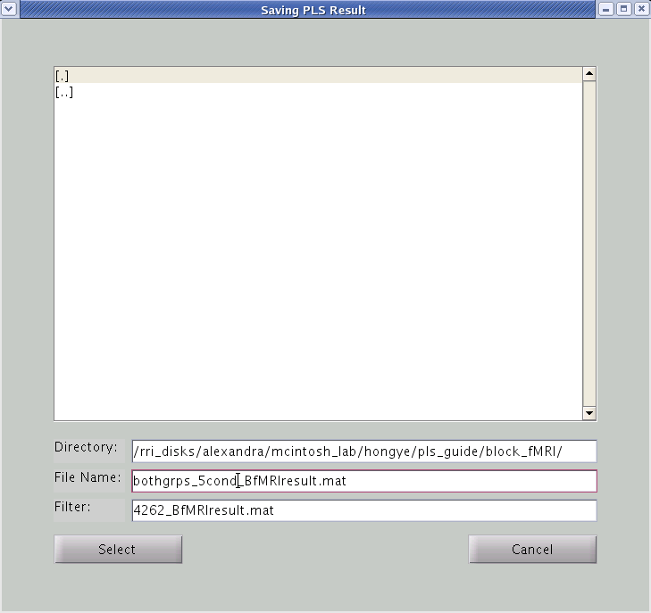

Save the result file with an obvious name, so you know what the analysis is about.
Last part of the filename should be BfMRIresult for block designs or fMRIresult for event-related studies.

We are going to name the result file:
bothgrps_5cond_BfMRIresult.mat

Click “Select”

A status window will appear that tells you how many permutations or bootstraps have been completed. When the run is done, the Run analysis window will reset and you will be prompted “RunPLS is done...” in the matlab window. You have successfully created your results file.

Create Batch File: Step 4b: Specifying the result file name
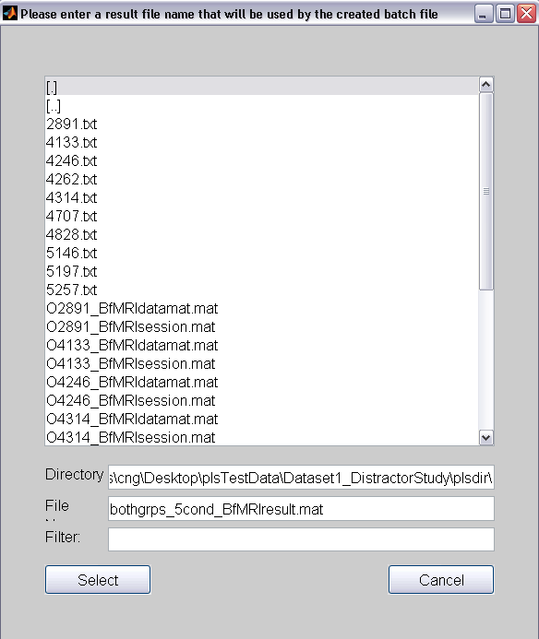

Save the result file with an obvious name, so you know what the analysis is about. Make sure the suffix is _BfMRIresult.mat
This is automatically assigned so don’t change this.

Click “Select”

Step 5: Specifying the Batch file name

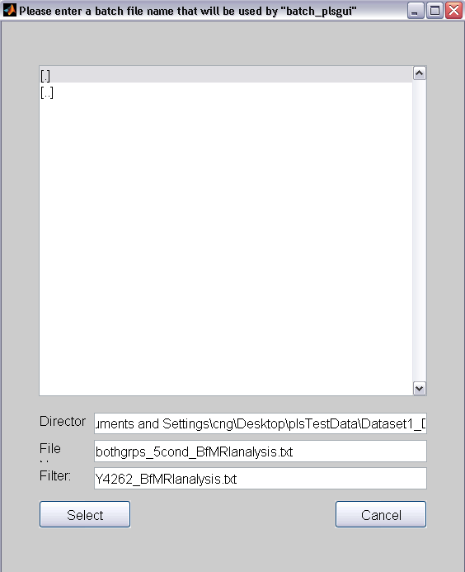

Save the batch text file. Remember to make sure the extension ends with .txt (otherwise the batch command won’t run)

Click “Select”
The window will disappear. But you will be prompt that your batch file is created!

Step 6: Running batch analysis

Run the batch file using the same technique as creating the sessiondata files. Using the batch file method allows you to run multiple analyses and have a record of what you specified as your groups and the options that you chose. If you run the analysis straight from the gui, no record will be kept of what you did. In the command line type:

>batch_plsgui bothgrps_5cond_BfMRIanalysis.txt

If you get the msg ‘ERROR: Duplicated bootstrap orders are used!’, don’t be alarmed. This just means that there are not enough unique bootstraps found (usually the case for large number of bootstraps and small datasets).

Now, you have your results files!

FOR PLSNPAIRS JAVA USERS

We will begin by running the mean-centered task PLS. We are going to use the dataset from The Distractor Study. In this example, we are interested in the difference in brain activity between younger and older adults in all five conditions (baseline, AP_NW, AP_W, AL_NW, and AL_W). In order to run pls analyses, you have to navigate to the folder where your session/datamat files are located.

Load PLS.

Step 1: Choose the data type

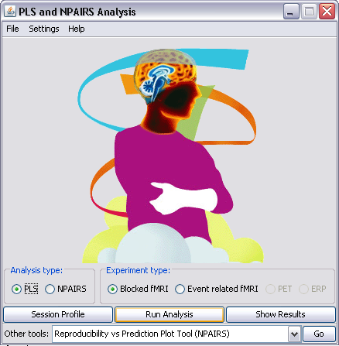
Click “Run Analysis”
Select data type
‘Blocked fMRI’

Select analysis type ‘PLS’

Step 2: Create your groups
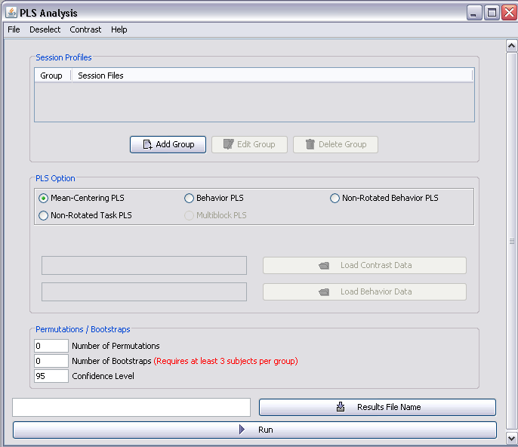
Specify groups. Click ‘Add’
For this dataset, we have 2 groups (i.e., young and old adults).

Click ‘Browse’ and navigate to the folder Dataset1_DistractorStudy plsdir.

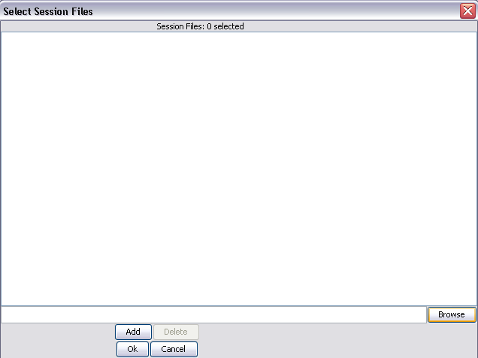

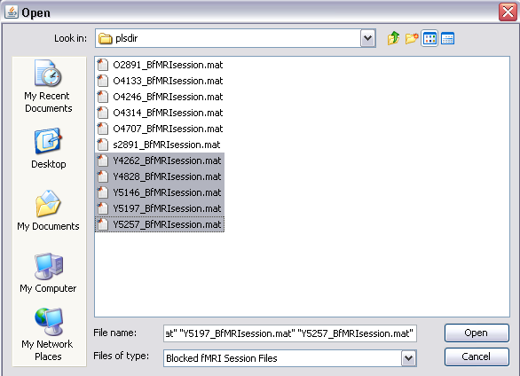

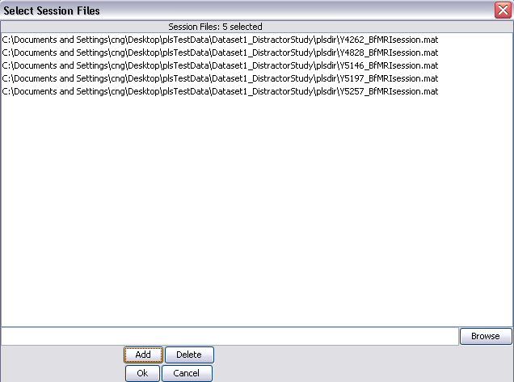

Click ‘Add’ to add the group. Notice you have 5 session files selected.

After you have added the subjects, click ‘Ok’

Select all the participants in the group (i.e., Y prefix) and click ‘Open’.

Make sure the subjects are in ascending alphabetical and numeric order (this should be the case by default)

Step 3: Specify Options (type of PLS, permutation, bootstrap)
Select all the participants in the group and click ‘Open’

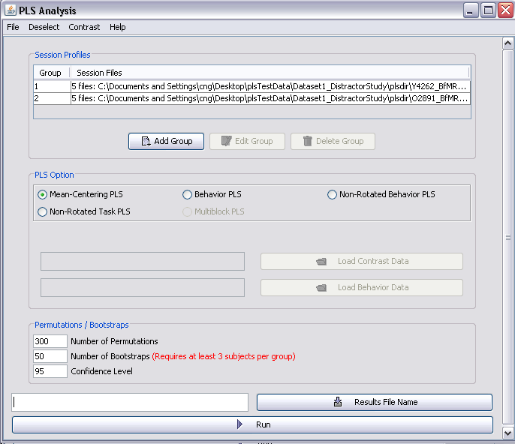
If you wish to drop conditions from analysis go to Deselect (see below)

Select the group and click “Edit” if you like to edit the groups

Select the PLS option. In most cases, you will be using mean-centering PLS unless you are running contrast analysis or have behavioral data.

Number of permutation: gives the p-value for the LV.
Usually, we set this to 500 but since we only have 5 subjects per group; I am setting it to 300.
Note: This number can vary depending on researcher’s needs.

Number of bootstrap: gives you the bootstrap ratio and confidence intervals for mean brain scores.
Again, we usually set this to 100 but since we only have 5 subjects per group; I am setting it to 50 instead.
Note: This number can vary depending on researcher’s needs.

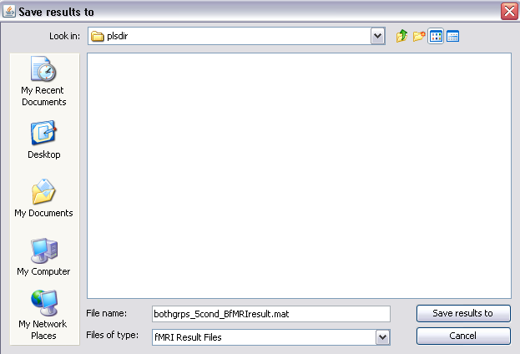

Click on ‘Result File Name’, and navigate to the plsdir folder. Save the result file with an obvious name, so you know what the analysis is about.
Last part of the filename should be BfMRIresult for block designs or fMRIresult for event-related studies.

We are going to name the result file:
bothgrps_5cond_BfMRIresult.mat

Click ‘Save results to’

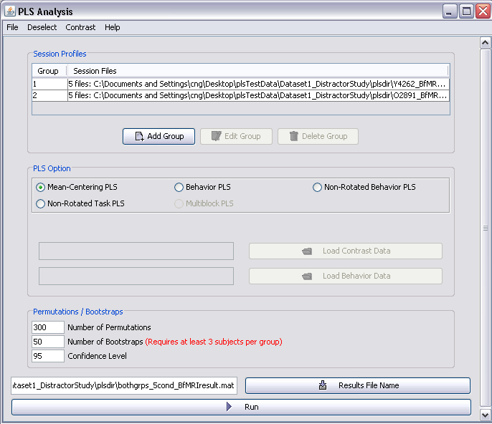

Deselecting Conditions
Click “Run” to run the analysis. However, you could go to File Save As to save the setup parameters. This will create a matlab file documenting what you did in the analysis.

Uncheck conditions you wish to take out. In our case, we are interested in all conditions
Go to Deselect -> Deselect conditions (before loading behavior data):
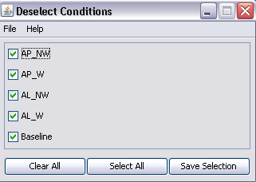

A status window will appear that tells you how many permutations or bootstraps have been completed. When the analysis is done it will say ‘Saving the results…’ [done].

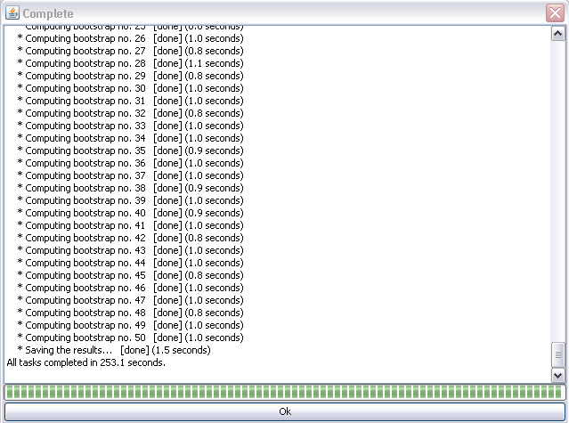

Click ‘Ok’

Non-Rotated Task PLS Analysis

If you choose the Non-Rotated Task PLS option, a priori contrasts are used to restrict the patterns derived from PLS. That is, we are specifying in advance the contrast(s) across conditions that we want PLS to assess (i.e., Design LV). You will need to provide a contrast file, which can be created using the Contrast drop down menu.

The general procedure for non-rotated task PLS is similar to mean-centered PLS, with the exception that the solution is “constraint”. Rather than performing SVD on the mean-centered data to obtain a set of orthogonal (independent) LVs, cross-block correlation is used to model the relationship between the data matrix and the set of contrasts, by maintaining maximal correlation.

The resulting pattern exhibited by the design LV reflects the specified contrast. In addition, the number of contrasts determines and is equal to the number of LVs generated in the solution.

Again, three components are generated:

1) Design LV, specified contrasts,
2) Singular Values, which represent the ‘importance’ of each LV. These values are calculated by taking the sum of square of the cross-block correlation.
3) Brain LV (i.e., salience/weights for each voxel), which are the cross-block correlations.

Similar to mean-centering PLS, the permutation test is performed followed by the bootstrap estimate (For detail on the permutation and bootstrap procedures, see pg. 41-42).

A flow-chart summarizing the procedure above is illustrated on the next page.

Permutations
Re-sampling) are done on the order of the conditions for each subject. This generates a new dataset.
Bootstrap
Re-sample are done for all subject within a condition for all voxels generating a new dataset.

Data
Matrix
Condition 1 | Subject 1
 | Subject 2
Condition 2 | Subject 1
 | Subject 2

Condition 1 | Mean 1  Task Means  Means for each condition across subjects  for each voxel and/or timepoint are calculated
Condition 2 | Mean 2

Grand Mean
Task means are averaged
to obtain grand mean for each voxel

Mean-Centered
(According to the Mean-Centering Type)
Data Matrix is mean-centered for each voxel

Correlation
Design Data (Normalized):
Set of Specified Contrasts
Mean-Centered
Data Matrix

Cross-Block Correlation
Models the relationship between two blocks of variables

Design LV:
Set of Specified Contrasts
Cross-Block (weights):
How well each voxel relates to the contrasts
Singular Value
= sum of squares of Cross-Block

Iterations (whole process repeats for each permutation and bootstrap generating new Singular Values and Saliences)

FOR MATLAB USERS

Again, we are using the dataset from The Distractor Study. Suppose we would like to highlight the contrast between the AP and AL conditions. In addition, we would like to see how these conditions compare with baseline.

Step 1: Select Run PLS Analysis

Select “Run PLS Analysis”

Step 2: Select the Groups
Click to open Contrast Window

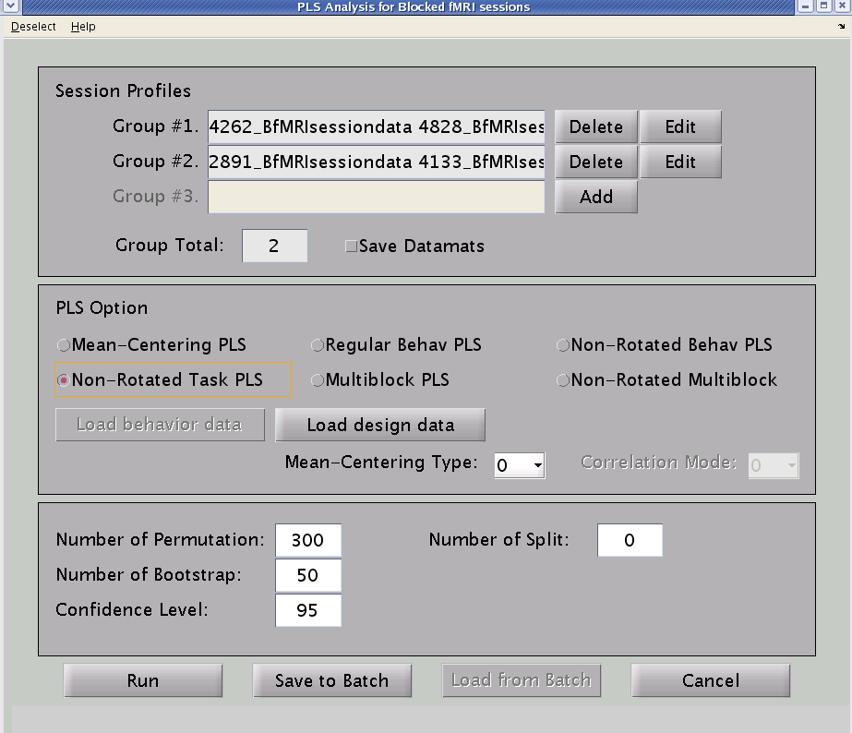

Select “Non-Rotated Task PLS”

Create/Load your groups. To load the text file, click “Add”, then under File (in the new window) “Load from a text file”

Step 3: Specify the contrast(s)
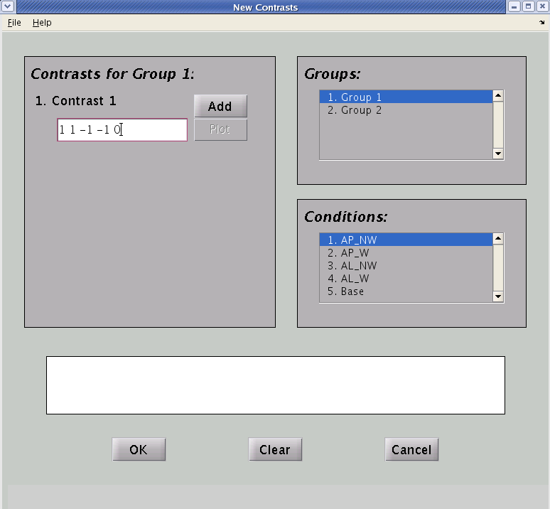
The contrast for the group highlighted here.

The conditions to include in the contrast will be whatever was defined in the session profiles.

If you want to exclude a condition from the contrast, please “Deselect” it at the previous window.

Type in the contrast. Remember that the order correspond to the ordering of the conditions. We are contrasting the AP and AL conditions from each other, and from baseline. So, my weights are 1 1 -1 -1 0. Note that the sum of the weights is zero. The Click “Add”

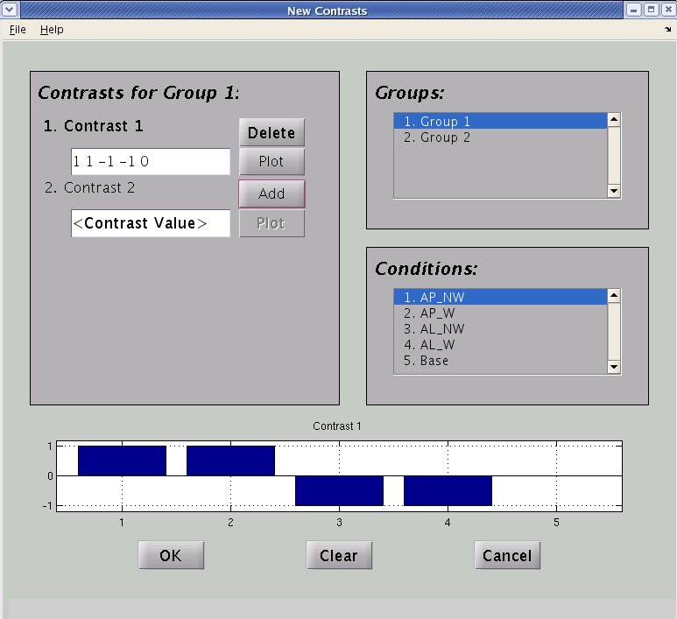

Click “Plot”, to plot the particular contrast

You can have multiple contrasts, by inputting the weights and clicking “Add”

You will see your contrast plotted; verify that the set up is correct.

For a between-subjects design, you can go to the second group and define the same contrast to look at the main effect. If you want to look at the interaction between groups, you can reverse the +/- signs of the weights to look at the interaction between groups.
We are interested in the main effect of conditions, so we specify the same contrasts for group 2.

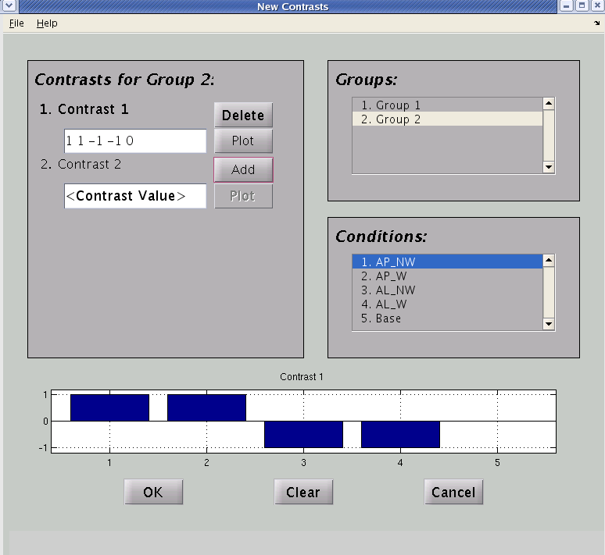

Once you are done specifying your contrast, Go to File Save As to save the contrast as a .txt file to be used for analysis

Step 4: Save the contrast as .txt file

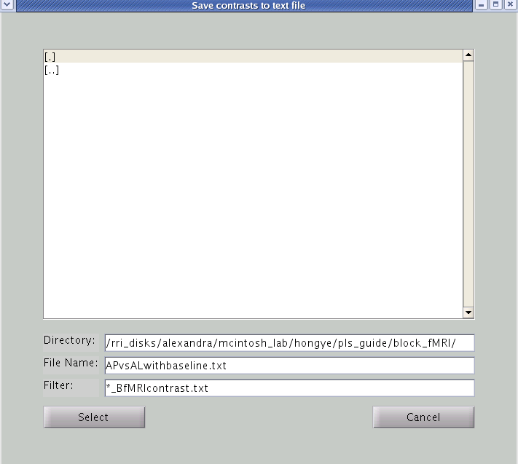

Save the contrast as a .txt file. Again, it’s better to save it with an obvious filename.

Click “Select”

Once the file is saved, you can click OK on the Contrast Window to close it.

Step 5: Load the contrast file and Run the analysis

Click “Load design data” and select the contrast text file.

Again, you can choose to either run straight from the GUI or create a batch file. Please see mean-centered Step 3 for more details between Run and Save to Batch.

You will be prompted to specify the filename of the result (and text) file.

Alternatively, you can create your own contrast file (in text file) and load it. Let’s take a look at our contrast file (created above):

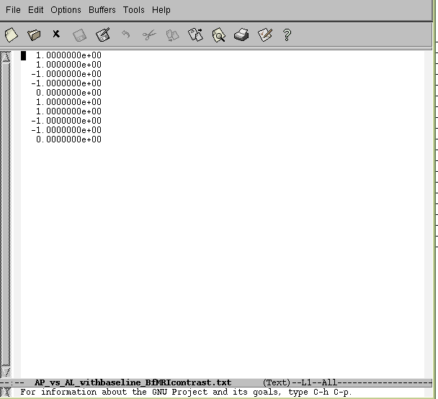

Notice the structure of the text file. The contrast weights for each condition for Group1 are listed, followed by each condition for Group2.

FOR PLSNPAIRS JAVA USERS

Again, we are using the dataset from The Distractor Study. Suppose we would like to highlight the contrast between the AP and AL conditions. In addition, we would like to see how these conditions compare with baseline.

Step 1: Choose the data type

Click “Run Analysis”
Select data type
‘Blocked fMRI’

Select analysis type ‘PLS’

Step 2: Select the Groups
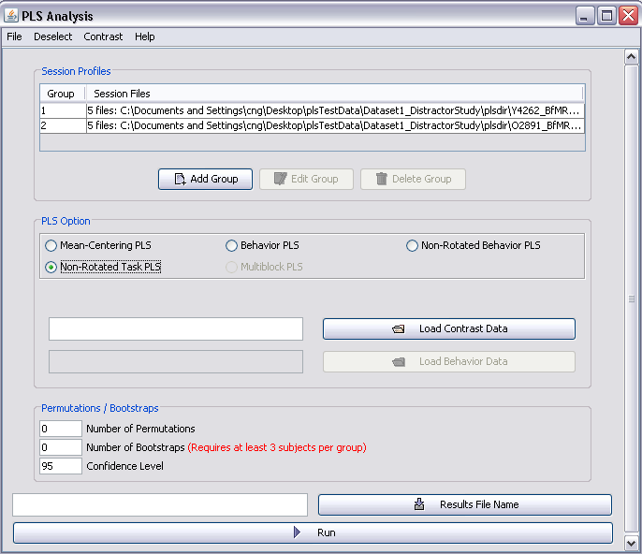

Create your groups by clicking ‘Add Group’ and selecting the appropriate subject files. “Load from a text file”. Please see mean-centered analysis Step 2 for more details.

Select “Non-Rotated Task PLS”

Step 3: Specify the contrast(s)
Note: The Contrast Window is currently unavailable so we are going to load the contrast data from a text file instead. The text file is provided and is labeled APvsALwithbaseline_BfMRIcontrast.txt in the plsdir. You can also create your own by type the following values into Notepad.
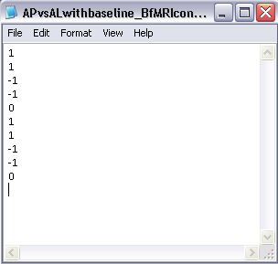
Let’s take a look at the text file.

Notice the structure of the text file. The contrast weights for each condition for Group1 are listed, followed by each condition for Group2.

Also note that there should be (# conditions) x (# groups) rows. In our case it would be 5 x 2 = 10 rows.

The number of contrasts equals the number of columns. Since we only have 1 contrast, we only have 1 column of data.

Step 4: Load the contrast file and Run the analysis

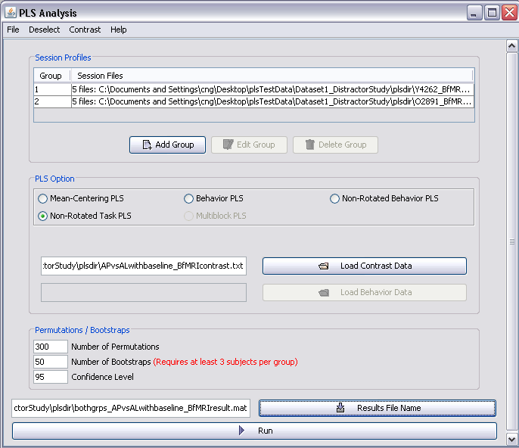

Click “Load” and select the contrast text file.

Click ‘Run’ to run the analysis.

You can also save the setup parameters by going to File Save As.

Make sure you fill in the Number of Permutations and Bootstraps.

Also, specify a result file name.

A status window will appear that tells you how many permutations or bootstraps have been completed. When the analysis is done it will say ‘Saving the results…’ [done]. Click “Ok”.

Regular Behavioral PLS

If you choose this option, behavior measures [usually reaction time (RT) or accuracy (percent correct)] corresponding to each condition are used to compute the correlation matrix between the behavioral measures and the data matrix. Basically, PLS looks at how activity in the brain covaries with the behavioral measures (as opposed to conditions in task PLS). The behavior matrix contains one or more behavioral measures. The number of rows in the behavioral matrix should be the same as the data matrix, with a separate column for each behavioral measure

Correlation between behavior and brain activity at each voxel and/or timepoint is computed across subjects and then these correlations are contrasted across conditions/groups. Correlation Mode is a new feature that applies to behavioral PLS and Multi-block PLS. You can choose among different measures of association between brain data and behavioral data. The options are as follows:

0 - (default) Pearson correlation
2 - covariance
4 - cosine angle
6 - dot product

SVD is then performed on the correlation matrix, resulting in three components (i.e., behavioral LV, singular values, and salience). The permutation procedure is performed followed by the bootstrap procedure (See pg 41-2 for detail). Similar to mean-centered PLS, the final values used by PLS to plot the results (i.e., design LV, singular values, BSR) are the averaged values from the re-sampling procedures. You will need to provide a behavior file (in plain text) in order to run the analysis.

A flow-chart summarizing the procedure above is illustrated below.

Condition 1 | Subject 1  Data
 | Subject 2
Condition 2 | Subject 1
 | Subject 2
Correlation
Behavioral Measures

Correlation Matrix
Correlations between the behavioral measures and data matrix

SVD (Correlation Matrix)
yields three components

Singular Values
(Each SV corresponds to each LV)
Behavioral LV:
How well the behavioral measures relate to each LV (overall pattern).
Salience
(weights or brain LV): How well each voxel relates to each LV (pattern).

Iterations (whole process repeats for each permutation and bootstrap generating new Singular Values and Saliences)
Permutations (e.g., 500 times)

Bootstrap (e.g., 100 times)

The behavioral file is in the following format. Each column stands for one measure, and is separated by a space. PLS orders numbers in the following structure format.

Behavioral Measure 2
Behavioral Measure 1

Data for subject 1, in condition 1, in group 1
  - 0.9318
  - 0.466
0.6068 0.4186
0.4861 0.8462
0.8913 0.5252
. .
. .
. .
Subject 1
Group 2
Group 1
Condition 2
Condition 1
Subject 2

It is important to note that the subject ordering in the behavioral text file should be the same as the order you used to input the subjects when creating your group.
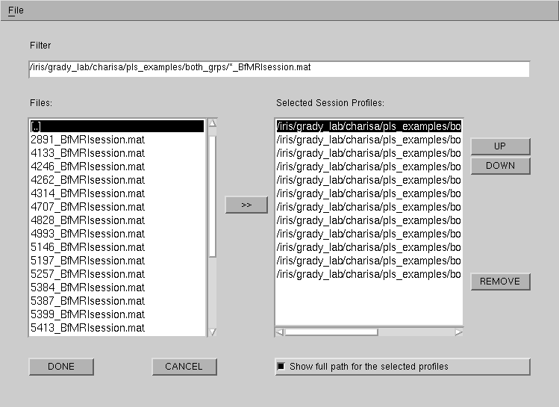

When you run a behavioral PLS analysis with multiple behavioral measures, the analysis is performed on all the behavioral measures simultaneously. Therefore, the results are different from individual behavioral analysis on each measure. We are going to use the Bilingual dataset (from the E.R. fMRI design) for this analysis. As you may recall, this study looked at the effects of bilingualism on cognitive control. In addition to fMRI data, behavioral data (reaction time, RTs) were collected to determine how fast participants responded to each stimulus. The RTs were then averaged across conditions/trial type.

FOR MATLAB USERS

In this example, we are interested in how activity in the brain relates to performances that requires cognitive control in bilinguals and monolinguals by comparing the congruent, incongruent, and neutral trial type.

Step 1: Select Run PLS Analysis
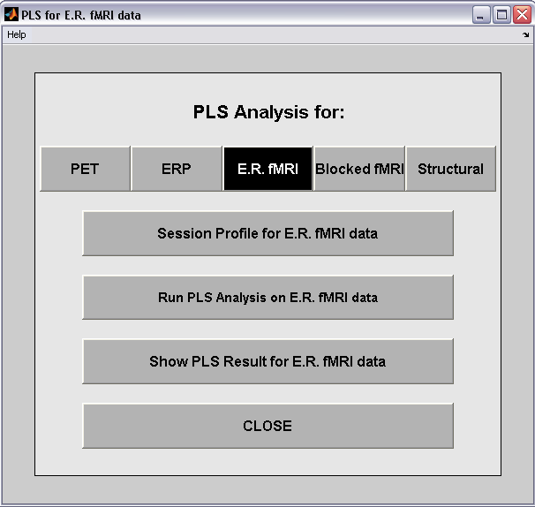

Select “E.R. fMRI”

Select “Run PLS Analysis”

Step 2: Select the Groups
Create/Load your groups. Click “Add”
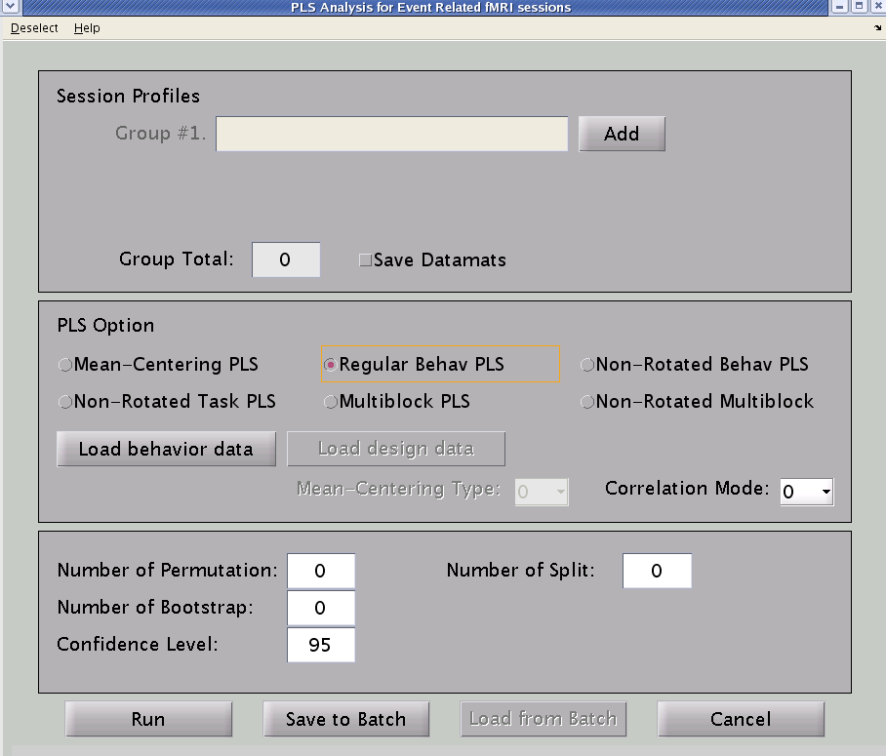

Select “Regular Behav PLS”

After clicking “Add”
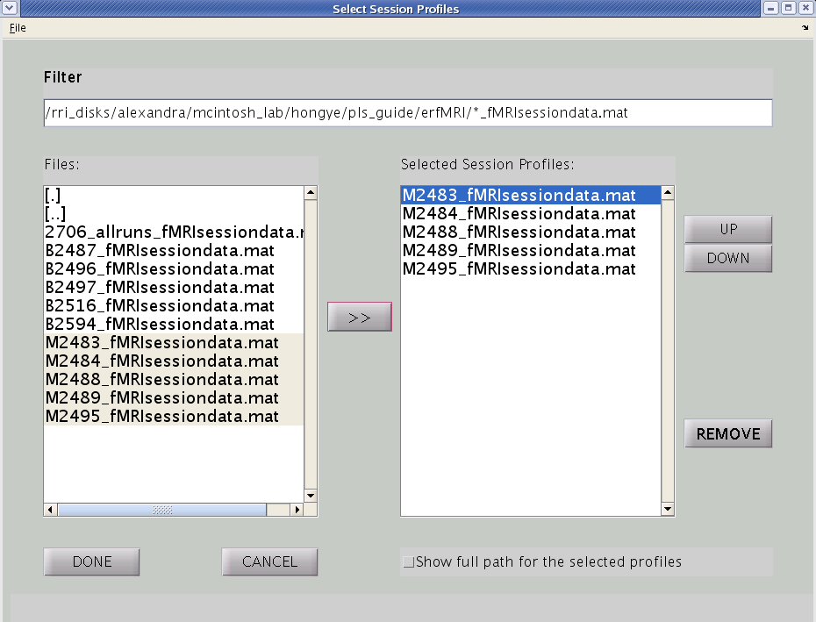
Important: Make a note of the order of your subject shown here. The subjects in the behavioral file should be in the same order.

If you would like to change the order of the subjects, you can highlight that subject and click on the UP or DOWN keys

To remove subjects from the list

Click “DONE”

Follow the same procedure as above to add the second (bilingual) group.

Step 3: Select the conditions
You will need to select the conditions you would like to include, before loading a behavioral file.
Go to “Deselect”
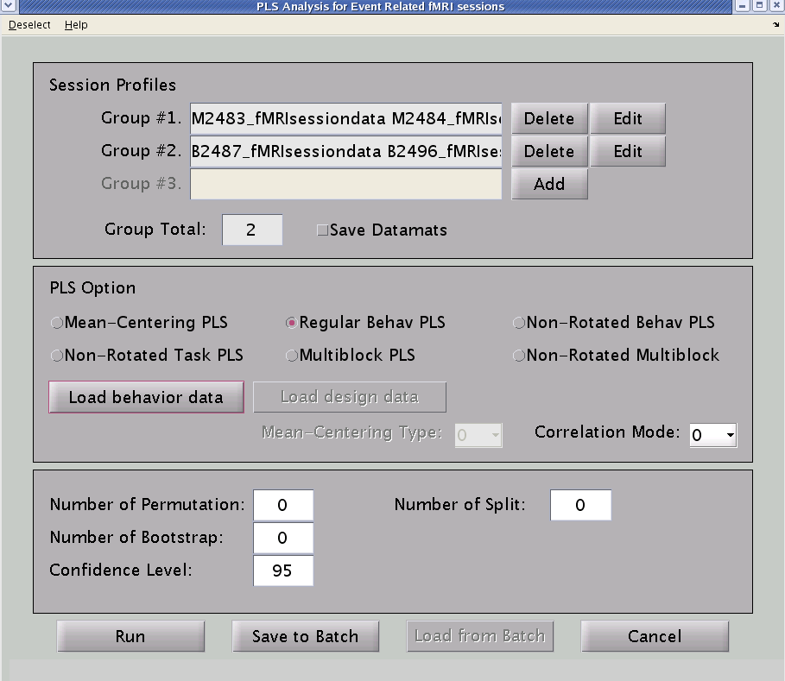

After clicking on “Deselect”
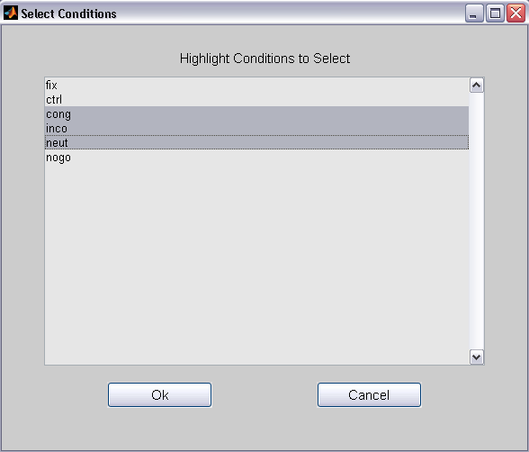
Select the congruent, incongruent, and neutral conditions.

Click “OK”

Step 4: Load the behavioral file

Click “Load behavior data”

Before we continue, let me show you a screenshot of my behavioral excel file.
Noticed the way I have ordered the data. As mentioned above, PLS follows the structure where subjects are nested in conditions, and conditions are nested in Group.

Each value reflects the average behavioral measure for the condition for each subject. If want to exclude certain data points, just don’t include them when you are calculating the average.
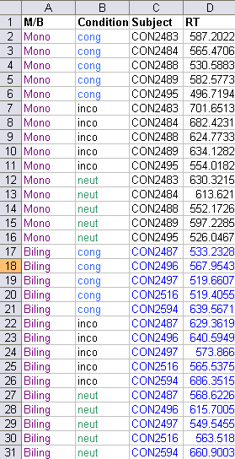

Subject 1
Subject 2

Condition 1

Group 1
Condition 2

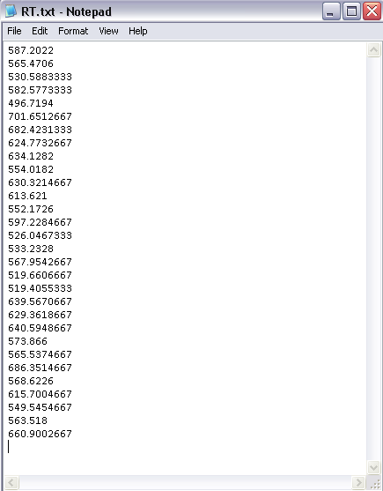
Condition3

Copy and paste the behavioral measures ONLY into the text file. Do not include the header
You can either create your behavioral data here, or you can load the behavioral text file.
Click “Load” and select your behavioral file. Make sure the text file is in the same directory as where you load plsgui.

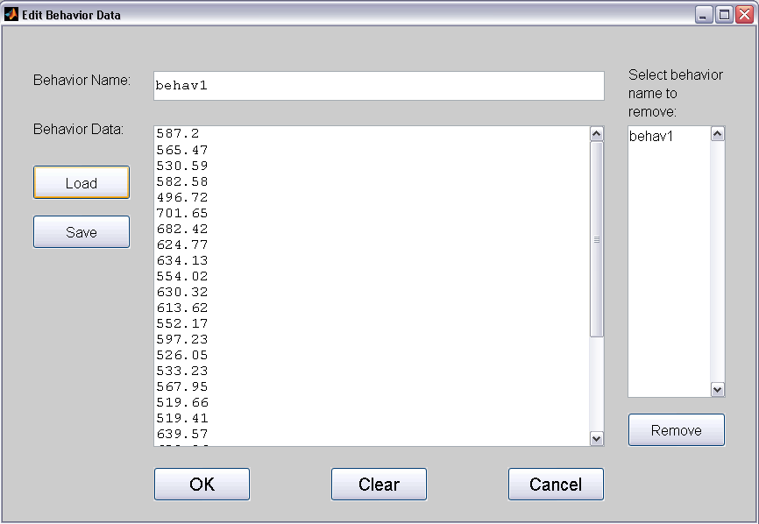
Change the name to something meaningful

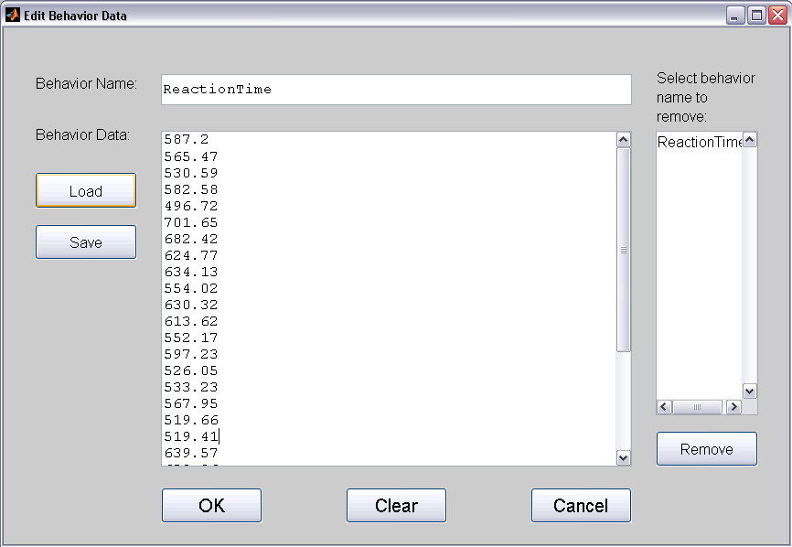
If you input the behavioral measures here, you can always save it as a text file by clicking on “Save”

Click “OK”

Step 5: Create the result file
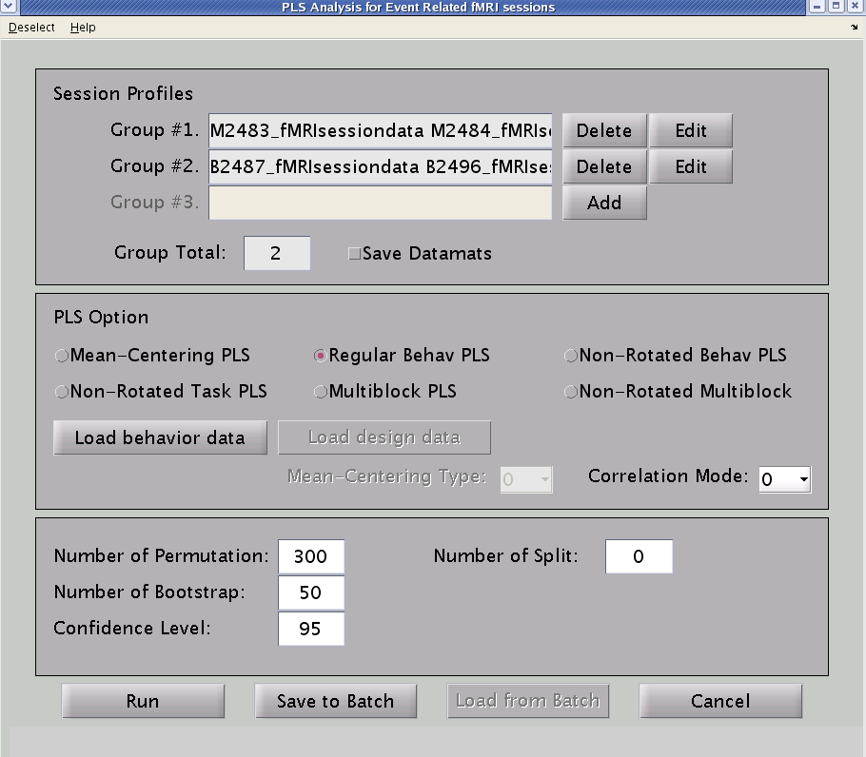
Make sure you change the permutation and bootstrap values.
You can either choose to run it from the GUI or create a batch file (and run it using batch pls).

Note: PLS checks to see if the number of rows in your behavioral text file corresponds to the number of subjects and conditions. If you get an error message, all the options reset to default, so you will have to go to Deselect and load the behavioral data again.

Step 6: Specify your result file name
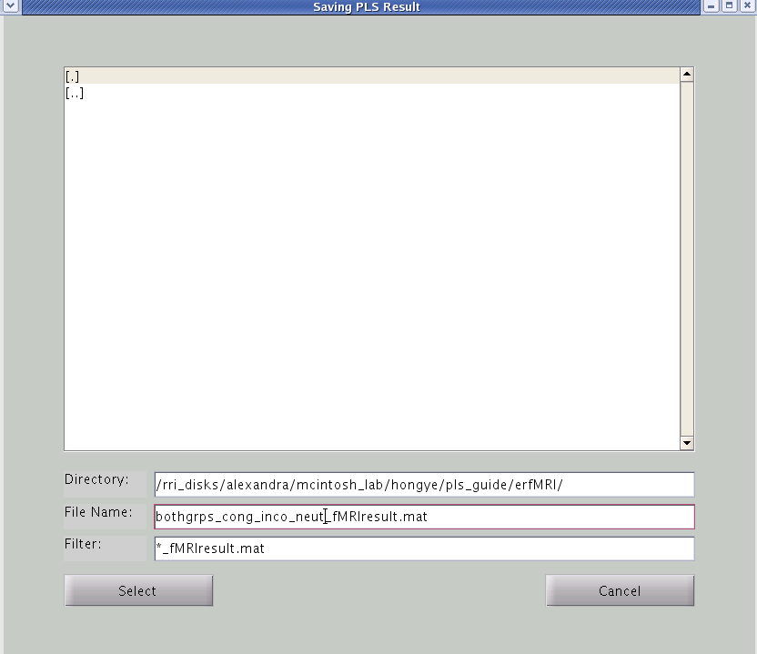

Name your results file with an obvious name so you know what analysis you have done. Also, it is important to keep the default suffix that PLS usess, otherwise you may encounter problems opening the file.

Change the filter to *_fMRIresutls.mat

Click “Select”

A status window will appear that tells you how many permutations or bootstraps have been completed. When the run is done, the Run analysis window will reset and you will be prompted “RunPLS is done...” You have successfully created your results file.

FOR PLSNPAIRS JAVA USERS

In this example, we are interested in how activity in the brain relates to performances that requires cognitive control in bilinguals and monolinguals by comparing the congruent, incongruent, and neutral trial type.

Step 1: Select Run PLS Analysis
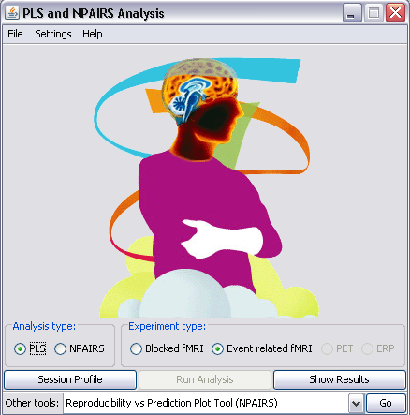

Select “E.R. fMRI”

Select “Run Analysis”

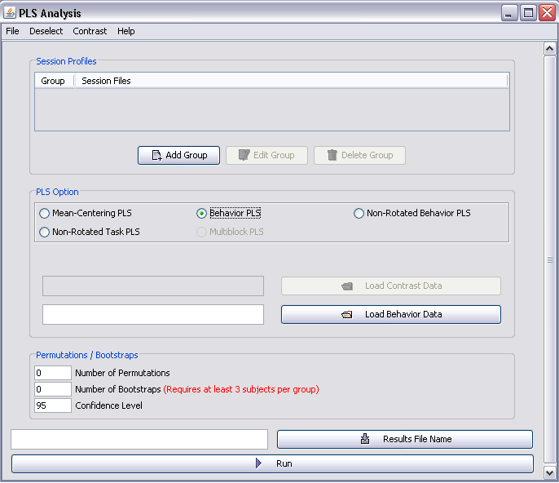Step 2: Select the Groups
Create/Load your groups.
Click “Add Group”

Select “Behavior PLS”

After clicking “Add”
Important: Make a note of the order of your subject shown here. The subjects in the behavioral file should be in the same order.

I have added all the monolinguals (M prefix).
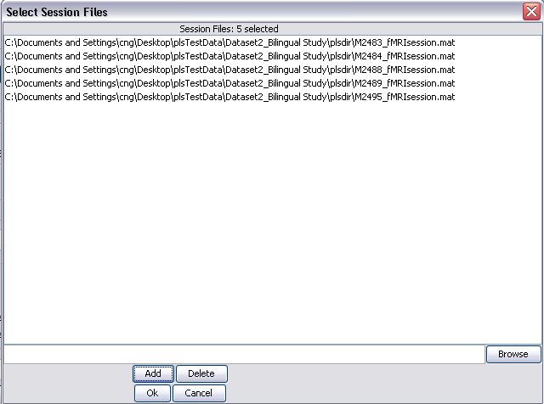

Click “OK” after you have added your subjects.

Follow the same procedure as above to add the second (bilingual) group.

Step 3: Select the conditions
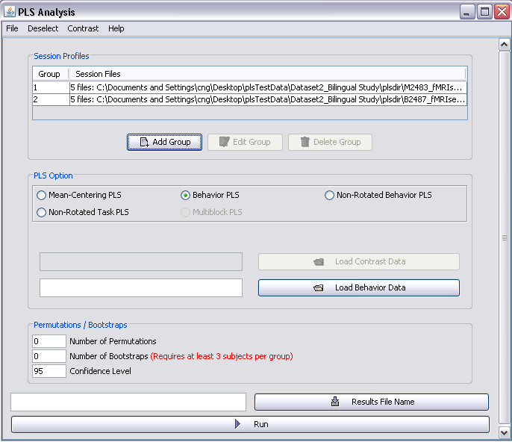
You will need to select the conditions you would like to include, before loading a behavioral file.
Go to “Deselect”

After clicking on “Deselect”
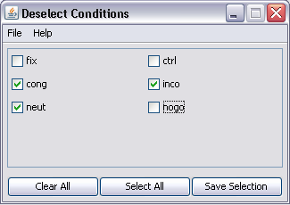
Select the congruent, incongruent, and neutral conditions.

Click “Save Selection”

Step 4: Load the behavioral file

Click “Load behavior data” and navigate to Dataset2_BilingualStudy and select “RT.txt”

Before we continue, let me show you a screenshot of my behavioral excel file.
Noticed the way I have ordered the data. As mentioned above, PLS follows the structure where subjects are nested in conditions, and conditions are nested in Group.

Each value reflects the average behavioral measure for the condition for each subject. If want to exclude certain data points, just don’t include them when you are calculating the average.
Subject 1
Subject 2

Condition 1

Group 1
Condition 2

Condition3

Copy and paste the behavioral measures ONLY into the text file. Do not include the header
Step 5: Create the result file
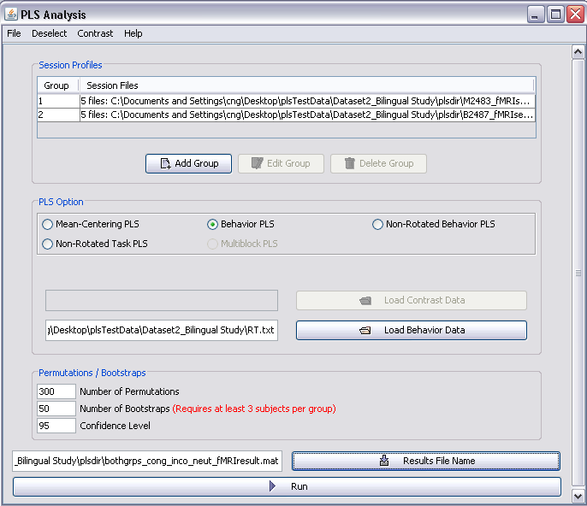
Make sure you change the permutation and bootstrap values.
Click “Results File Name” and navigate to your plsdir folder.

Name your results file with an obvious name so you know what analysis you have done. I named the file: bothgrps_cong_inco_neut_fMRIresult.mat.

Also, it is important to keep the default suffix that PLS uses; otherwise you may encounter problems opening the file.

A status window will appear that tells you how many permutations or bootstraps have been completed. When the analysis is done it will say ‘Saving the results…’ [done]. Click “Ok”.
Click “Run”

Non-Rotated Behavioral PLS

This is the same analysis as Non-Rotated Task PLS but with behavioral data rather than tasks. Again, by specifying a set of contrasts, the solution is constrained. The procedures are the same as Non-Rotated Task PLS (on pg. 49), except the correlation matrix is used in place of the mean-centered data. You will need to provide a behavior file (in plain text) in order to run the analysis. A flowchart summarizing this procedure is provided below:

Condition 1 | Subject 1  Data  Matrix
 | Subject 2
Condition 2 | Subject 1
 | Subject 2
Correlation
Behavioral Measures

Correlation Matrix
Correlations between the behavioral measures and data matrix

Correlation Matrix

Design Data (Normalized): Specified Contrasts

Cross-Block Correlation
Models the relationship between two blocks of variables

Design LV:
Set of Specified Contrasts
Singular Value
= sum of squares of Cross-Block
Cross-Block (weights):
How well each voxel relates to the contrasts

Iterations (whole process repeats for each permutation and bootstrap generating new Singular Values and Saliences)

Permutations (e.g., 500 times)
Bootstrap (e.g., 100 times)

FOR MATLAB USERS

Using the Cognitive Control dataset, we are interested in contrasting the congruent with the incongruent condition. The steps to run the analysis are the same as Behavioral PLS with the addition of specifying your contrasts. Follow Steps 1 to 4 in Behavioral PLS (section above).

Step 5: Specify the contrasts
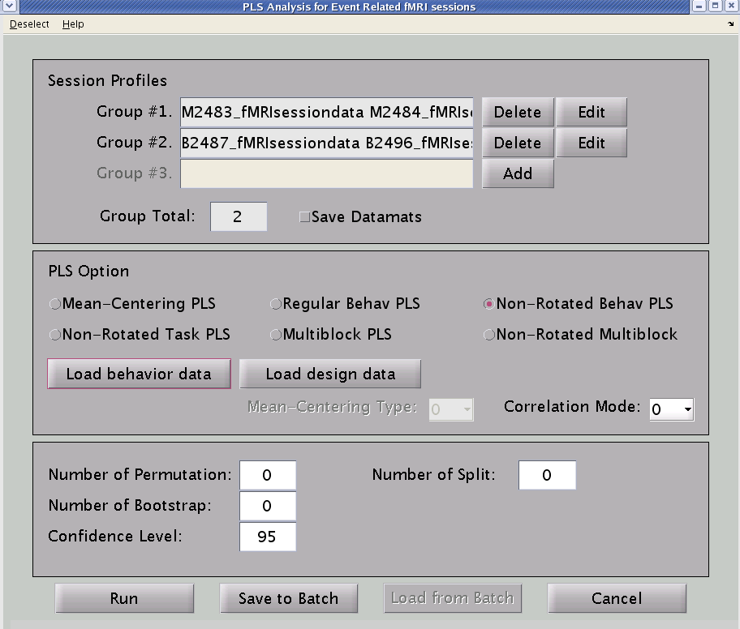
Click to Open Contrast Window

Note that you need to deselect the conditions BEFORE loading the behavioral file and the contrast window.

At this point, we have already loaded the behavioral files.

Select “Non-Rotated Behav PLS”

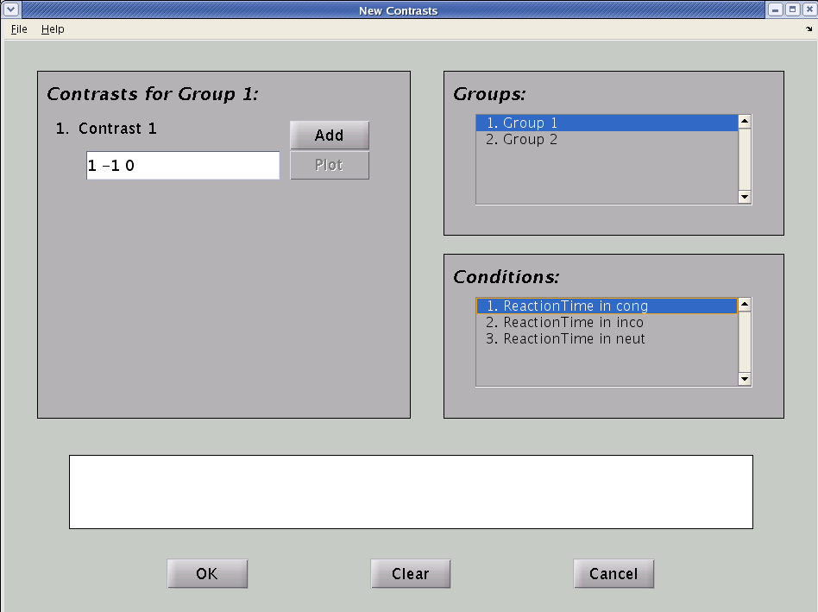
The contrast for the group highlighted here.

The conditions to include in the contrast will be whatever was defined in the session profiles.

If you want to exclude a condition from the contrast, please “Deselect” it at the previous window.

Type in the contrast. Note that the sum of the weights is zero. Then Click “Add”

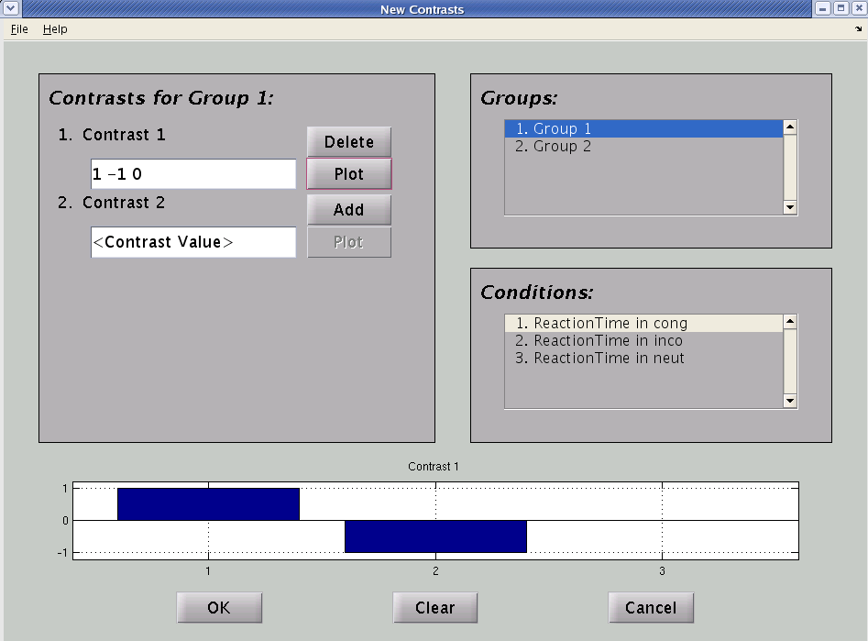
Click “Plot”, to plot the particular contrast

You can have multiple contrasts, by inputting the weights and clicking “Add”

You will see your contrast plotted; verify that the set up is correct.

For a between-subjects design, you can go to the second group and define the same contrast to look at the main effect. If you want to look at the interaction between groups, you can reverse the +/- signs of the weights to look at the interaction between groups.

We are interested in the main effect of conditions, so we specify the same contrasts for group 2.

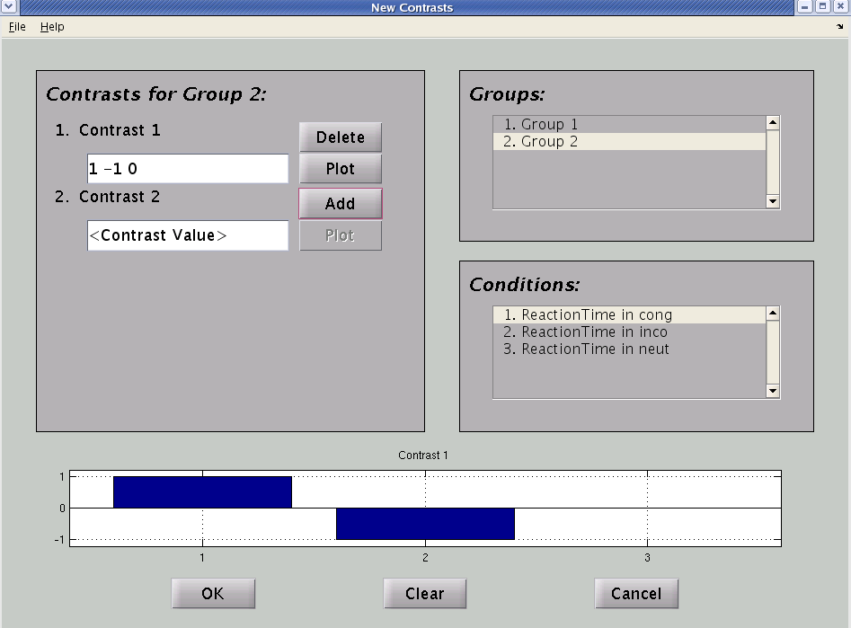

Once you are done specifying your contrast, Go to File Save As to save the contrast as a .txt file to be used for analysis

Step 6: Save the contrast as .txt file

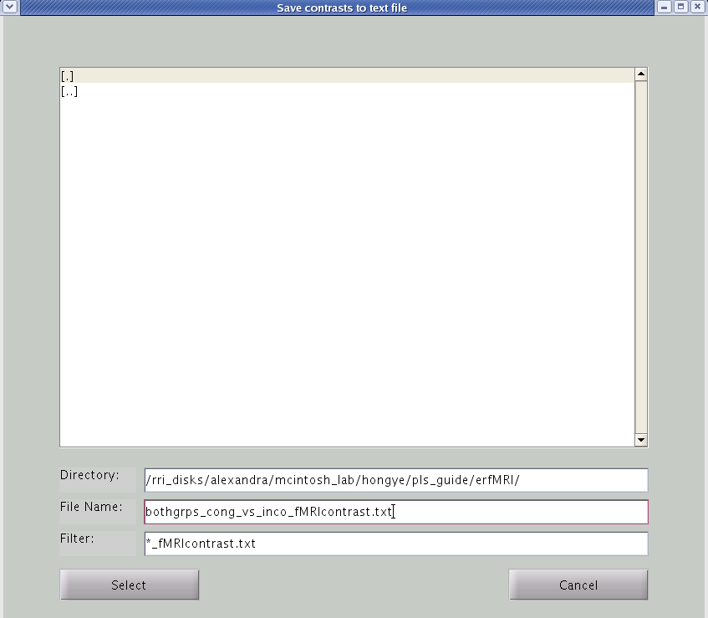

Save the contrast as a .txt file. Again, it’s better to save it with an obvious filename.

Click “Select”

Once the file is saved, you can go to File Close

Step 7: Load the contrast file and Run the analysis

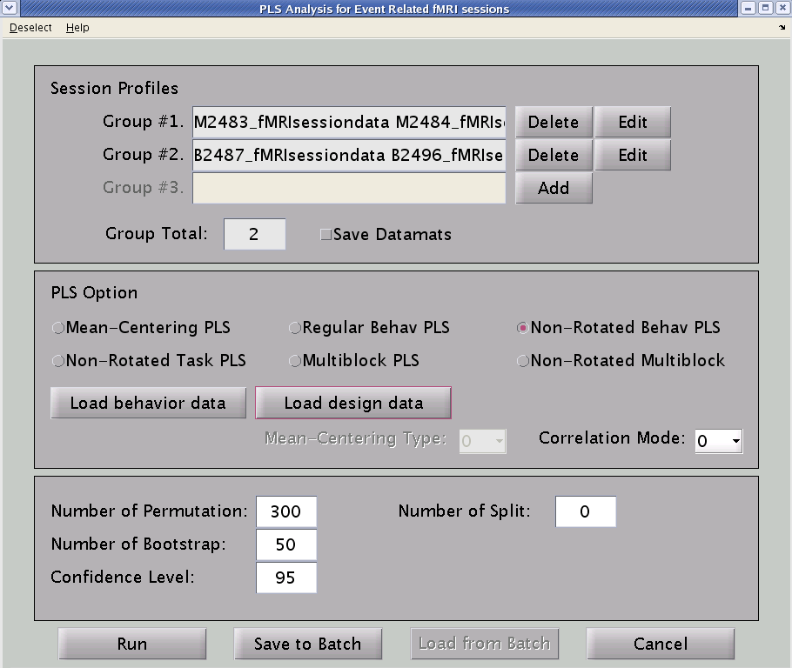

Click “Load design data” and select the contrast text file.

Again, you can choose to either run straight from the GUI or create a batch file.

You will be prompt to specify the filename of the datamat (and text) file.

FOR PLSNPAIRS JAVA USERS

Using the Cognitive Control dataset, we are interested in contrasting the congruent with the incongruent condition. The steps to run the analysis are the same as Behavioral PLS with the addition of specifying your contrasts. Follow Steps 1 to 4 in Behavioral PLS (section above).

Step 5: Specify the contrasts
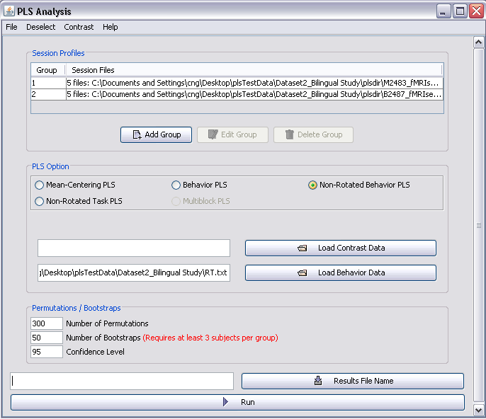

Note that you need to deselect the conditions BEFORE loading the behavioral and the contrast file.

At this point, we have already loaded the behavioral files.

Select “Non-Rotated Behav PLS”

Select “Load Contrast Data”

Note: The Contrast Window is currently unavailable so we are going to load the contrast data from a text file instead. The text file is provided and is labeled bothgrps_cong_vs_inco_fMRIcontrast.txt in the plsdir. You can also create your own by typing the following values into Notepad.
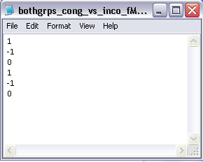
Let’s take a look at the text file.

For a between-subjects design, you can will go to the second group and define the same contrast to look at the main effect. If you want to look at the interaction between groups, you can reverse the +/- signs of the weights to look at the interaction between groups.

We are interested in the main effect of conditions, so we specify the same contrasts for group 2.

Notice the structure of the text file. The contrast weights for each condition for Group1 are listed, followed by each condition for Group2.

Also note that there should be (# conditions) x (# groups) rows. In our case it would be 3 x 2 = 6 rows.

The number of contrasts equals the number of columns. Since we only have 1 contrast, we only have 1 column of data.

Step 6: Run the analysis

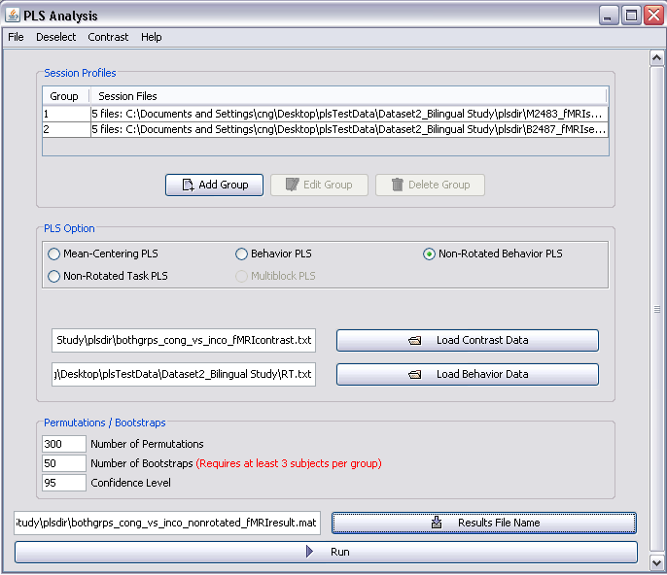

Specify the
Result file name.

Click “Run”

A status window will appear that tells you how many permutations or bootstraps have been completed. When the analysis is done it will say ‘Saving the results…’ [done]. Click “Ok”.
Click “Run”

Seed PLS

In seed analysis, PLS looks at how activity in the brain covaries with a particular seed (a region of interest, specific voxels). The procedures are exactly the same as Behavioral PLS, however, rather than loading behavioral data, the multiple voxel extraction group text file is used (See Multiple Voxel Extraction section on page 80).

Therefore, in order to run seed PLS, you need to run an initial analysis (e.g. mean centering) on the dataset to generate the multiple voxel extraction file then, re-run the analysis following the Behavioral PLS procedures.
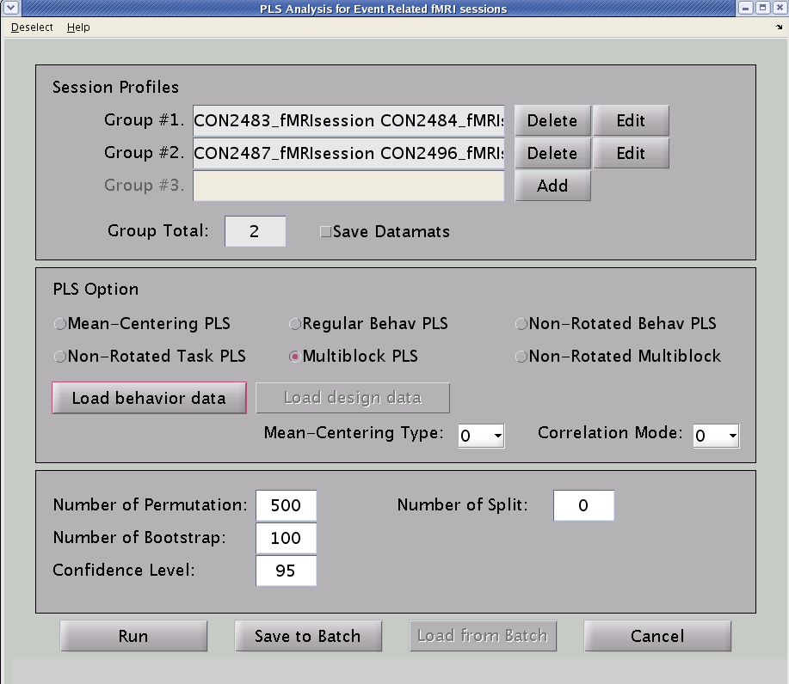

Click “Load behavior data”

Then, click “Load” and select the multiple voxel extraction file (text file).

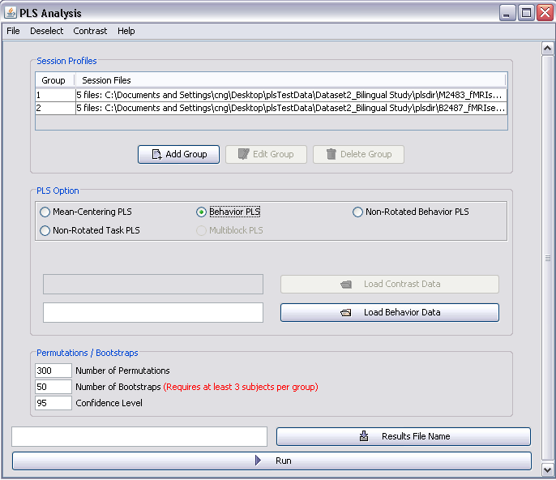

Chapter 3: Looking at PLS Results

FOR MATLAB USERS

For Blocked fMRI Design

This manual will only describe how to display PLS result file. Please read relevant papers provided in the Reference section, if you would like to know how to interpret your results. Let’s take a look at the results for the Distractor study. Note that this analysis was run on the complete dataset, 12 subjects per group, whereas the analysis we ran in Chapter 2 only included 3 subjects per group.

Step 1: Choose data type
Select “Show Results”

Step 2: Selecting the appropriate results file
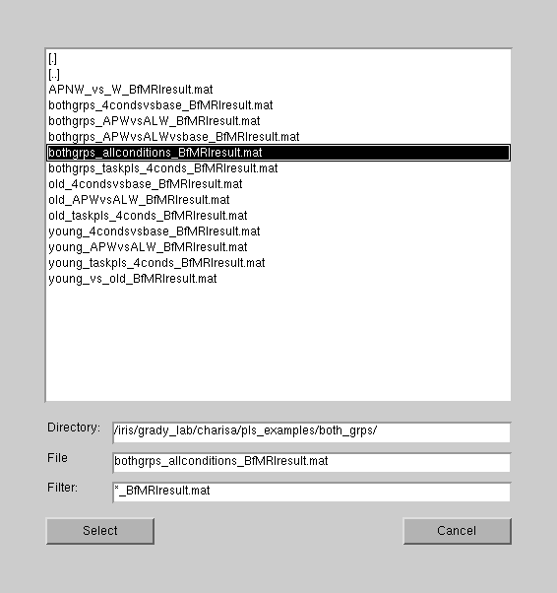

Select the results file. We will be looking at all conditions.

Click “select”

Step 3: Looking at your results
The bootstrap ratio (BSR) results are shown here.
BSR = salience (weights) / SE (reliability)
If a voxel has ↑ signal and ↓noise, the resulting BSR will be high and the voxel will be assigned with more weight (importance). Whereas, a voxel with ↑ signal but ↑ noise will have a low BSR and will have less weight (less important).

Two different threshold values are used in case the distribution of the data is extremely skewed. Usually, we use threshold of +/- 3. Important to keep the number for the upper and lower bound the same to ensure the approx. p-value is accurate (p-value affected by threshold and max/min ratio).
The LV (latent variable) that is currently displayed. LV can be understood as groupings or patterns of activity. 2 of 10 LV, means you are looking at 2 of 10 possible groupings (or brain activation patterns). Note: The number of LVs is equal to the number of conditions (2 grp x 5 conditions)

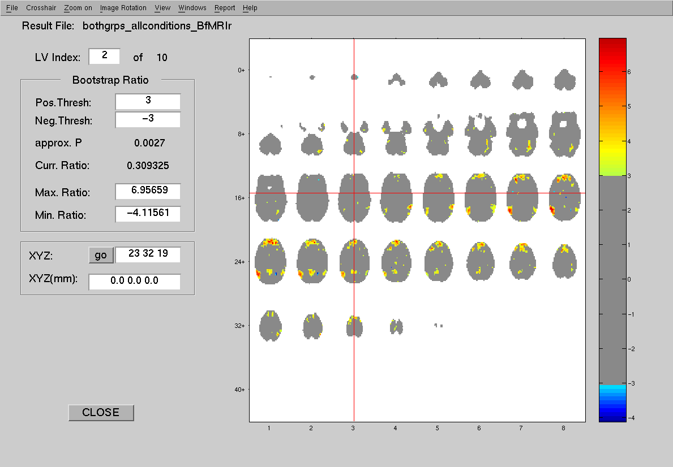
BSR for select voxel (crosshair)
BSR scores legend
MNI space
Voxel space

You can move the crosshair and the coordinates of the crosshair are displayed. You can also specify the coordinate.

Toolbar Options:

File:
Load a background image (structural image as underlay). Make sure the image has the same dimension as your functional images
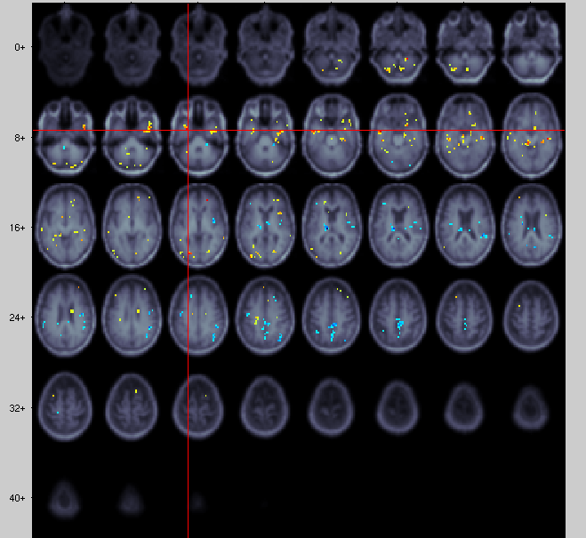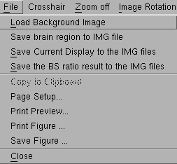
You can save just the brain region, the entire display, or just the BS ratio result as an IMG file.

You can then open afni and use the BSR file as an overlay over your anatomic image.

Crosshair:
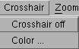
To change the color of the crosshair
To turn off the crosshair

Zoom off: Click to turn this option “on” or “off”. Useful if you want to get a closer look at the region of interest. Just left-click, hold, and drag to make a rectangle around the regions you would like zoomed in. This region will fill the viewer (so the image may look warped). You will notice a little magnifying glass when you scroll over the image window. Left-click to zoom in and right-click to zoom out.

Image Rotation:
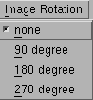
If you want to rotate your images, choose ‘none’ to return to original view.

View:
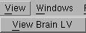
Display salience values rather than BSR in the main results window.

Windows (Most useful for rendering result data):
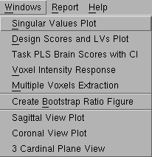
This one will make a nicer image of whatever you see in the results window (e.g., can be copied and put in powerpoint).
The brain images can be displayed at different views
These will be explained in the following sections

Report:
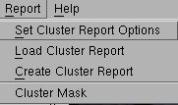
Only clusters that pass specified BSR threshold will be shown on the viewer, but you will need to generate a report (Create cluser report) first.
To create cluster reports. These options will be explained in the section “Cluster Reports”.

Step 4: Rendering results data
The singular values generated from PLS from the original data matrix. These are related to the numbers generated using SVD.

Singular Values Plot

Go to Windows Singular Values Plot

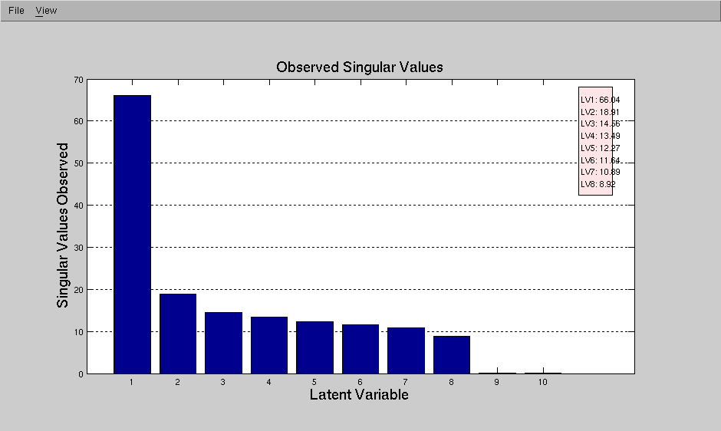

Go to View Percent Crossblock Covarience
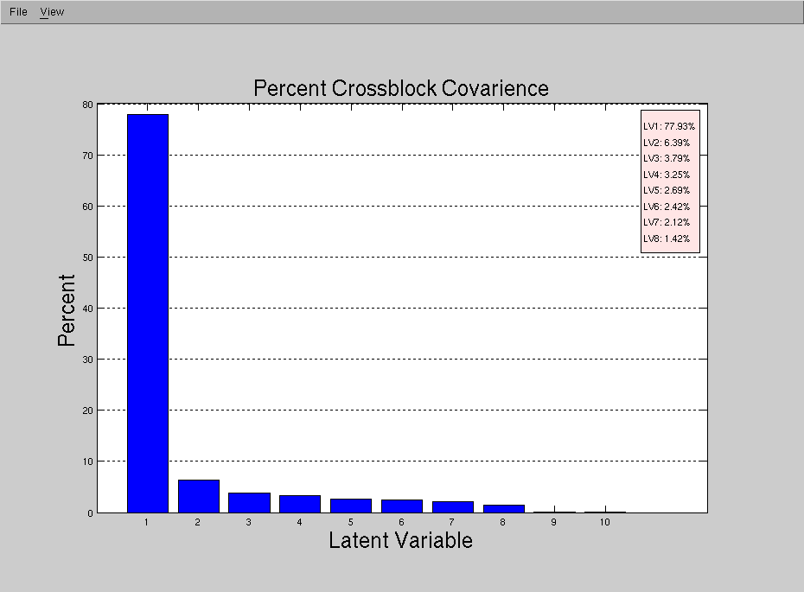
These numbers are more meaningful. They tell you the percent variance accounted for by a particular LV.

PLS tries to maximize these values via SVD/Crossblock

Go to View Permuted Singular Values

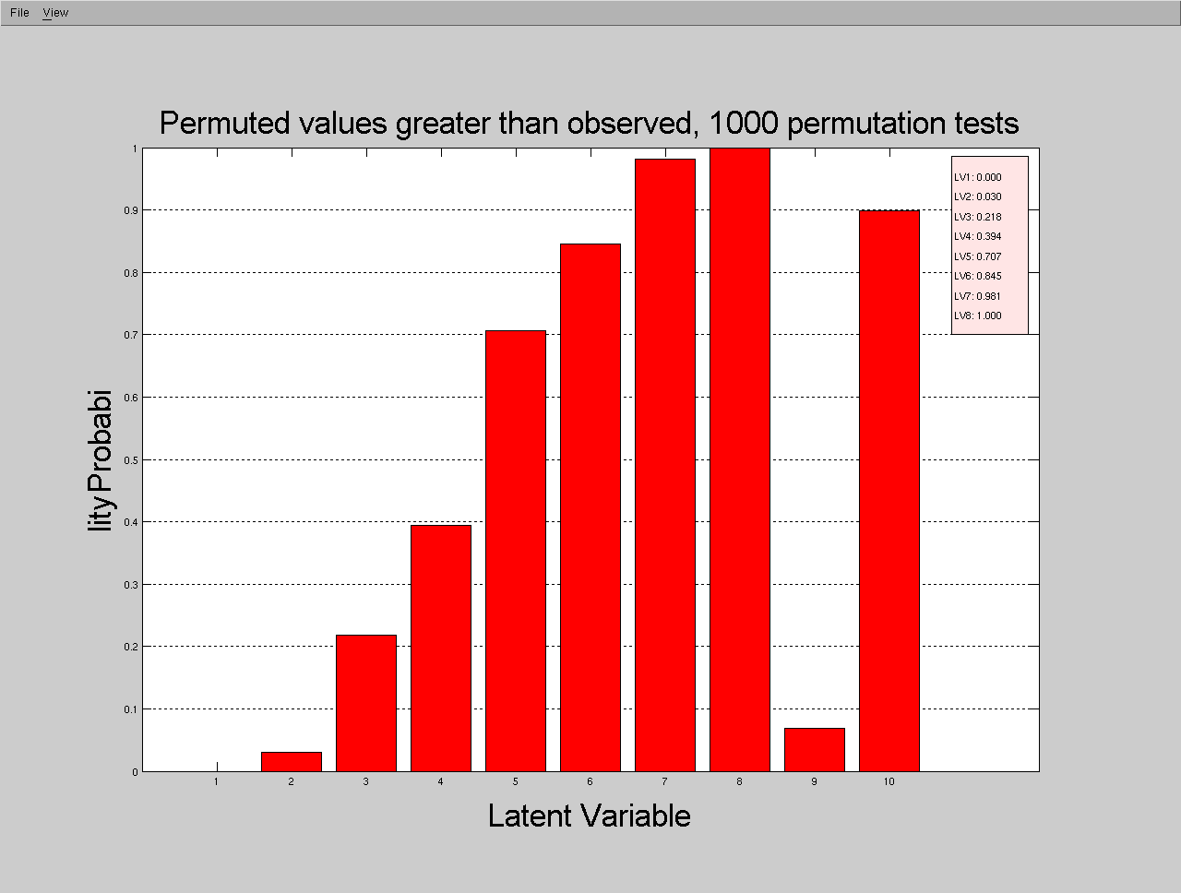
Values correspond to the variance accounted for by each LV, these are the p-values for the LVs. This will tell you whether the LV is significant or not.

Design Score and LV Plots
Display information on the LV, the percent variance accounted for, and the p-value (p < .05 is significant)

Go to Windows Design Score and LV Plots

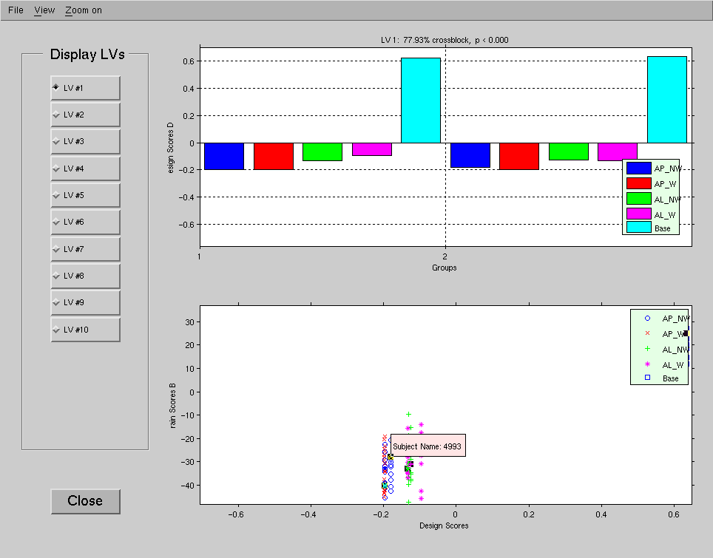
The Design Score for each condition for LV1. The values are arbitrary so you cannot interpret the actual values. However, you can make inferences about the direction of the bars (overall trend or pattern). In this example, LV 1 highlights the difference between the baseline and task conditions, among group 1 (old) and 2 (young). The bar graph highlights the similarity (or what is common) among conditions with the same sign (+/-) design score, and the differences between conditions with positive and conditions with negative scores.
Select the LV you want to display.

This breaks it down into individual subject scores. You can click on individual data points to identify outliers.

LV1 seems to highlight the difference between baseline (resting state) and task, and accounts for almost 78% of the observed variance. However, what we are really interested in are the differences among the tasks. Let’s look at LV2.

It is important to note that the values of the design scores are arbitrary, so you can shift the origin (in a meaningful way). So I could potentially shift the 0 line to 0.61 (baseline condition), and have the rest condition as the reference point.

Looking at the general pattern of the design scores, LV2 seems to highlight differences between the task conditions. Specifically, that the AP conditions are different than the AL conditions. Notice the baseline condition is in opposite direction for our two groups (positive for old, negative for young). So, we can say that for older adults, the baseline condition is more similar to the AP conditions and for younger adults the baseline condition is more similar to the AL conditions.

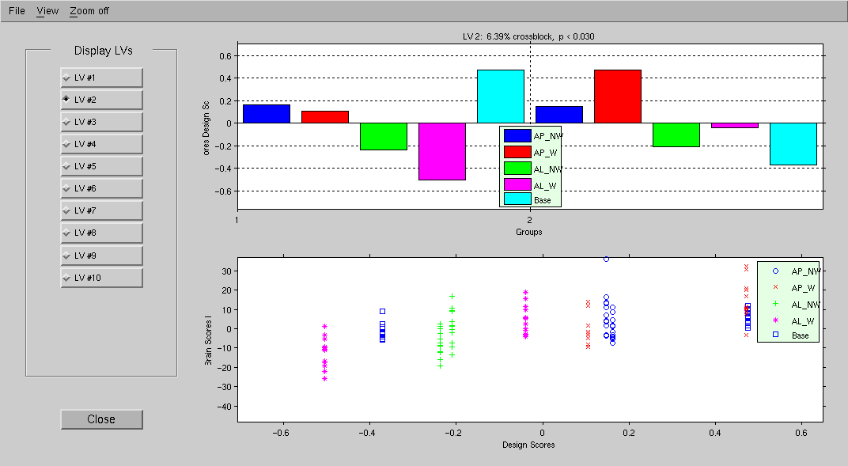

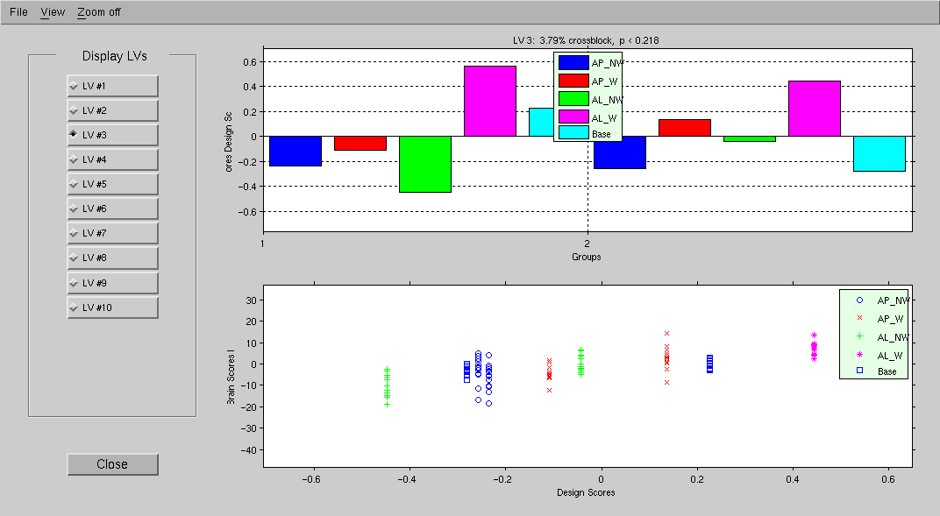
LV3 is not significant. In most cases, the subsequent LVs (4-10) will not significant but it might be a good idea to check.

We do not interpret patterns with ns. LV in task PLS, unless you have a good reason to do so.

Task PLS Brain Scores with CI

Go to Windows Task PLS Brain Scores with CI

The first thing you will notice is that the directions of the bars are the same as the design scores. However, the values are different. Brain scores tell you where the pattern is found in the brain and summarizes the pattern across the brain regions. You will notice that the brain scores in the previous window, and those shown here, are on a different scale. That is because the brain scores shown with the confidence intervals have been mean-centered.

Salience: how well the summed over all voxels relates to LV (pattern)
Data
Matrix
Brain Scores = *

More importantly, confidence intervals (CI) for the brain scores are also shown, which allows you to determine whether there are significant differences between conditions (and from zero). CI bars that overlap with 0 means the condition is not significantly different from 0 (or is not different from the mean across conditions). CI bars that overlap each other also indicate that the conditions are not significantly different from each other. CI bars that are non-overlapping indicate that the conditions are significantly different from each other at your specified level (e.g., 95% CI shows significance at the α = .05 level).

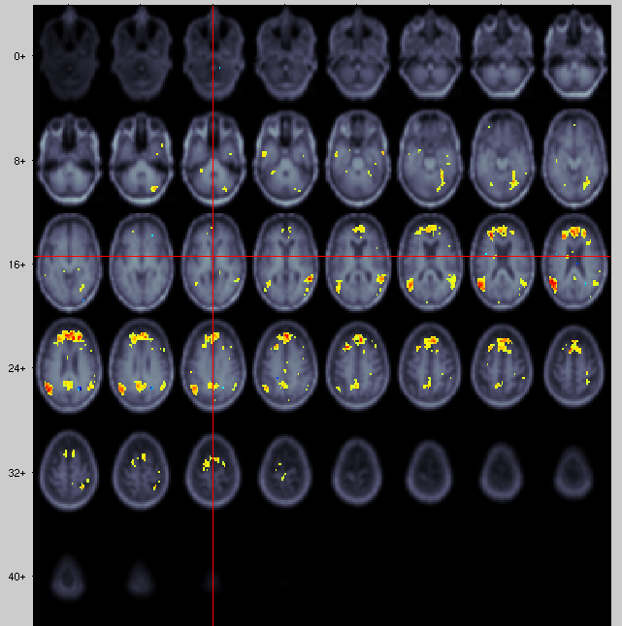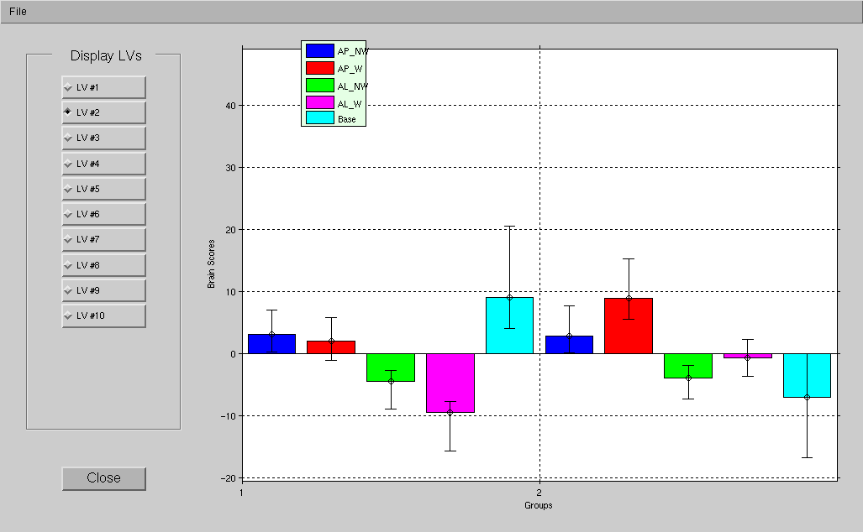
Condition AL_W is not significantly different from the mean.
The AP conditions are significantly different from the AL conditions, but the W and NW conditions within are not significantly different from each other.

In relation to the brain activity, you can say that this cluster is positively correlated with the LV2 pattern. That is, the circled cluster has greater activity in the AP conditions, and less activity in the AL conditions. If there are regions in blue, you can say this cluster is negatively correlated with the LV2 patterns, and shows more activity in the AL conditions and less in the AP condition

Voxel Intensity Response

Go to Windows Voxel Intensity Response

This option shows you the signal or activation value (as a percent change from the reference scan) for the selected voxel (at crosshair). You can redefine the region of interest (ROI) and specify the distance of neighboring voxels to include.

Then, click on the voxel you are interested in [on the brain in your results window (main window)]. You can click and drag the legend, to move it out of the way.
Legend showing symbol for each individual subject
Option for you to export intensity data as .mat file

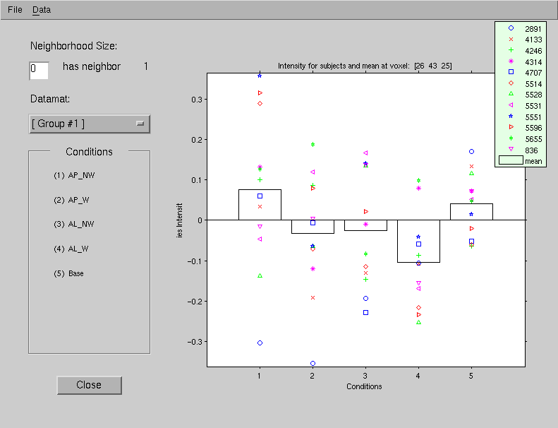
To include neighboring voxels (distance in voxel from clicked voxel), then the graph will show the average intensities of the voxels that meet bootstrap threshold criteria.
You will see the distribution of the individual scores for each condition. The bar graph displays the mean intensity for the voxel (26 43 25) for the particular condition.
Condition, check legend for corresponding condition name
Voxel Intensity.
Voxel of interest (in voxel space)
Select the group you are interested in.

Multiple Voxels Extraction

Go to Windows Multiple Voxels Extraction

This allows you to extract data from analysis from specific areas (seed). You will need to specify the coordinates of the seed (in the space as your normalized scans [e.g., MNI]) in a .txt file and select this file when prompted.

Step 1: Create a text file with coordinates & specify the text file when prompted

Select the text file with the coordinates of the seed.

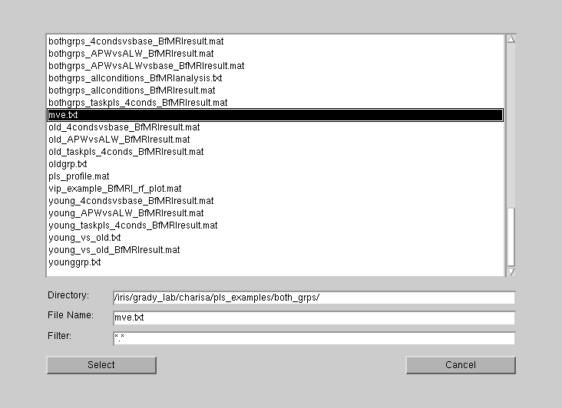

You can specify more than 1 seed, just enter the coordinates in the following line.
Click “Select”

Step 2: Specify output file name.
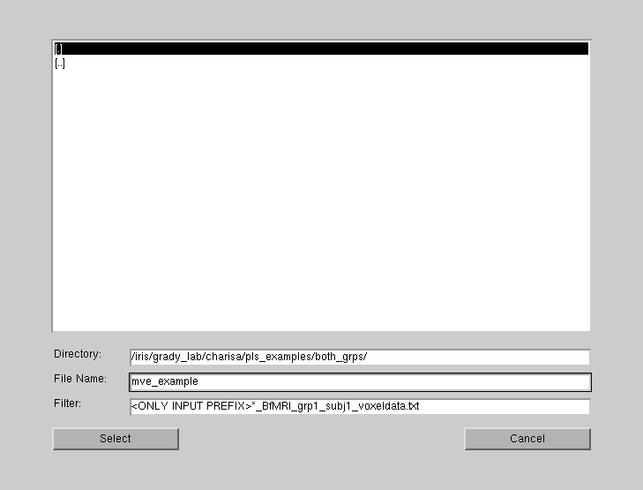

Output file name

Click “Select”

Step 3: Select neighboring voxel size
Specify distance in voxel from seed you would like to include, the default is 0.
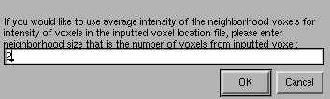
Click “OK”

Done! In your plsdir folder, you will notice that multiple files were created:
mve_example_BfMRI_grp1_subj1_voxeldata.txt
mve_example_BfMRI_grp1_subj2_voxeldata.txt
.
.
.
mve_example_BfMRI_grp1_subj12_voxeldata.txt
mve_example_BfMRI_grp2_subj1_voxeldata.txt
mve_example_BfMRI_grp2_subj2_voxeldata.txt
.
.
.
mve_example_BfMRI_grp2_subj12_voxeldata.txt
mve_example_BfMRIvoxeldata.txt

Let’s open group 1, subject 1 voxel data (this is why it is important to note the order in which you input the subjects when you created the results datamat files).

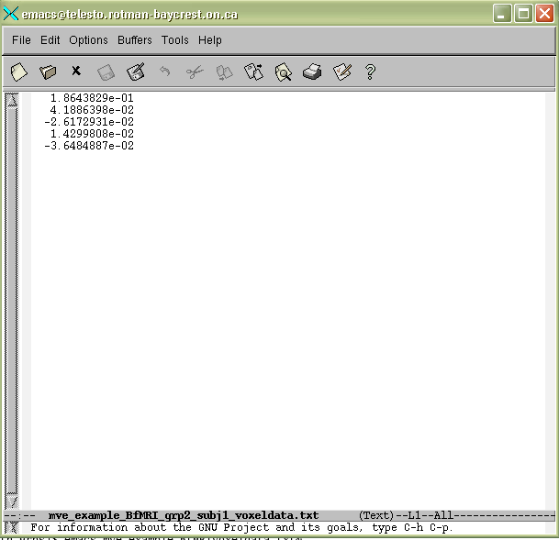

These are the averaged signal activity across the specified voxels for each condition (we have 5 conditions), for subject 2891 (first subject in the old group).

You will also notice a single file with just the prefix (mve_example_BfMRIvoxeldata.txt). This is the group file containing signal activities for all subjects in all conditions.

Let’s open it:

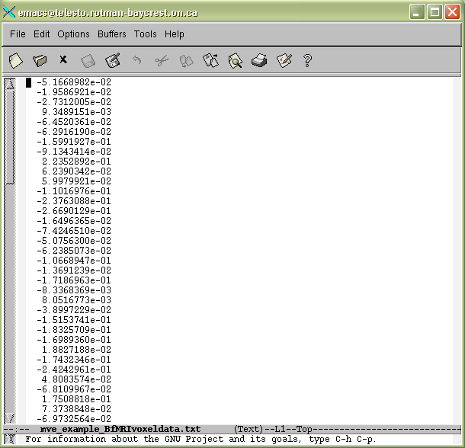
PLS orders the numbers are in the following structure:

Meaning that, the first 12 rows are the average signal activities for the 12 subjects (subjects), in the AP_NW condition (condition 1), in the young group (Group 1). The next 12 numbers are the signals for the 12 subjects in the AP_W condition (condition 2), in the old group (Group 2), etc.

Group 2
Group 1
Condition 2
Condition 1
Subject 1
Subject 2

This particular text file is important for seed analysis, which will be discussed in later sections. If you specified multiple seeds, then the resulting text files will have additional columns (1 column per seed).

Cluster Reports

Step 1: Go to Report Set Cluster Report Options

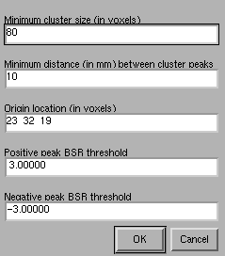
Set cluster size. This number depends on the researcher and on the voxel dimensions.
Click “OK”
The BSR thresholds should be the same as the main result window. If it is not, it will use whichever value is higher.
Where to start looking for cluster (usually leave this at default value)
Minimum distance between the peaks in mm.

Step 2: Go to Report Create Cluster Report

Corresponding p-value
Peak location in Voxel space
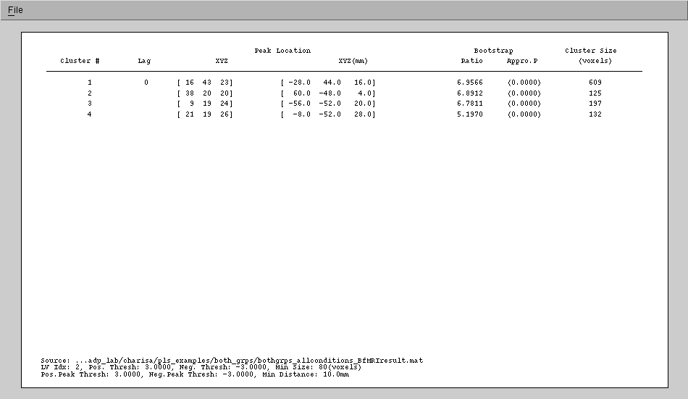
Cluster size in voxels
BSR value
Space that you normalized your scans to, in this case, MNI space
The number of clusters identified

Step 3: Save the report

Go to File Save to .txt file
You can then FTP it back to your computer and open it with excel using import wizard (or list out the file at the unix command line and copy/paste into excel; >cat cluster_report1.txt). Useful when you want to other programs (SPM or GingerAle) to find the corresponding brain region (name) for the cluster.

Go to File Save to .mat file
You can load the report in PLS at a later time. Go to Report Load Cluster Report and select the appropriate _BfMRIcluster.mat file.

Mean-Centering options

Let’s take a look at the results for the Distractor study again by choosing different mean-centering options and splithalf option. Note that this analysis was run on incomplete dataset, 5 subjects per group.

1. mean-centering type: 0

LV1 highlights the condition effect, among group 1 (young) and 2 (old)
Notice how brain pattern changes with different Mean-centering type
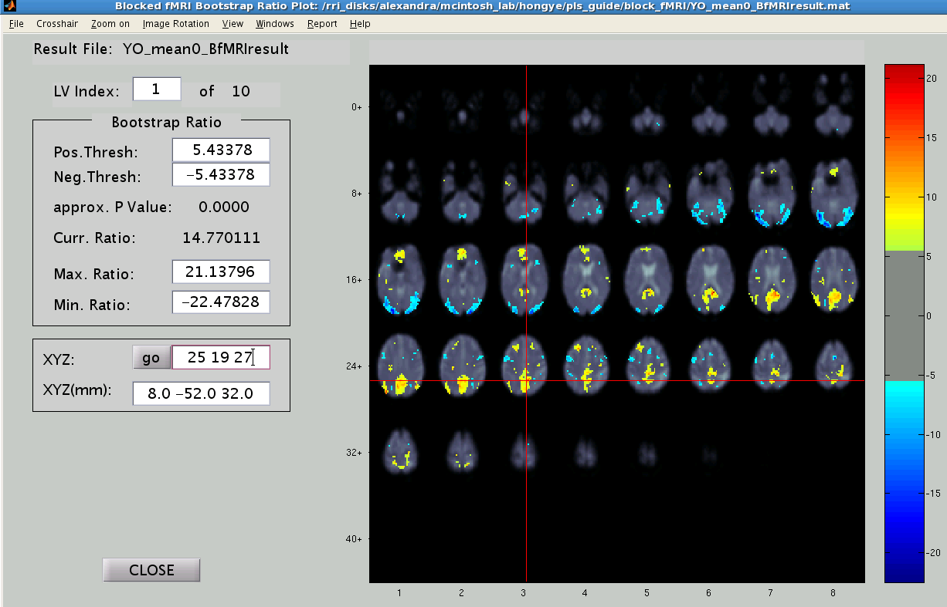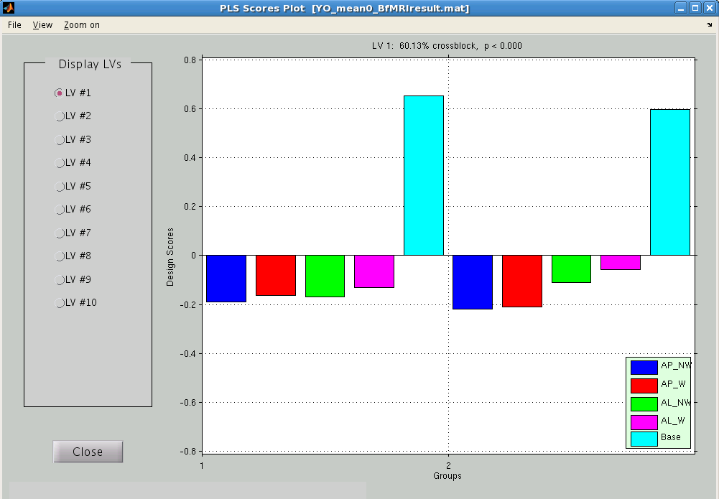

2. mean-centering type: 1

LV1 highlights the group effect

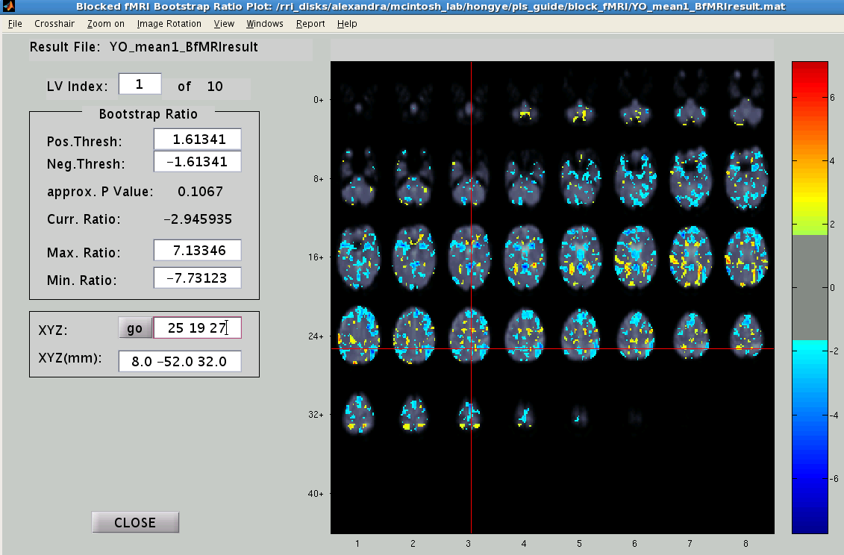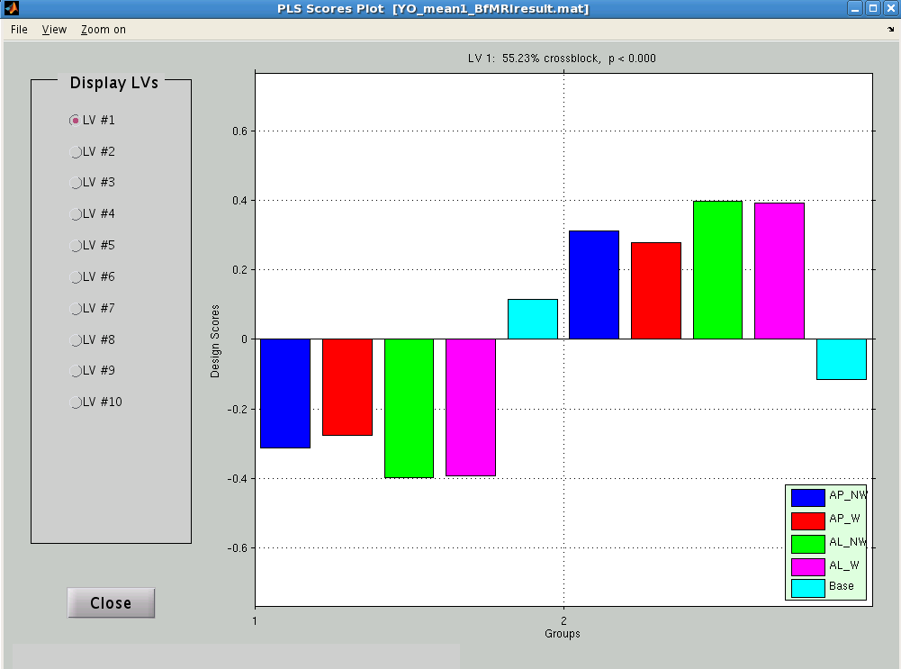

Splithalf options

Design pattern for the effect is reliable (p_designcorr = 0), but the brain pattern is not (p_braincorr =0.66). Compare this to the analysis without using splithalf (see above), where this effect was found to be significant (p=0). The two analyses produce identical design patterns and brain patterns. However, the splithalf analysis indicates that brain pattern is not reliable. This example illustrates how splithalf procedure can provide more insights into associations between brain and design patterns.

Values of p_braincorr and p_designcorr (<0.05) indicate that both brain pattern and design pattern are reliable for the effect captured by LV1.
1. splithalf: 100, mean-centering type: 0

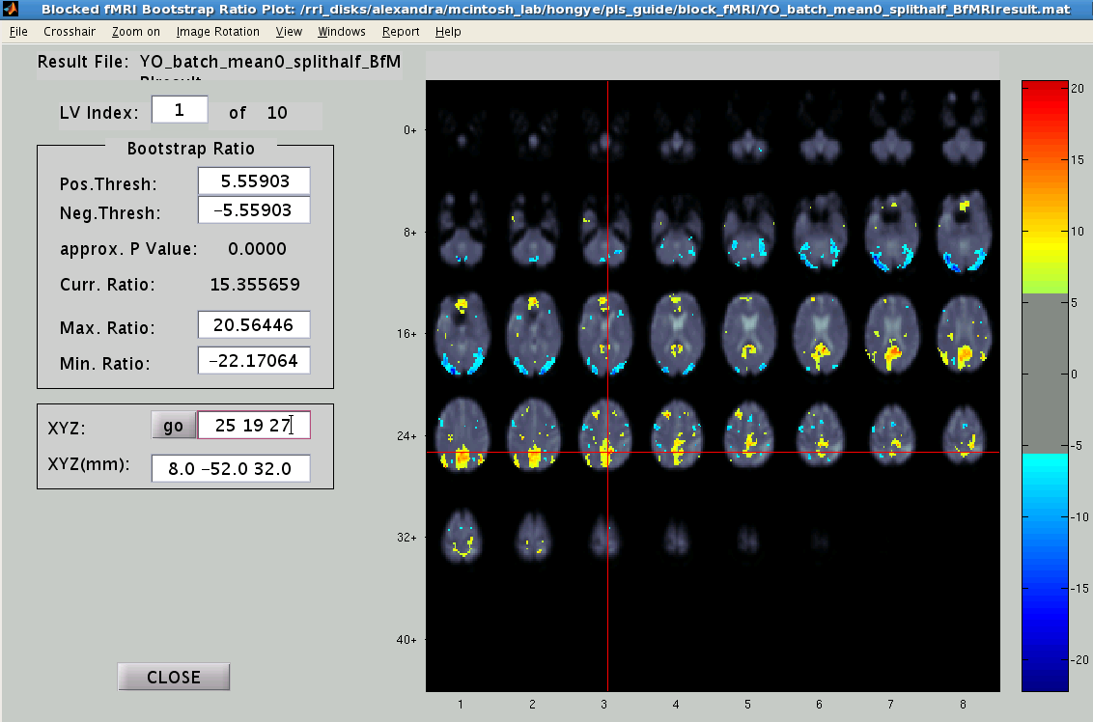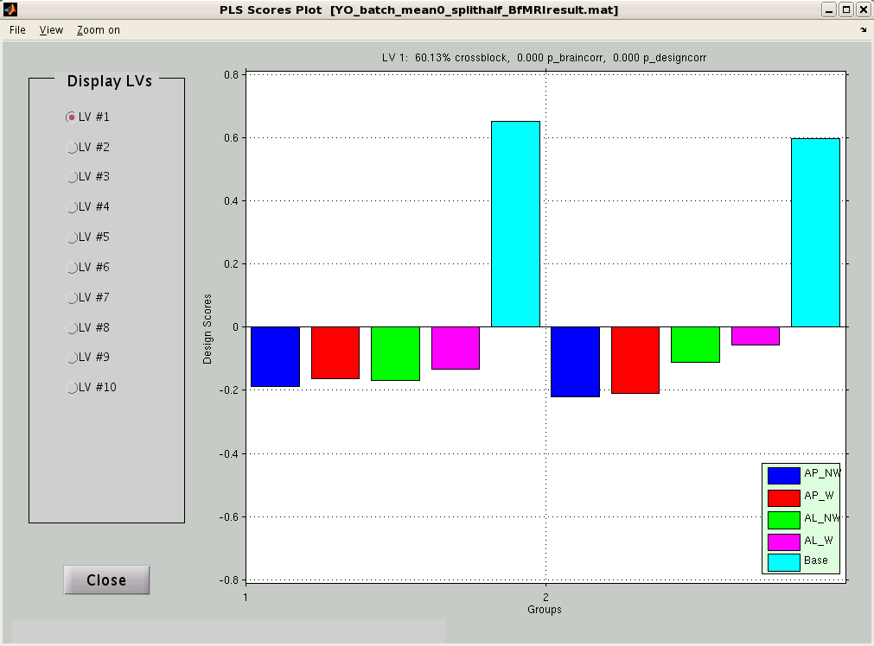

2. splithalf: 100, mean-centering type: 1

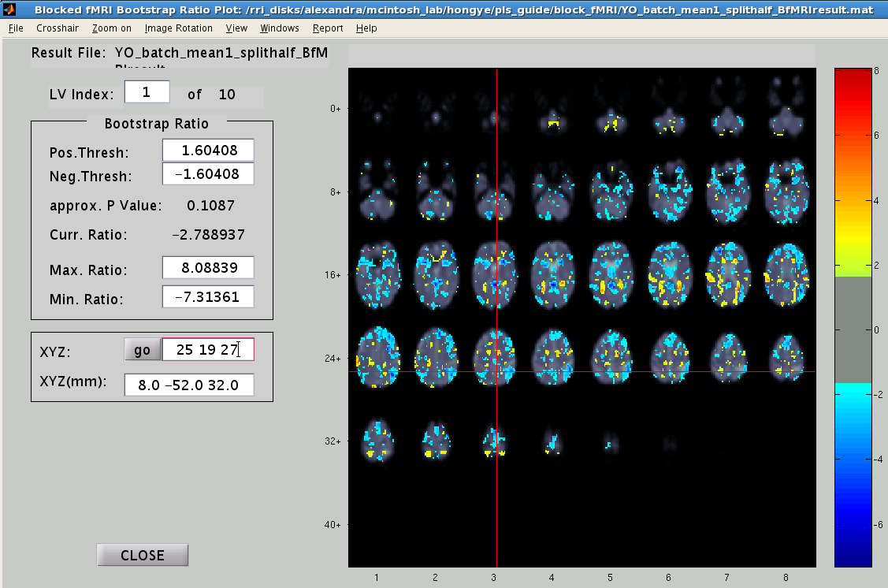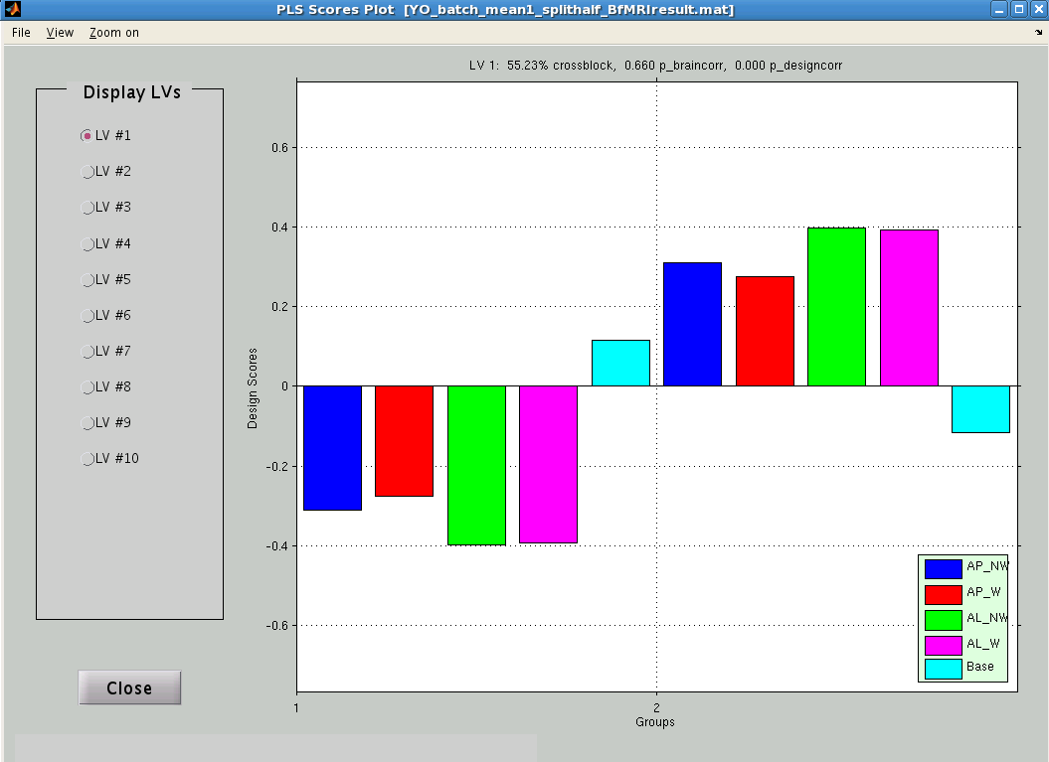

For E.R. fMRI Design

The following options are for event-related designs only. Let’s look at the results of the Cognitive Control study. Again, please note that the following analysis was run on the complete dataset (9 subjects per group), whereas in Chapter 2 we only included 5 subjects per group.

Step 1: Choose data type

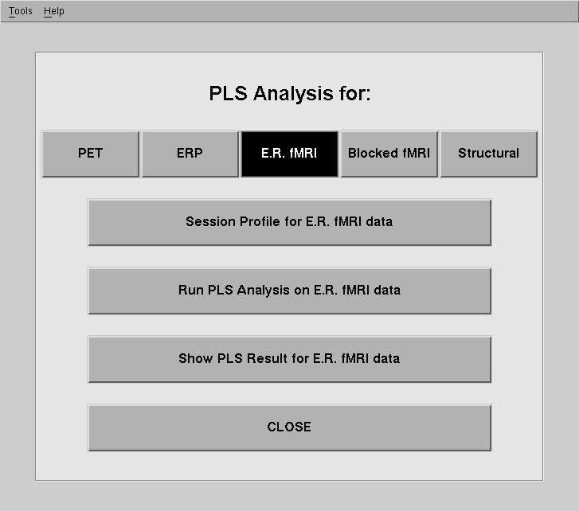
Select “Show Results”

Step 2: Selecting the appropriate results file

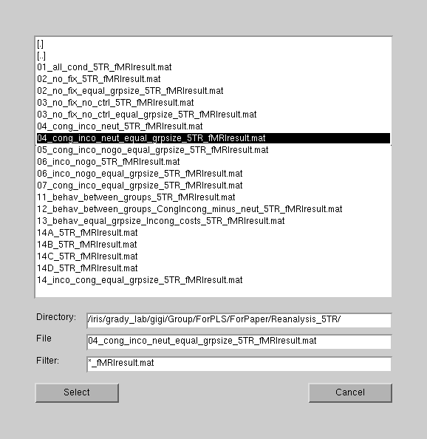
Select the results file. Let’s look at the results comparing the congruent, incongruent, and neutral condition (mean-centering PLS)

Note: This analysis was not shown in the examples.

Click “select”

Step 3: Looking at results

This is similar to the result window from blocked fMRI design, except the lags and the brain slices are shown.
LV displayed
Lags (Temporal window = 5 TRs or scans)

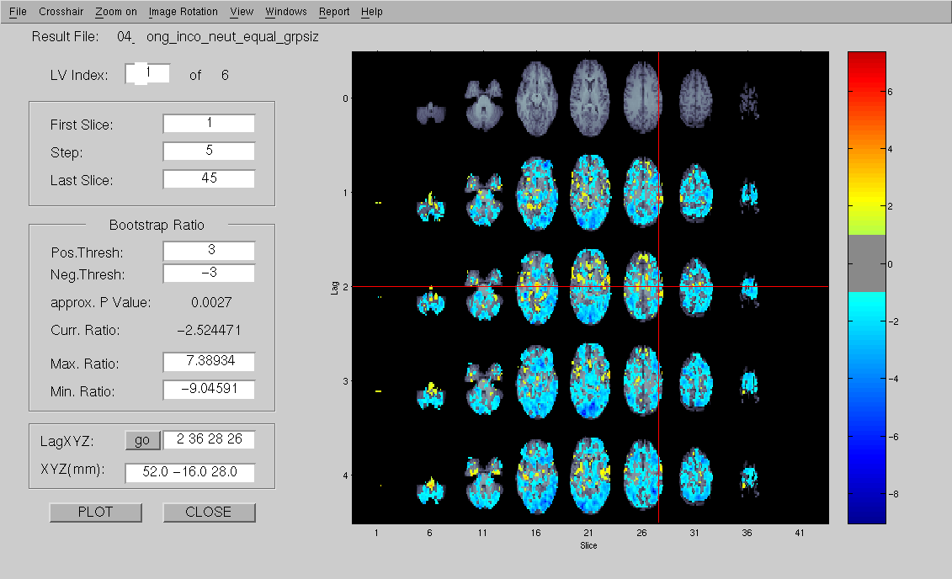
Indicates skipped slices
Brain Slices
MNI space
Voxel space
BSR Thresholds
BSR scores legend

Toolbar Options:
Most of the options are same as the blocked fMRI results.

Windows:
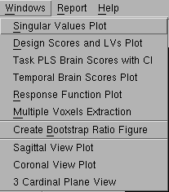
Different options are displayed for E.R. fMRI design

Response Function Plot

Go to Windows Response Function Plot

This option displays the plots of the intensity changes of the selected voxel (at the crosshair from the previous results window) for the entire temporal window. This is similar to the Voxel Intensity Response (in Blocked fMRI results).

In the response function plot windows, intensity values are shown on the y-axis and the lag number is displayed on the x-axis. You can redefine the region of interest (ROI) and specify the distance of neighboring voxels (from the crosshair) to include.

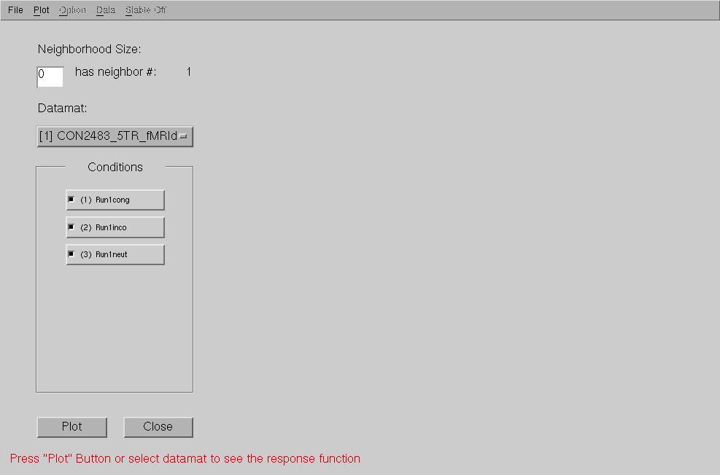
Go to “Plot” and select “Plot group data”
Click “Plot”

The circle and diamond represent the stable time points for the LV 1 and 2. You can hide them by clicking on “Stable off” * (see notes below)
To export data, select “Data” “Export Data”. Data is exported as .mat file.
To include neighboring voxels (distance in voxel from clicked voxel), then the graph will show the average intensities of the voxels that meet bootstrap threshold criteria.
Each row represents a condition

Tells you the type of plot you chose
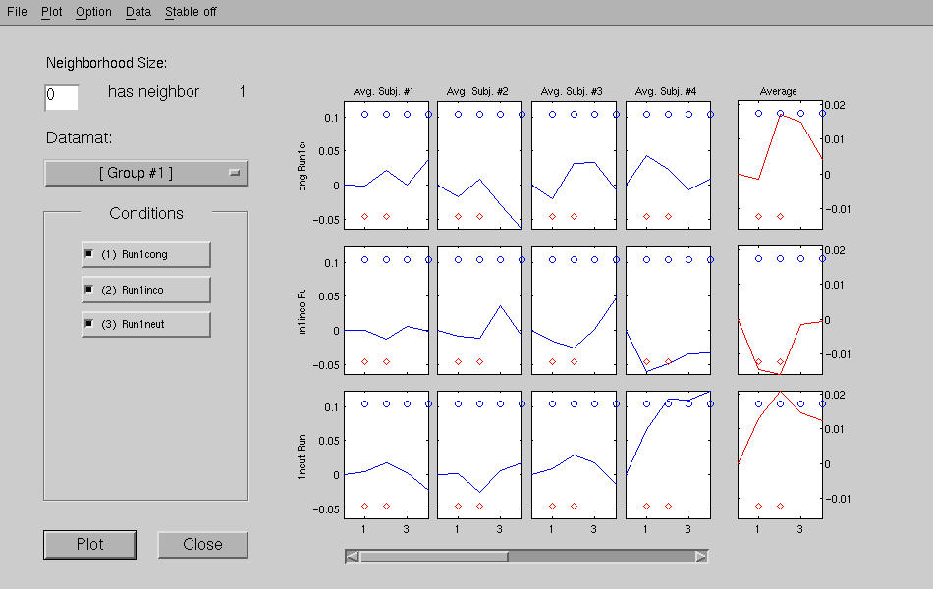
Conditions included in the analysis
The average intensity changes for each subject, plotted for each lag (at crosshair)
Group 1 (Monolinguals) is shown, you can click here change it to group 2.
The average intensity changes for the condition across all subjects

You can scroll through to see each subject
Additional Options:
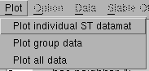

You can also display plots for individual subjects or all the subjects (across both groups).
Just select the one of these options and click “PLOT” on the window

*Stable on options allows you to determine whether the selected voxel (at crosshair) is reliable. If the BSR for the selected voxel exceeds the BSR threshold (say, ± 3.0) for LV 1 at lag 1, the blue circle is plotted at lag 1. If the BSR for the voxel exceed the threshold of LV 2 at lag 1, the red diamond is plotted. If a blue circle or red diamond appears in the response function plot, then the selected voxel should be visible in the results window at the selected threshold value for the particular LV and lag indicated.

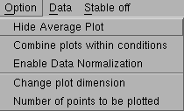
Hide the Average plot (last column)

You can display all the individuals’ plots for one condition in the same graph.

You can normalize the data to the hemodynamic response and display on the graph

Change the number points plotted
Change the number of rows or columns displayed.

Option Combine plots within conditions:
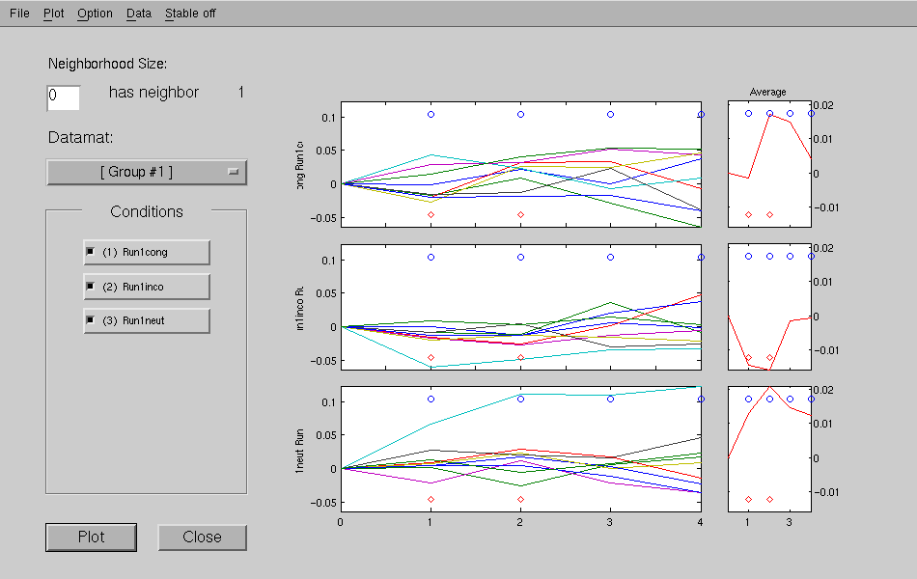

Option Enable Data Normalization
Normalize the signal intensity data so the maximum value corresponds to 1 and the minimum value corresponds to 0. The normalized data have values between 0 and 1.

This allows you to compare the response function across condition.
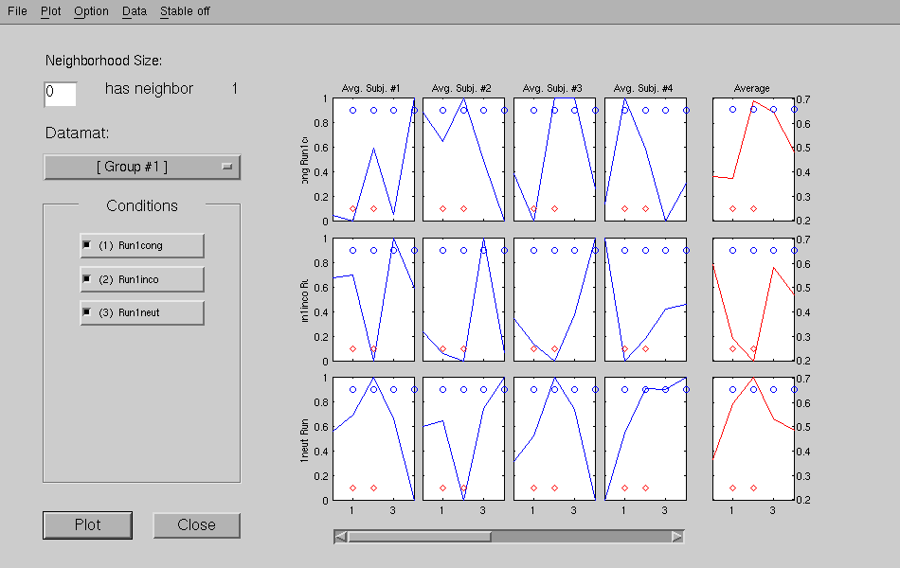

Temporal Brain Scores

Go to Windows Temporal Brain Scores

This option displays the brain scores for the entire temporal window. Basically, you can see how the brain scores changes across time.

Go to “Plot” and select “Plot group data”
Click “Plot”
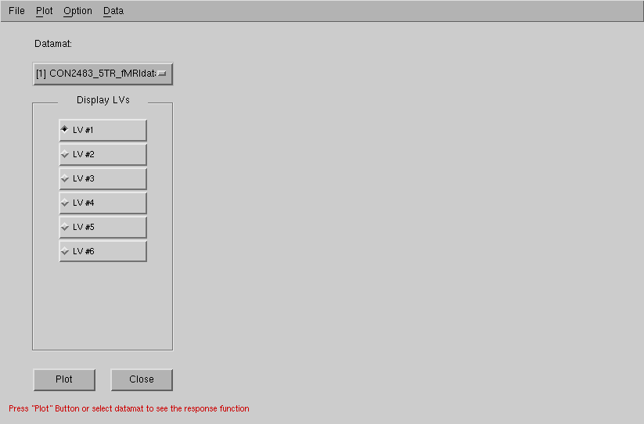

The layout is similar to the Response Function Plot. This time, the brain score rather than the intensity values are plotted.
Under “Option”, you can choose to:
- Hide Average plot (last column)
- Combine plots within condition (display individual plots within one condition in the same graph)
- Change the number of row and columns displayed

To export data, select “Data” “Export Data”. Data is exported as .mat file.
Each row represents a condition

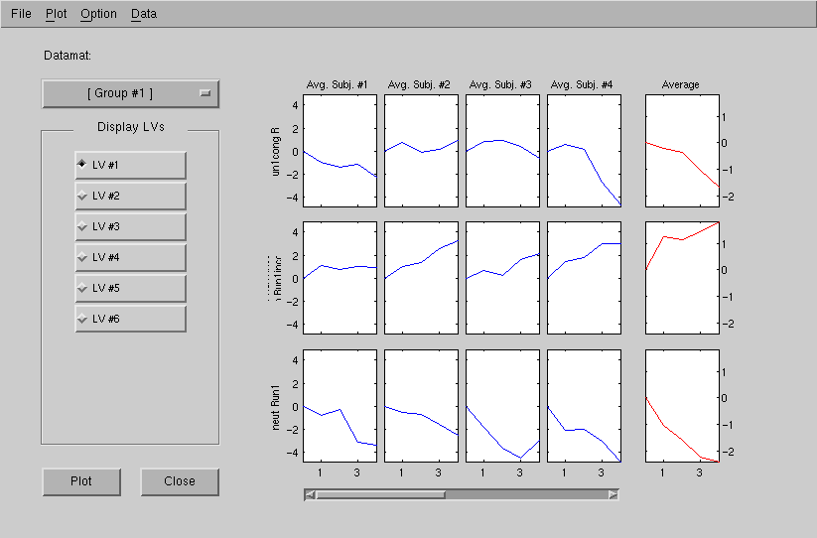
Tells you which group you are looking at
Brain scores corresponding to the selected LV are shown. In this case, it’s LV 1.
You can scroll through to see each subject
The average brain scores for each subject, plotted for each lag (at crosshair)
The average brain scores for the condition across all subjects

You can also display plots for individual subjects or all the subjects (across both groups).
Just select one of these options under “Plot” option on the toolbar and click “PLOT” on the window

For Non-Rotated PLS analysis

We are quickly going to take a look at a non-rotated PLS results (from the Non-Rotated PLS analysis of the Distractor dataset contrasting the AP, AL, and baseline condition).

The first thing you will notice is there is only 1 LV. This is because in non-rotated PLS the solution is constrained to the pattern specified in the contrast design.

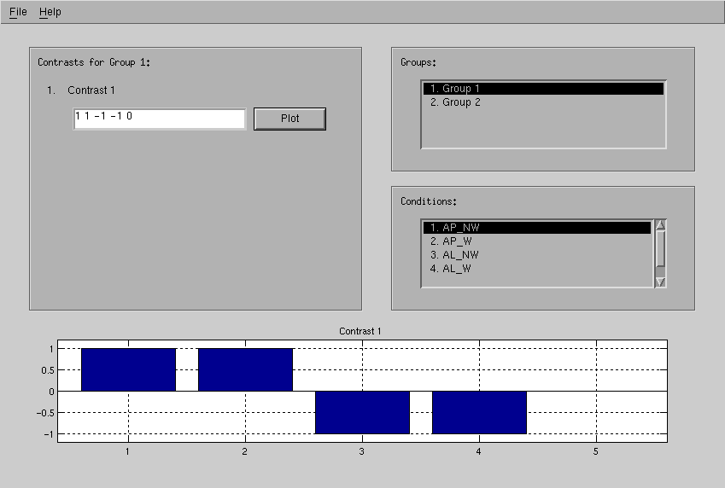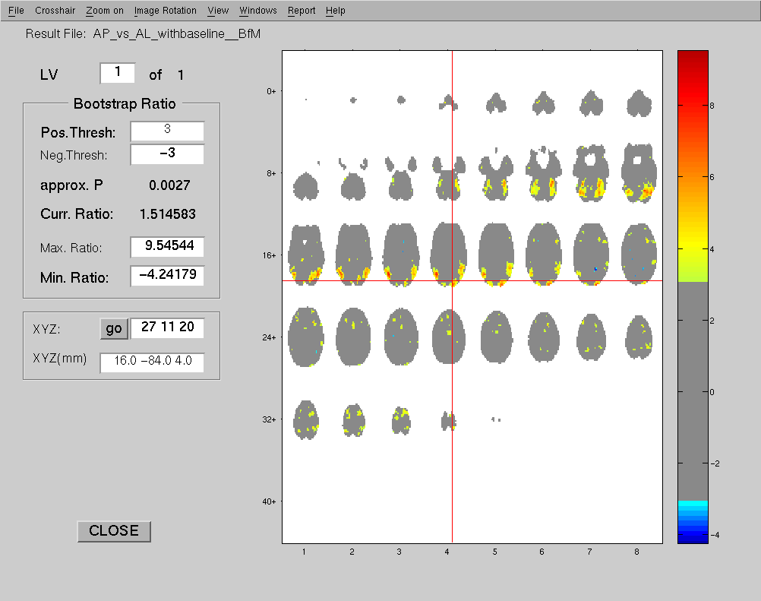
You can take a look at the contrast information by going to Windows and selecting “Contrasts Information”.

Here is the contrast information, click “Plot” to plot the contrast values

Go to Windows Design Scores and LV plots. You will notice that the patterns in graphs are the same as the specified contrast (contrast plot above). That is, PLS constrained the solution to the specified contrasts resulting in only 1 LV. The brain scores with confidence interval view will actually show you what was found.

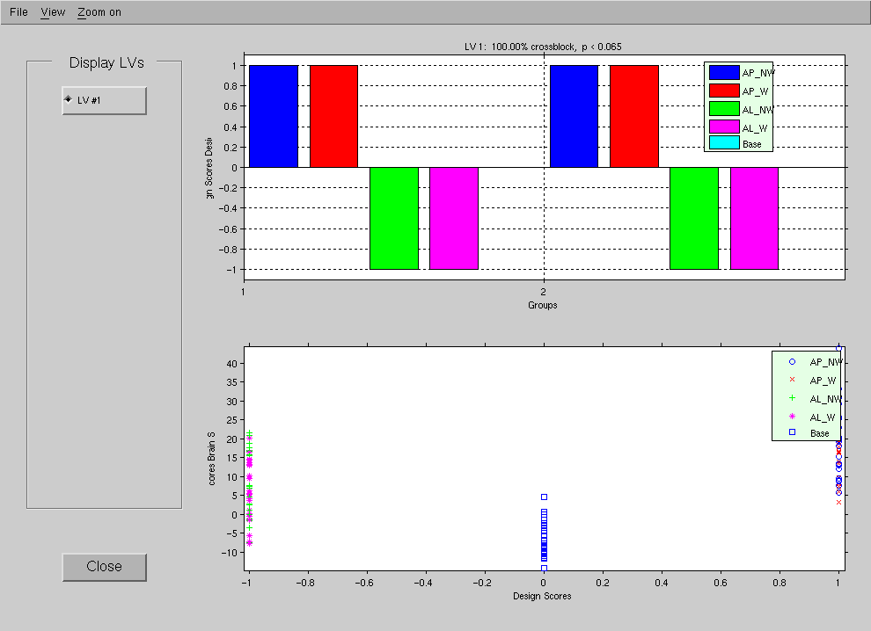

Notice the design scores only have the values, -1, 0 and 1.

For Behavioral PLS Results

The following options are for behavioral PLS analyses. Let’s take a look at a behavioral PLS results from the Cognitive Control study, comparing the incongruent and incongruent conditions. The behavioral measure in this analysis is raw reaction time (RawRT).

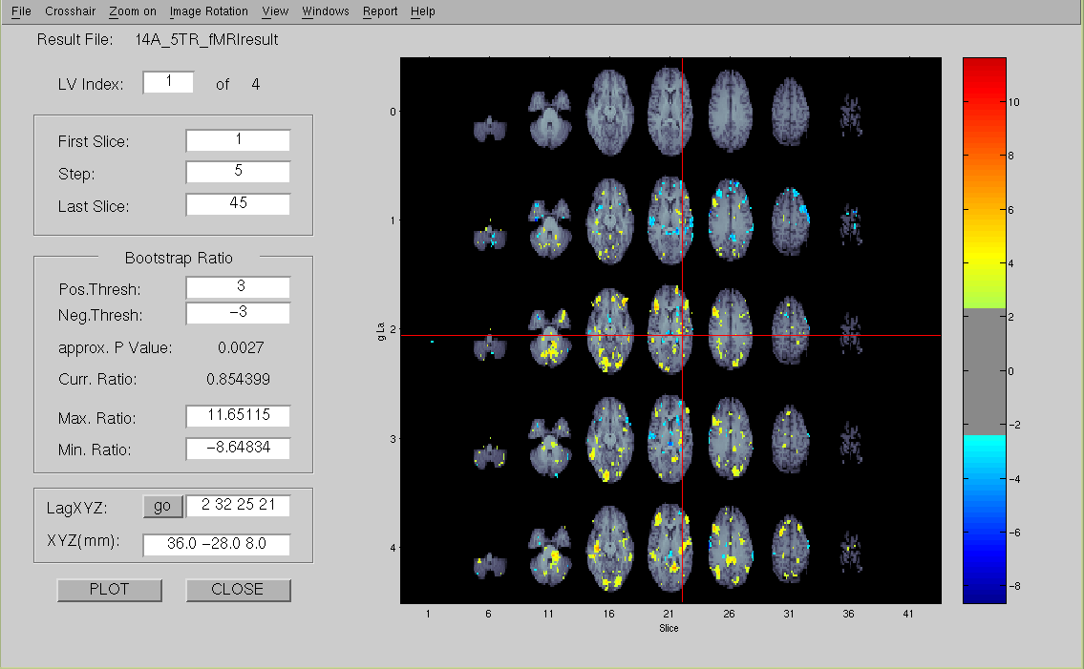

Options under Window:

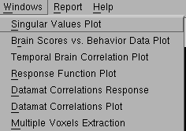

Go to Windows Brain Scores vs. Behavior Data Plot

For LV 1, the plot shows that higher brain scores (brain regions highlighted with warm colors) are related to lower RawRT (faster reaction time, better performance). Lower brain scores (brain regions highlighted in cool colors) are related to higher RawRT (slower reaction time, worst performance). Both positive and negative brain scores reflect increased activity but for different brain regions (high brain scores = warm areas, low brain scores = cool areas).

Under Option Change Plot Dimensions, you can change the number of rows and columns displayed

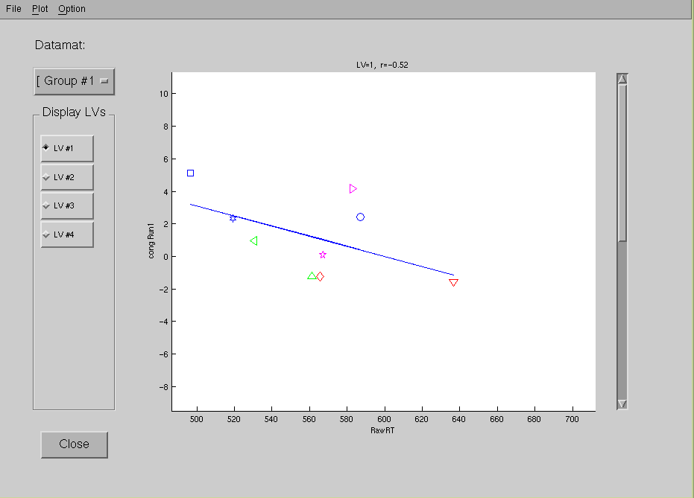
Click on individual data points to show the subject ID. Useful for identifying outliers.
The correlation between brain score for this condition and Raw RT
Current group data on display
LV one displayed. Click on other LVs to see their corresponding plots.
Brain Scores for the congruent condition are plotted against Raw RT, for the monolingual group (Group 1), for LV 1.
Scroll down to see other conditions; in this case, it would be the incongruent condition.

Under Plot: Each plot option is discussed in the following section.

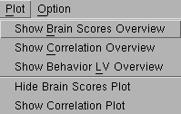
Plot Show Brain Scores Overview

Display all the plots (brain scores against Raw RT) for all conditions at once. Note that these plots are for LV 1. To display plots for other LVs, go back to the previous window and select the corresponding LV.

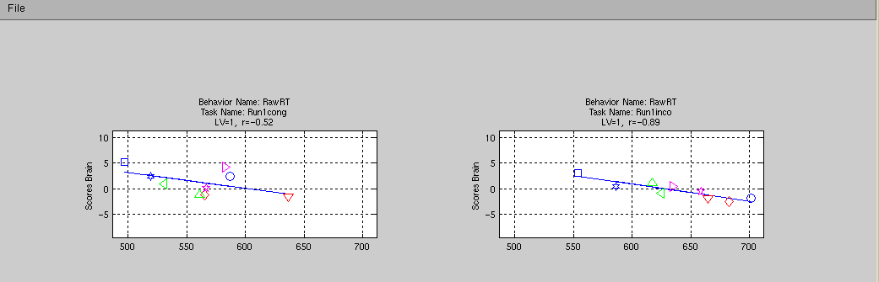
The condition, LV, and correlations are shown above each plot.

Plot Show Correlation Overview

This option plots the correlation values (between brain scores and behavioral variable) for each condition in each Group. The confidence interval (CI) bar allows you to determine whether there are significant differences between the correlations in each condition (and from zero). CI bars that overlap with 0 means the correlation is not significantly different from 0. CI bars that overlap each other also means the correlation are not significantly different from each other. CI bars that are non-overlapping indicate that the correlations are significantly different from each other. This is a quick way of assessing the trends for all the conditions in all groups.
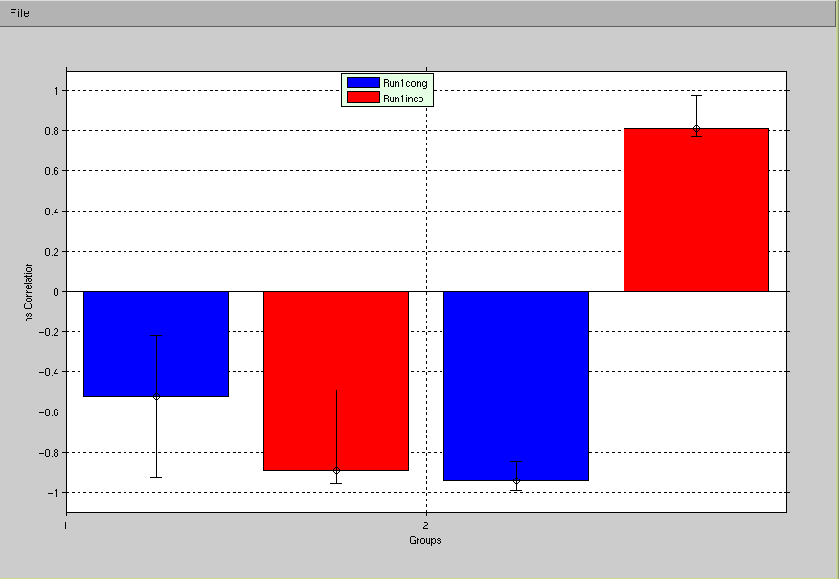

Notice the correlation between brain scores against RT is POSITIVE only for the bilingual group in the incongruent condition. This tells us the bilinguals in the incongruent conditions are performing the tasks differently than monolinguals.

Plot Show Behavioral LV Overview

Behavioral LV relates to the design score (in Task PLS). The values are arbitrary so you cannot interpret the actual values. However, you can make inferences about the direction of the bars (overall trend or pattern).
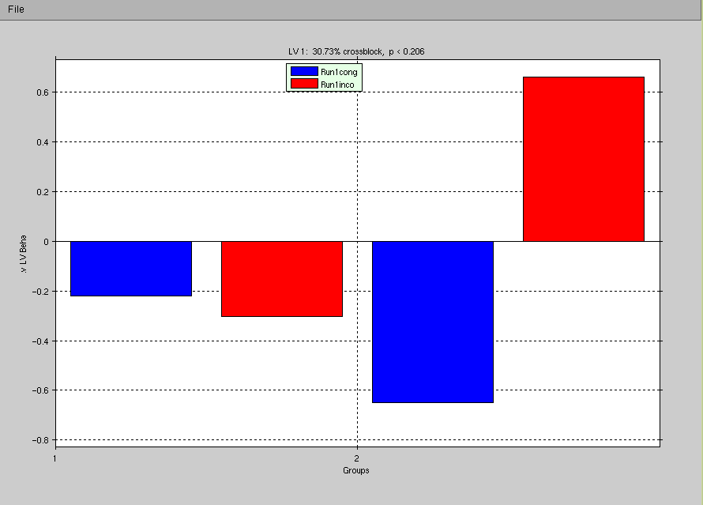

Display information on the LV, the percent variance account for, and the p-value (p < .05 is significant)

Plot Hide Brain Scores (Show Correlation Plot)
The two options are analogous. So, if you hide the brain score, the correlation plot is shown. You can switch back the default view, by going to Plot Show Brain Score/Hide Correlation Plot.
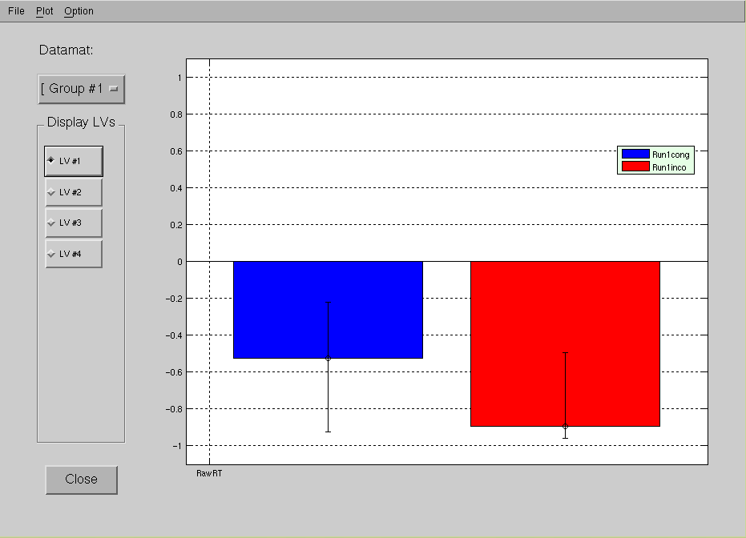

The correlations are plotted for each condition in Group 1 (for LV 1).

Temporal Brain Correlation Plot

Go to Windows Temporal Brain Correlation Plot

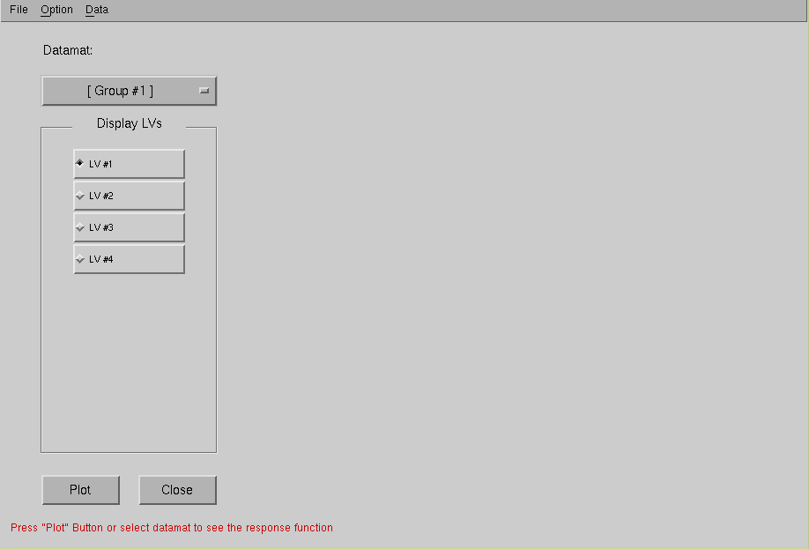
Select the LV and click “Plot”

Under “Option”, you can choose to:
- Hide Average plot (last column). If you have more than 1 behavioral measure, the last column would be the average of all the measures.
- Combine plots within condition (display individual plots within one condition in the same graph)
- Change the number of row and columns displayed

To export data, select “Data” “Export Data”. Data is exported as .mat file.
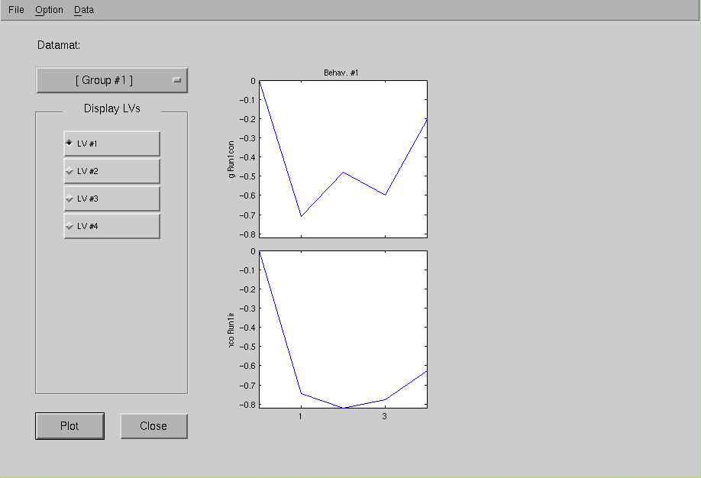

Lag number
Condition
Select the LV and click “Plot”
Correlation
Plots the correlation between brain scores and RawRT for each lag. You can see how the correlation changes across time.

Datamat Correlations Response

Go to Windows Datamat Correlations Response Click “Plot”

This option shows the correlation between the signal intensity of the selected voxel and the behavioral measure (Raw RT) for each lag (over the entire temporal window). For blocked design, bar graphs for each condition are shown because the signals are averaged within each condition across time.

Under “Option”, you can choose to:
- Combine plots within condition (display individual plots within one condition in the same graph)
- Enable Data normalization
- Change the number of row and columns displayed
- Change the number of points to be plotted

Plots the correlation between signal intensity and RawRT for each lag.

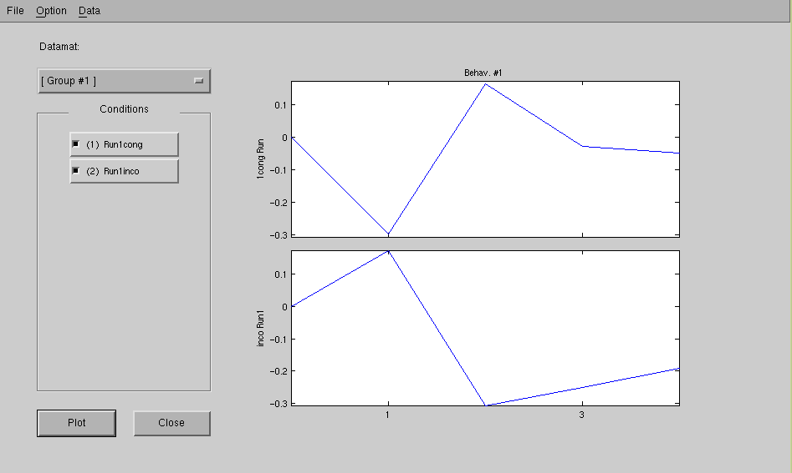
To export data, select “Data” “Export Data”. Data is exported as .mat file.

Lag number
Condition

Datamat Correlations Plot

Go to Windows Datamat Correlations Plot

This window is similar to the main result window, except the datamat correlations are shown (as opposed to the BSR). What is actually plotted are the covariance between the actual data and the behavioral measures before decomposition.
Correlate
Data
Matrix
Behavioral Measures

Correlation
Matrix
Plot of these values (before the cross-block procedures)

Monolinguals (Group 1) of 2 groups

Congruent condition (Condition 1) of 2 conditions

The current correlation value at crosshair is shown here.
You can change the threshold, and only voxels above the threshold will be displayed
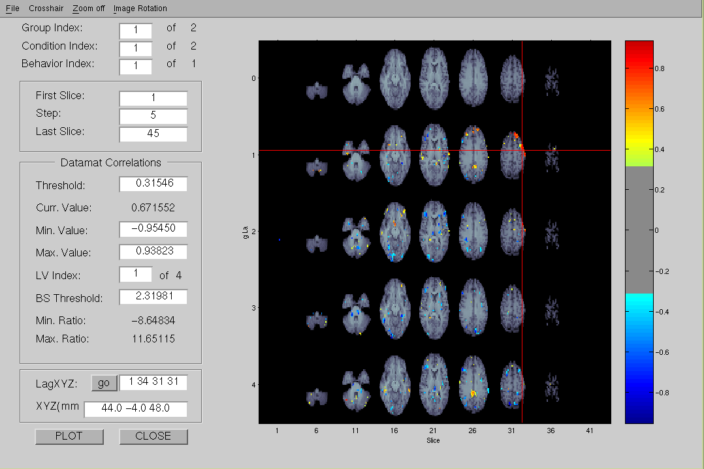
You can also change the BSR threshold. But if you enter it here, it will assume symmetry, so if you type 3, the BS ratio is actually set at ± 3.
Datamat correlations

For Seed PLS Results

The results are interpreted the same way as behavioral PLS. Rather than looking at behavioral measures you are looking at how activity at a particular seed is correlated with all other brain voxels. For the following example, the seed is in the parietal lobe with MNI coordinates (36 -40 40).

When you load a seed PLS result file, you may encounter something similar to what is shown below:
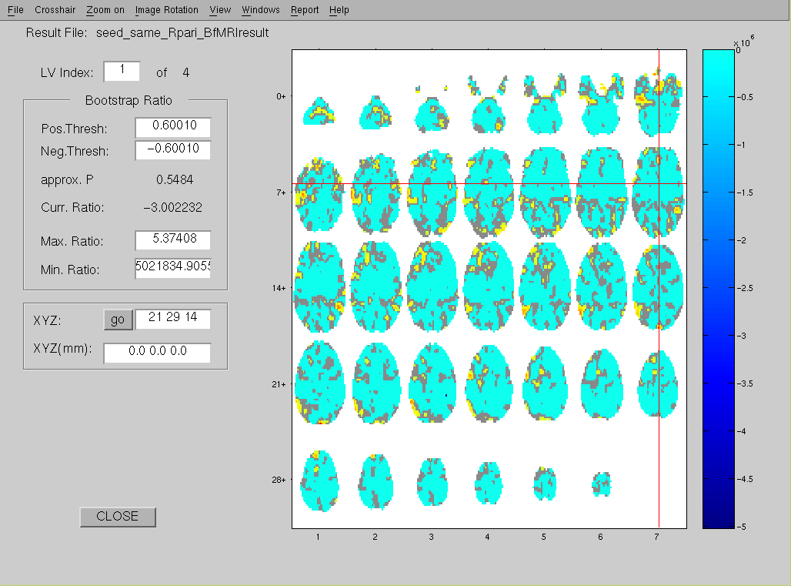
You will notice the range for the BSR is extremely skewed. The min. ratio is more than 500.
Sometimes the range of the BSR is extremely skewed in one direction. You will need to change the extreme end (in this case, the lower end), to something more sensible. You may need to ‘play’ around with the values. Generally, the sensible value is less than 25 depending on the non-extreme value.

After changing the minimum ratio and the threshold, the results will look more similar to this.

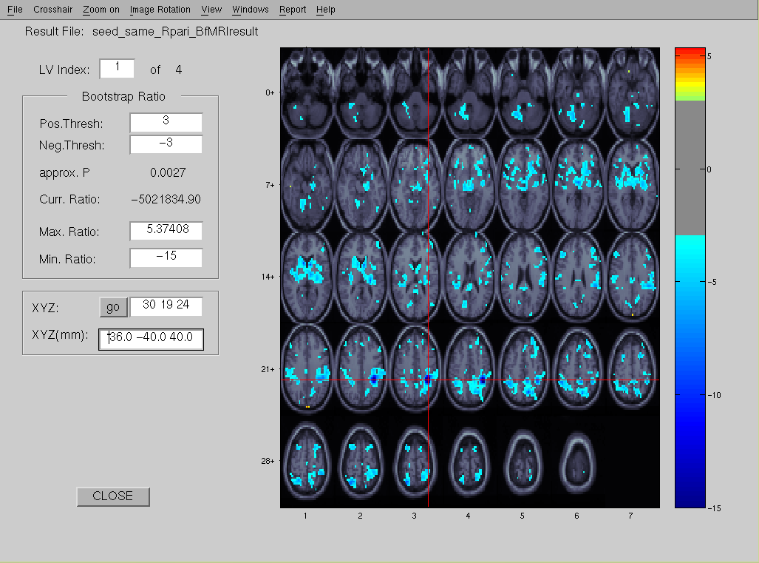
The seed is at the crosshair. Notice the activity around the seed is very high. This is very common in seed analysis since the activity at the seed should be highly correlated with activity surrounding it.

The options and interpretations for seed analysis are the same as the behavioral analysis. Rather than looking at how a behavioral measure covaries with activity in the brain, you are looking at how activity at a seed covaries with activity in the entire brain.

FOR PLSNPAIRS JAVA USERS

For Blocked fMRI Design

This manual will only describe how to display PLS result file. Please read relevant papers provided in the Reference section, if you would like to know how to interpret your results. Let’s take a look at the results for the Distractor study. Note that this analysis was run on the complete dataset, 12 subjects per group, whereas the analysis we ran in Chapter 2 only included 3 subjects per group.

Please visit http://code.google.com/p/plsnpairs/wiki/UserGuideUsingResultWindow for more details.

Step 1: Choose data type
Select analysis type ‘PLS’
Select data type
‘Blocked fMRI’
Click “Show Results”
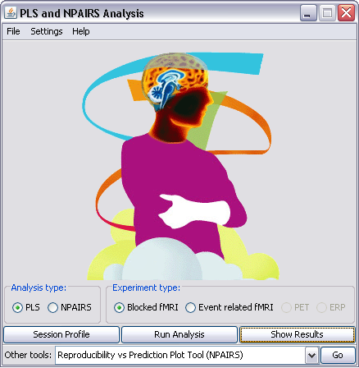

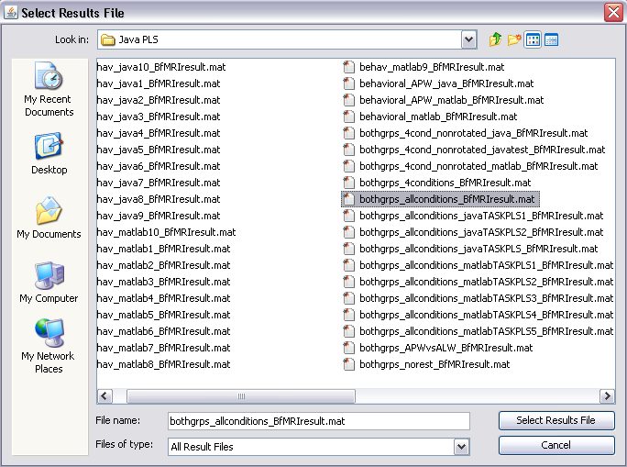Step 2: Selecting the appropriate results file
Click “select”

Select the results file. We will be looking at all conditions.

A progress window will appear indicating the plots are being loaded.
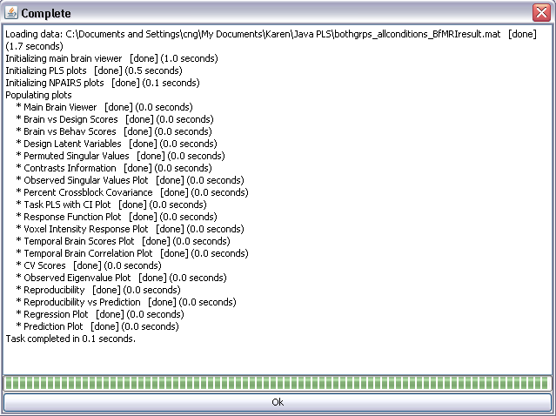

Click “OK”

Step 3: Looking at your results

You will see something similar to the following window.

The tab that is displayed by default is the Main Brain Viewer. Notice that by default, the Bootstrap Ratio Plot for the first latent variable is shown.

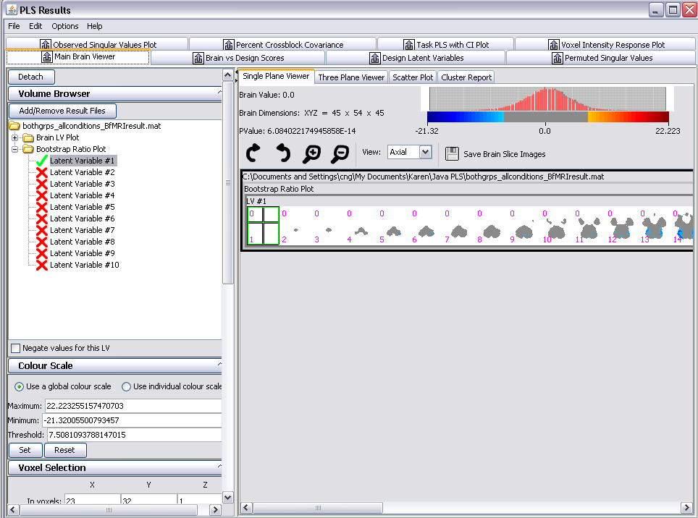
Your results are shown here, along with information regarding:
- Name of the result files
- Type of plots:
  - Bootstrap Ratio Plot
  - Brain LV Plot
- Latent Variable

The Latent Variable (LV) that is currently displayed. LV can be understood as groupings or patterns of activity. 2 of 10 LV, means you are looking at 2 of 10 possible groupings (or brain activation patterns). Note: The number of LVs is equal to the number of conditions (2 grp x 5 conditions)

Double-click on the LV # to see additional plots. Notice that additional plots are added in the Main Brain Viewer.

BSR for select voxel (crosshair)
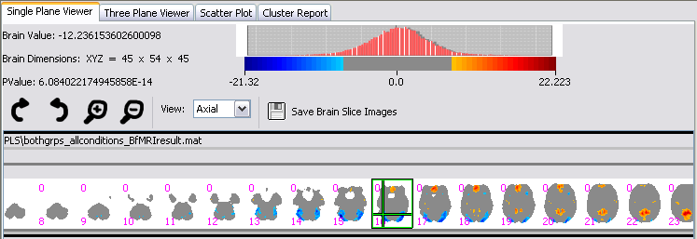The Bootstrap Ratio Plot
The P-value for the set threshold. This indicates whether the BSR surpassing the threshold is significant.
BSR scores legend

The Bootstrap Ratio Plot

The bootstrap ratio (BSR) results are shown here.
BSR = Brain LV (salience/weights) / SE (reliability)

If a voxel has ↑ signal and ↓noise, the resulting BSR will be high and the voxel will be assigned with more weight (importance). Whereas, a voxel with ↑ signal but ↑ noise will have a low BSR and will have less weight (less important).

Usually, we use threshold of +/- 3. Important to keep the number for the upper and lower bound the same to ensure the approx. p-value is accurate (p-value affected by threshold and max/min ratio).

The Brain LV Plot
The LV (latent variable) that is currently displayed. LV can be understood as groupings or patterns of activity. 2 of 10 LV, means you are looking at 2 of 10 possible groupings (or brain activation patterns). Note: The number of LVs is equal to the number of conditions (2 grp x 5 conditions)
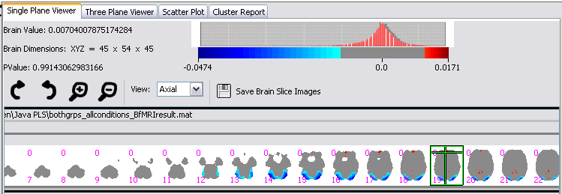You also have the option of plotting the Brain LV (salience) values rather than the BSR. This plot looks at the salience of the voxel regardless of its variability (i.e., standard error) during the bootstrapping.

Let’s look at the options available in the left-side panel.

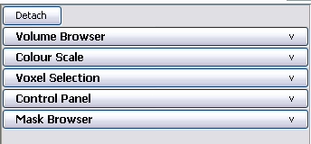
You can collapse/expand the option windows by clicking here.

Volume Browser
This window allows you to add or remove result files, and view the Brain LV Plot or the Bootstrap Ratio Plot for one or more LVs. That is, unlike Matlab PLS, you can view multiple result files and brain plots simultaneously.
Click here to add or remove result files.
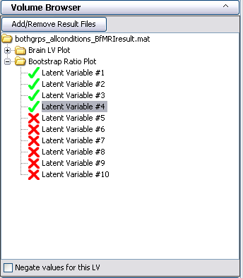
The LVs (latent variables) that are currently displayed have a green checkmark.

Double-click on the LV # to see additional plots. Notice that additional plots are added in the Main Brain Viewer.
It is important to note that in PLS, the direction (+/-) of the brain values is arbitrary. That is, you can flip the values to match those from another result file for comparison purposes.
Click here if you would like to negate the values for the selected LV (multiply all values by -1).

Colour Scale

This panel allows you to manipulate the colour scale applied to the displayed images. That is, red is assigned to positive values and blue is assigned to negative values. You can also set the threshold value for both Brain LV Plot & Bootstrap Ratio Plot, by changing the value in the threshold field.

For Bootstrap Ratio Plot, we usually set the threshold of +/- 3 for Bootstrap Ratio Plot, to approximate p-values of < .01. That is, only BSR values greater or less than 3 will be shown in the plot. You can also set the maximum and minimum values shown in the plot.

If you select global colour scale –the colour range will be consistent across all plots and if you choose individual colour scale it is optimized to the only the selected LV plot.

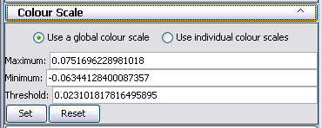

Voxel Selection

Allows to you set the crosshair at a given coordinate, in absolute voxel or mm (MNI) space, for a given lag. Note that for blocked design the lag # is always zero. Then, click ‘Go’

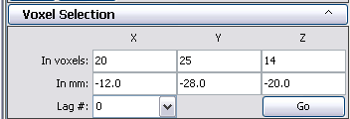

Control Panel
This window allows you to manipulate the brain slices shown in the Main Brain Viewer.

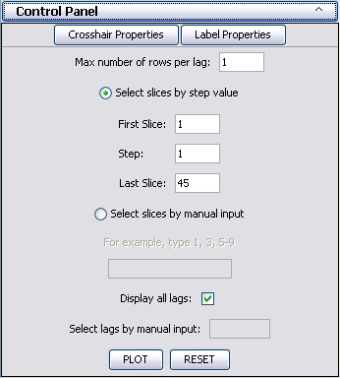
This indicates the maximum number of rows per a given lag.
You can select the slices you want to display by entering it manually.
You can set which slices you want to display by indicating the first and last slice and the step value.
The step value is the number of slices that are skipped after the first, and continues until there are no more slices.

Mask Browser
This lets you load and manage masks to be applied to the main brain viewer and scatter plot.

To add a nifti or analyze image as a mask, click on Add Mask. This will bring up a dialog where you can choose an image file. You can remove a mask from the list by clicking on Remove mask. You can enable and disable masks in the list by double clicking on them. You can also save an individual mask by clicking on it and then clicking on Save Mask.

Masks can also be created on the scatter plot by drawing regions of interest.

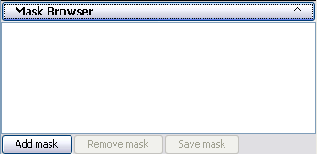

Step 4: Rendering results data
The singular values generated from PLS from the original data matrix. These are related to the numbers generated using SVD.

Singular Value Plot

Click on the tab ‘Observed Singular Value Plot’
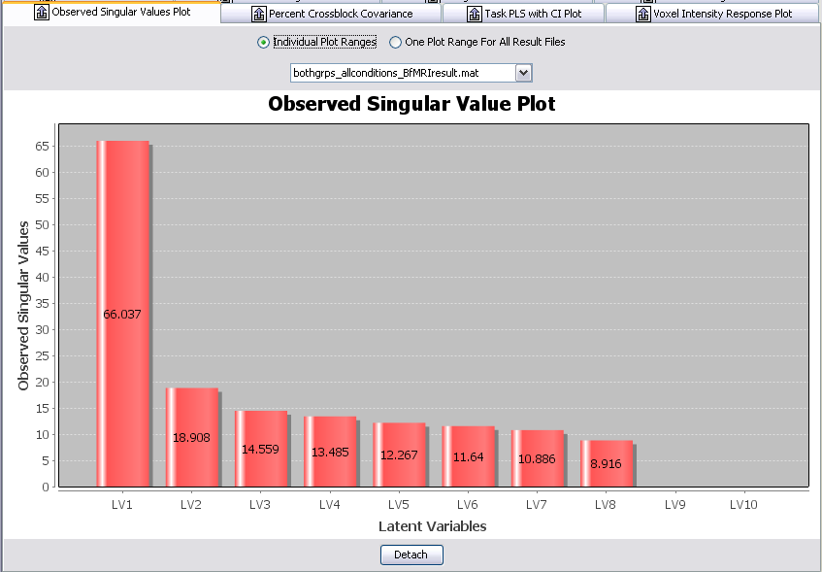

Click on the tab ‘Percent Crossblock Covariance’
These numbers are more meaningful. They tell you the percent variance accounted for by a particular LV.

PLS tries to maximize these values via SVD/Crossblock
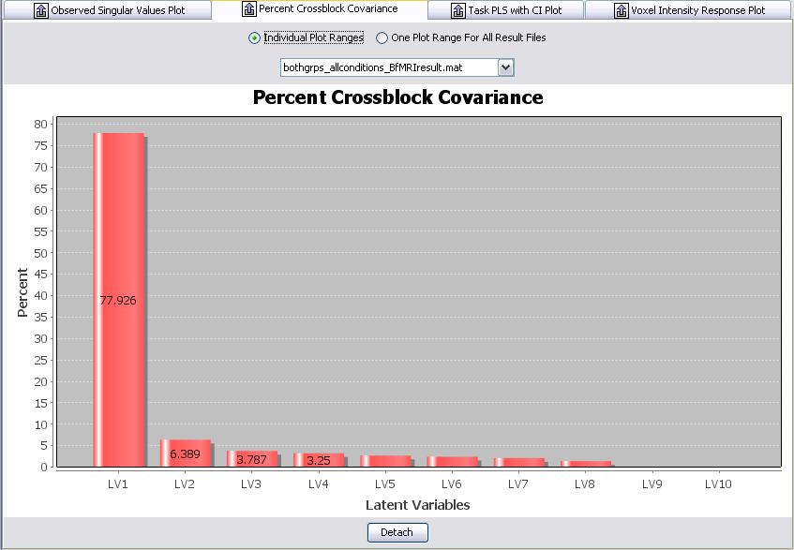

Click on the tab ‘Permutated Singular Values’
Corresponding to the variance accounted for by each LV, these are the p-values for the LVs. This will tell you whether the LV is significant or not.
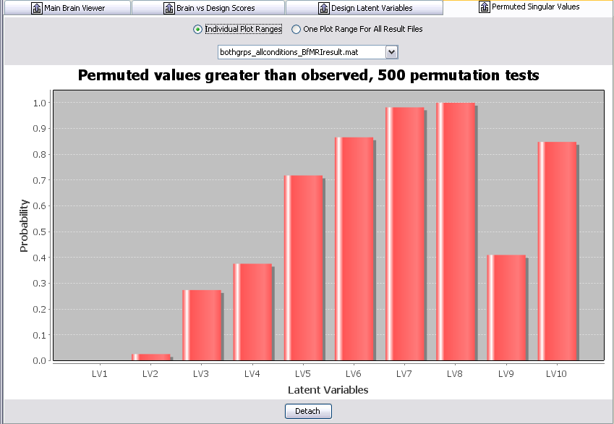

Design Score and LV Plots
Display information on the LV, the percent variance accounted for, and the p-value (p < .05 is significant)

Click on ‘Design Latent Variables’
Select Group
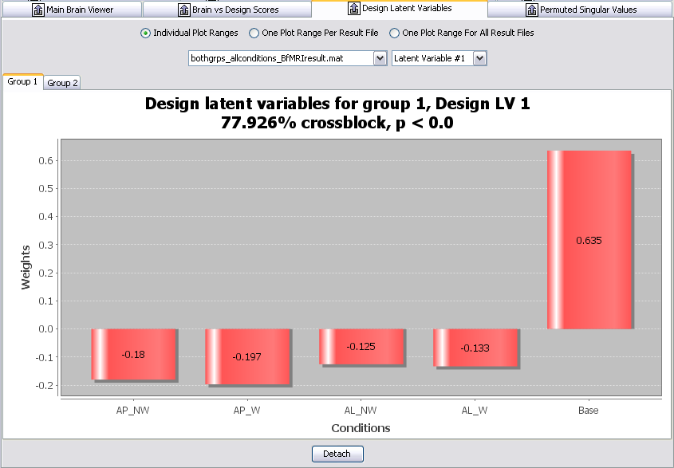
The Design Score for each condition for LV1. The values are arbitrary so you cannot interpret the actual values. However, you can make inferences about the direction of the bars (overall trend or pattern). In this example, LV 1 highlights the difference between the baseline and task conditions, among group 1 (old) and 2 (young). The bar graph highlights the similarity (or what is common) among conditions with the same sign (+/-) design score, and the differences between conditions with positive and conditions with negative scores.
Select the LV you want to display.

LV1 seems to highlight the difference between baseline (resting state) and task, and accounts for almost 78% of the observed variance. However, what we are really interested in are the differences among the task. Let’s look at LV2.

It is important to note that the values of the design scores are arbitrary, so you can shift the origin (in a meaningful way). So I could potentially shift the 0 line to 0.61 (baseline condition), and have the rest condition as the reference point.
Looking at the general pattern of the design scores, LV2 seems to highlight differences between the task conditions. Specifically, that the AP conditions are different than the AL conditions. Notice the baseline condition is in opposite direction for our two groups (positive for old, negative for young). So, we can say that for older adults, the baseline condition is more similar to the AP conditions and for younger adults the baseline condition is more similar to the AL conditions.
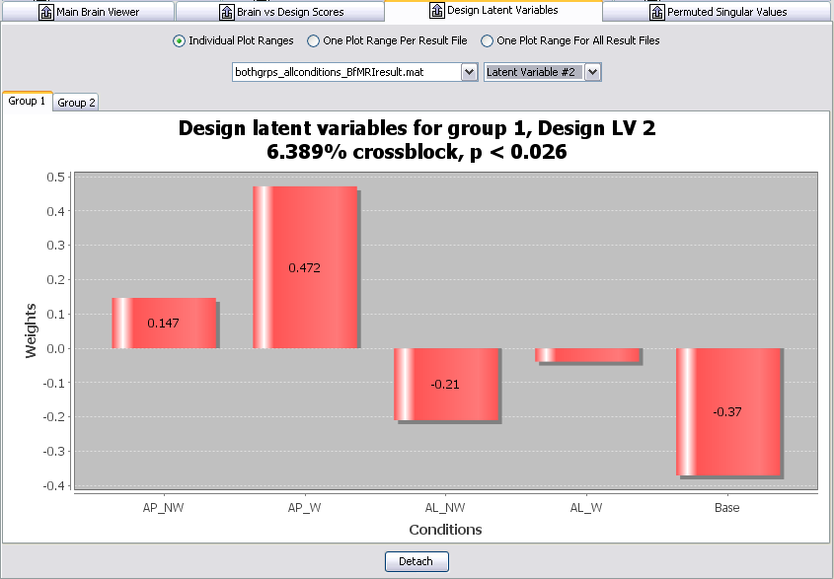

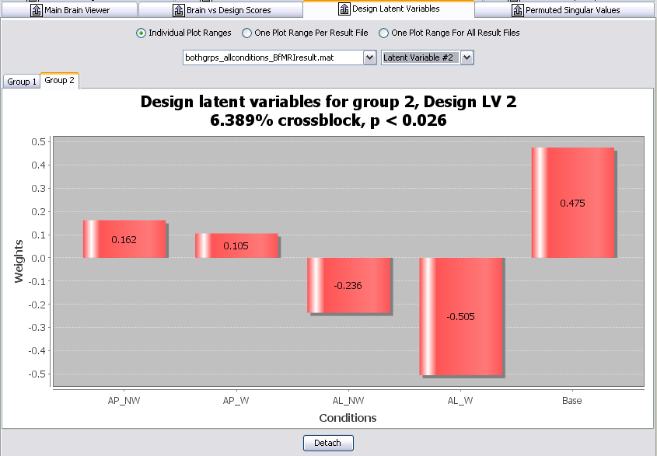

LV3 is not significant. In most cases, the subsequent LVs (4-10) will not significant but it might be a good idea to check.

We do not interpret patterns with ns. LV in task PLS, unless you have a good reason to do so.

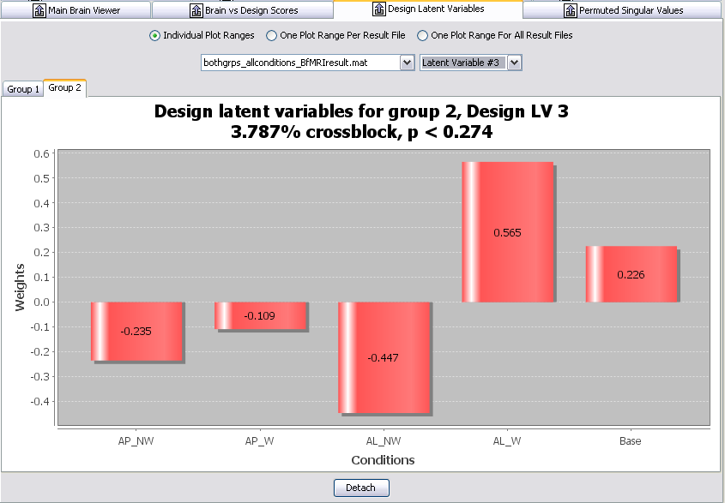Click on 'Brain vs Design Score’
LV3 is not significant. In most cases, the subsequent LVs (4-10) will not significant but it might be a good idea to check.

We do not interpret patterns with ns. LV in task PLS, unless you have a good reason to do so.

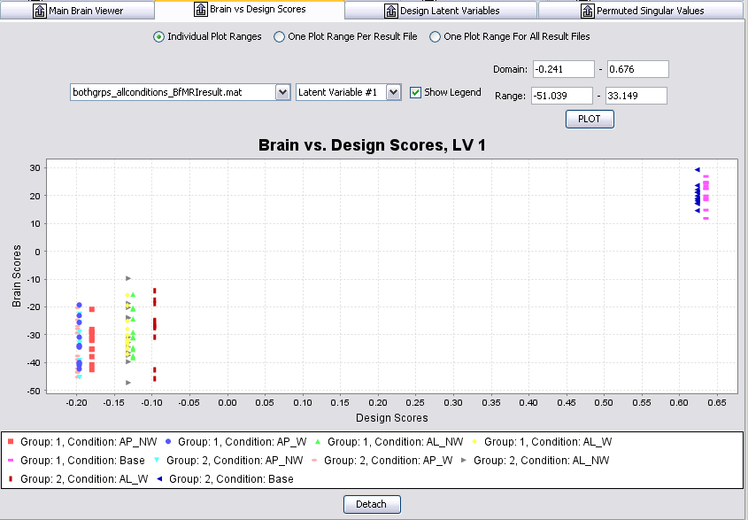

Condition AL_W is not significantly different from the mean.
This breaks it down into individual subject scores.

This breaks it down into individual subject scores. You can click on individual data points to identify outliers.

Task PLS Brain Scores with CI

Go to Windows Task PLS Brain Scores with CI

The first thing you will notice is that the directions of the bars are the same as the design scores. However, the values are different. Brain scores tell you where the pattern is found in the brain and summarizes the pattern across the brain regions. You will notice that the brain scores in the previous window, and those shown here, are on a different scale. That is because the brain scores shown with the confidence intervals have been mean-centered.

Salience: how well the summed over all voxels relates to LV (pattern)
Data
Matrix
Brain Scores = *

More importantly, confidence intervals (CI) for the brain scores are also shown, which allows you to determine whether there are significant differences between conditions (and from zero). CI bars that overlap with 0 means the condition is not significantly different from 0 (or is not different from the mean across conditions). CI bars that overlap each other also indicate that the conditions are not significantly different from each other. CI bars that are non-overlapping indicate that the conditions are significantly different from each other at your specified level (e.g. 95% CI shows significance at the α = .05 level).

The AP conditions are significantly different from the AL conditions, but the W and NW conditions within are not significantly different from each other.
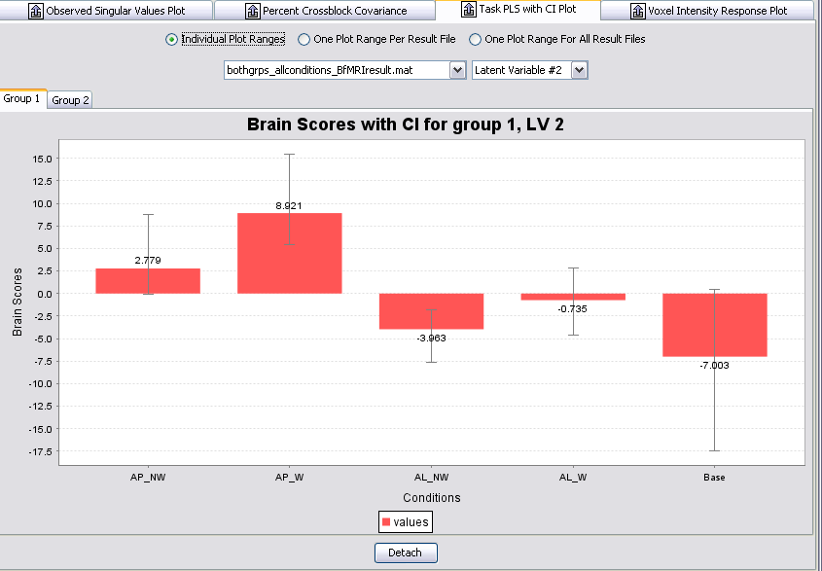
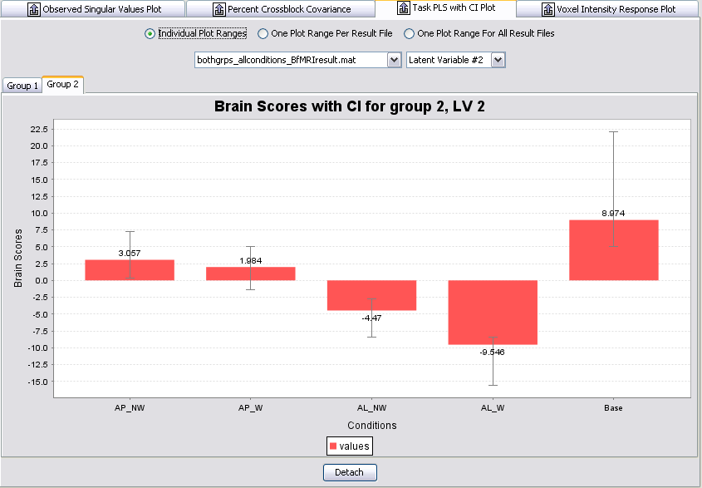

In relation to the brain activity, you can say that this cluster is positively correlated with the LV2 pattern. That is, the circled cluster has greater activity in the AP conditions, and less activity in the AL conditions. If there are regions in blue, you can say this cluster is negatively correlated with the LV2 patterns, and shows more activity in the AL conditions and less in the AP conditions.
The AP conditions are significantly different from the AL conditions, but the W and NW conditions within are not significantly different from each other.

Voxel Intensity Response

Click on ‘Voxel Intensity Response Plot’

This option shows you the signal or activation value (as a percent change from the reference scan) for the selected voxel (at crosshair). You can redefine the region of interest (ROI) and specify the distance of neighboring voxels to include.

Then, click on the voxel you are interested in [on the brain in your results window (main window)]. You can click and drag the legend, to move it out of the way.
Legend showing symbol for each individual subject
Select the Result File

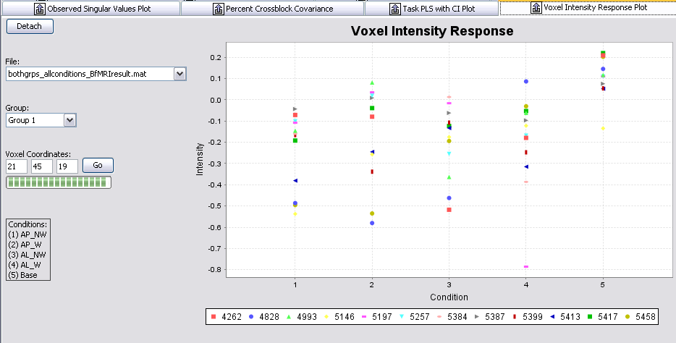
You will see the distribution of the individual scores for each condition. The bar graph displays the mean intensity for the voxel (26 43 25) for the particular condition.
Condition, check legend for corresponding condition name
Voxel Intensity.
Voxel of interest (in voxel space)
Select the group you are interested in.

Structural PLS with MATLAB
by Rebecca Charlton

Preparing files

Before creating your datamats etc, you need to prepare your images. Structural images (e.g. T1 volume scans and DTI images) should be smoothed and normalised. The images should contain values, so MD and FA data from DTI are okay as they are, but a probabilistic segmentation should be performed on T1-volume scans (this can be done along with the smoothing & normalisation in SPM).

You will also need to create a mean image and a binary mask of this mean image. You will need the binary mask to prepare the datamats. The binary mask just needs to be for the whole brain without the skull, as your probabilistic segmentation will take care of the grey matter/white matter/CSF distinctions.

Creating Datamats etc

Do this separately for each of your groups.
Your conditions are the number of different tissue types, e.g. for T1 volume scans, GM/WM/CSF.
You can use your mean image as a

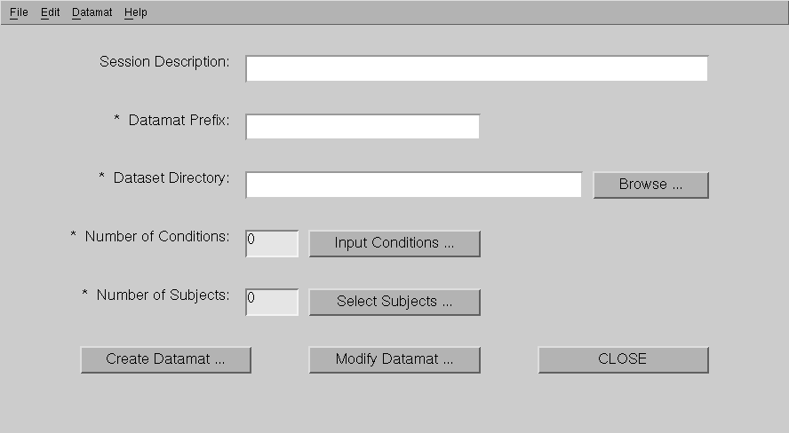

Session Description: Optional

Datamat Prefix: whatever the prefix is for your segmented smoothed images, e.g. mwc

Dataset Directory: location of files, browse to the location

Number of conditions: when you click on input conditions another window will open
Enter the condition and filters as below: for T1 volumes, e.g. GM, WM, CSF

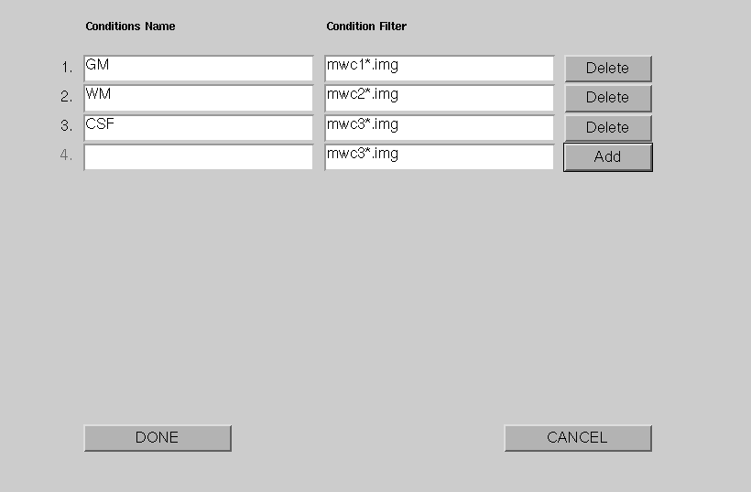

Select subjects: Select subjects from one group ONLY

Click CREATE DATAMATS
NB Change the file name it will be listed as the filter you entered for “Datamat prefix”; the file must end with “_STRUCTsession.mat”

A window will appear where you can exclude subjects.
At this point you must enter your binary mask file, nb if file not visible check extension i.e. *.img or *.nii. Then click, Create.

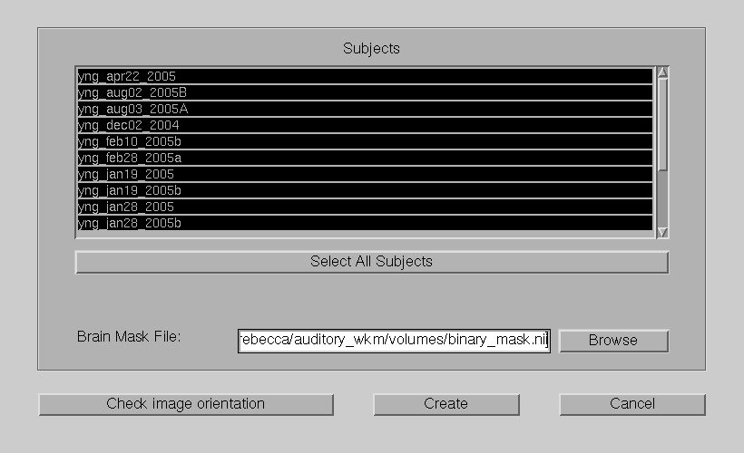
Repeat for other group/s. Close window.
Running analysis
This step is the same as for other PLS analysis.

Interpreting Structural PLS Results
The interpretation of the structural PLS is reliant on the data used in the analysis.

If analysis is using images which have been segmented into grey matter, white matter and CSF using a probabilistic segmentation, then the results will show the areas where the probability of the voxel being a given tissue type is greater for one group than the other.

You may choose to view your results separately for each tissue type or to include the three tissue-types in one analysis. This may be useful for assessing interaction effects, but may also be difficult to interpret.

Results for Grey matter only
As with other PLS analysis, you can set the Bootstrap ratio to around +/-3 to view significant clusters, and can use the Singular Values Plot to assess significance level of the LVs.

One significant LV is observed (p < .001)

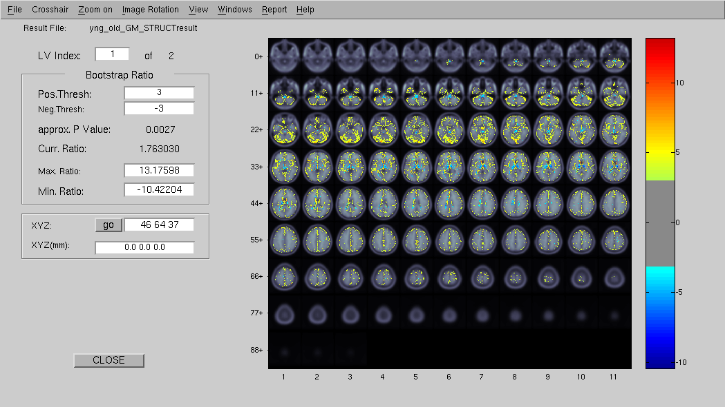

You can view both the Design LV and Design Scores plot:
And the Task PLS Brain Score with CI plots
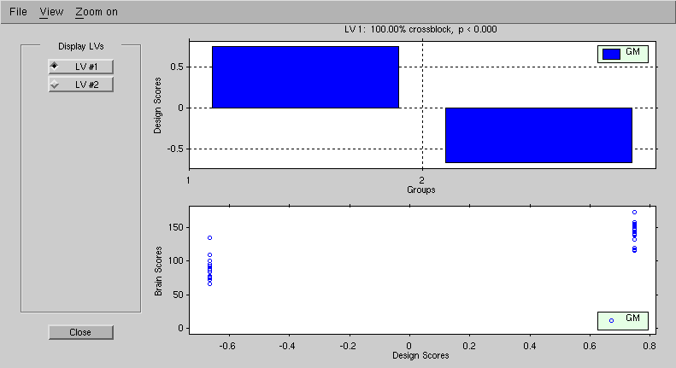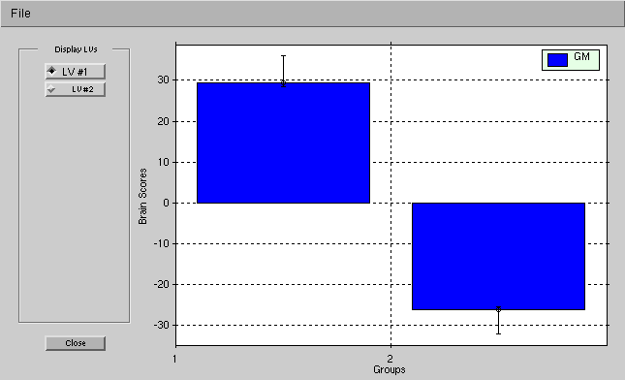

These plots indicate that group 1 (young subjects) have a greater probability of the identified (yellow areas) voxels being GM than group 2 (older subjects). The blue areas, are regions where group 2 (old) have a greater probability of the identified voxels being GM than group 1 (young).

There is greater probability that areas along the cortex throughout the brain are grey matter in the young group compared to the old group.

Results for white matter only

One significant LV is observed (p < .001)

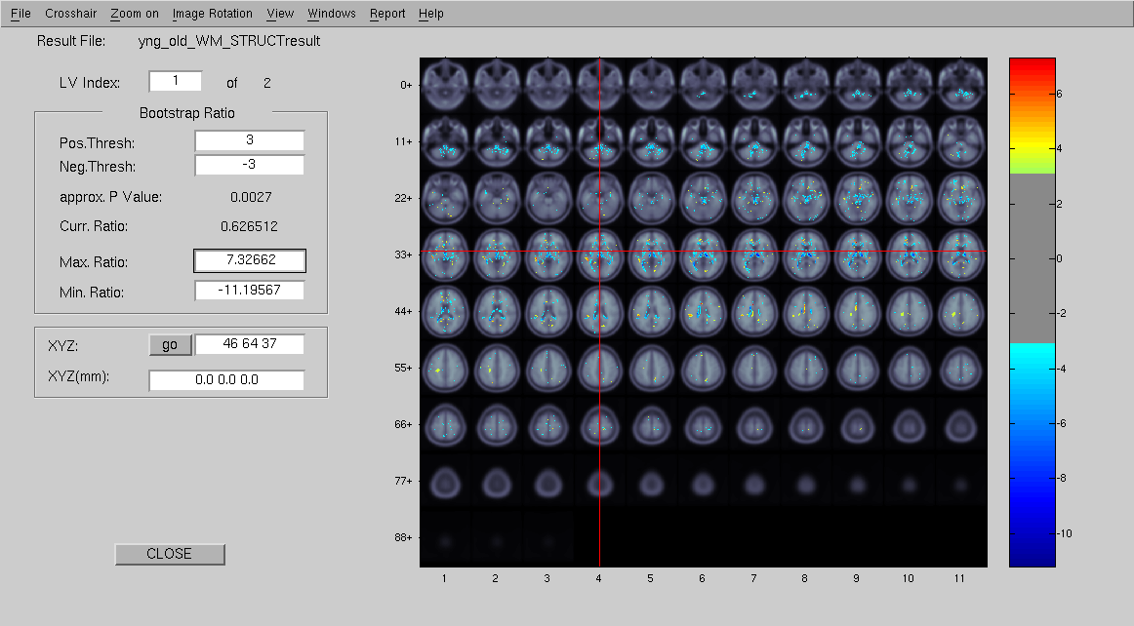
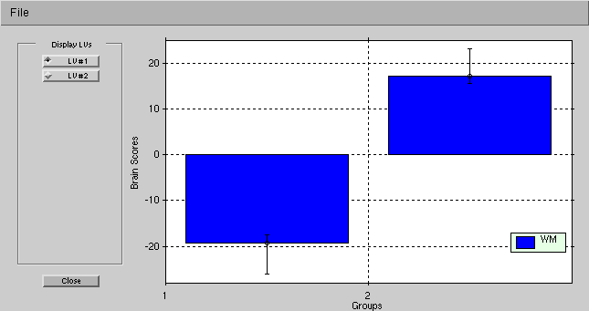
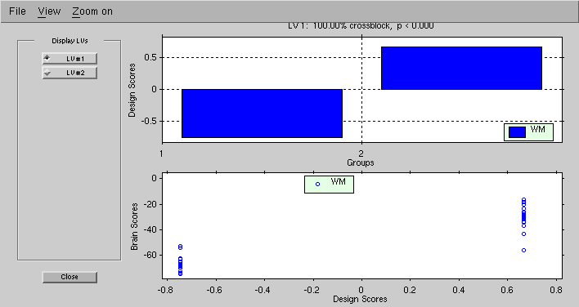
These plots indicate that, group 2 (old) have greater probability of the identified voxels being white matter than group 1 (young).
The blue voxel indicate where the probability of being white matter is greater in the young than the old (greater in group 1 than group 2).
The yellow voxels indicate where it is more likely that the identified voxels are white matter in the old group than the young group (greater probability in group 2 than group 1).

Results for WM and GM in the same analysis

Two significant LVs are observed (LV1: p = .002; LV2: p = .014).

LV1

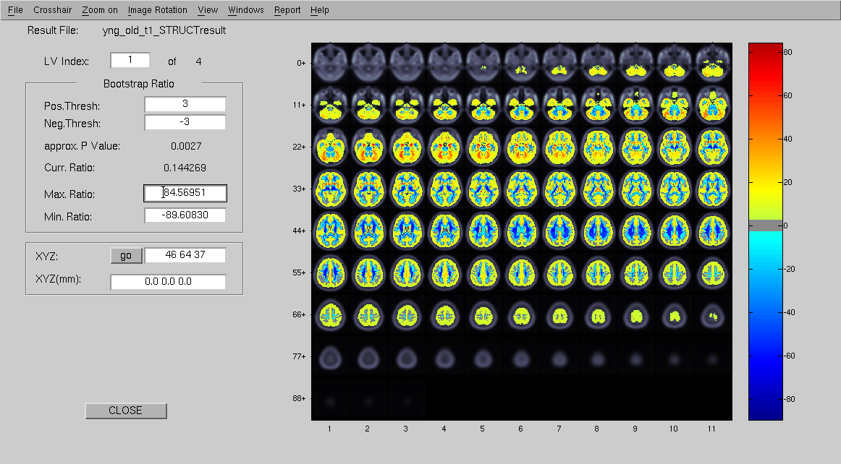
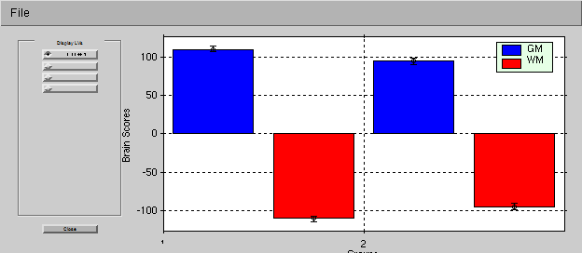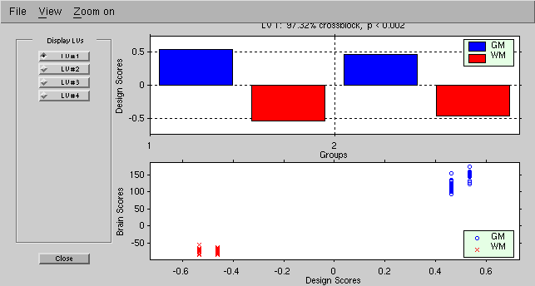

This LV demonstrates areas where probability of being WM or GM is the same in both groups. With greater probability of tissue being white matter being shown in the cool (blue) colours, and greater probability of tissue being grey matter being displayed in the hot (yellow) colours.

LV2

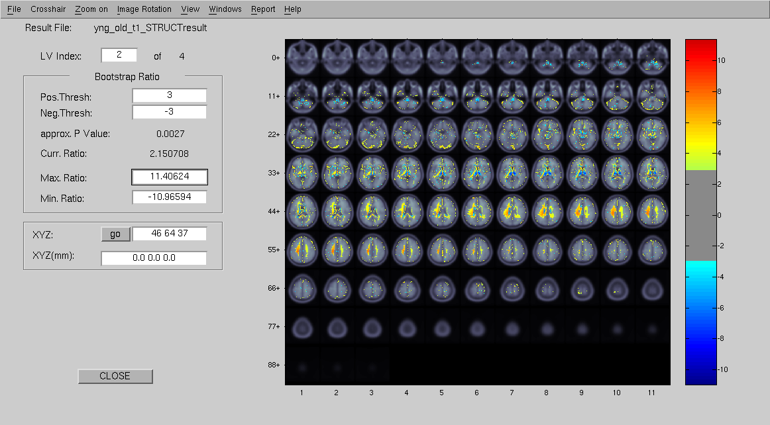
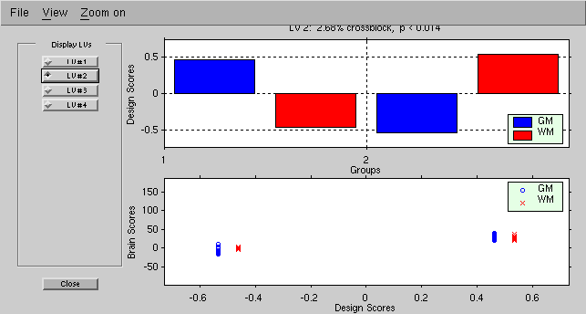
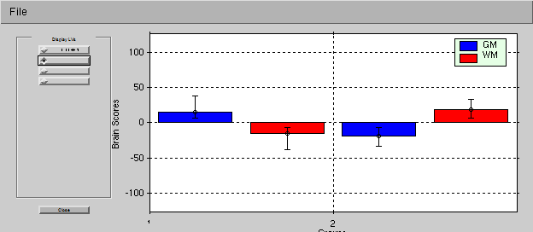
This LV demonstrates areas where there is an interaction, that is, areas where the young group are more likely to have tissue classified as grey matter are those areas where the older group are more likely to have areas classified as white matter (hot/yellow colours). Areas where the young group are more likely to have tissue classified as white matter are the areas where the old group are more likely to have tissue classified as grey matter (cool/blue colours).

NB – this may make more sense if CSF was included.

Results for GM, WM and CSF in the same analysis

Three significant LVs are observed (LV1: p < .001; LV2: p = .016; LV3: p =.098; LV4: p < .001)

LV1

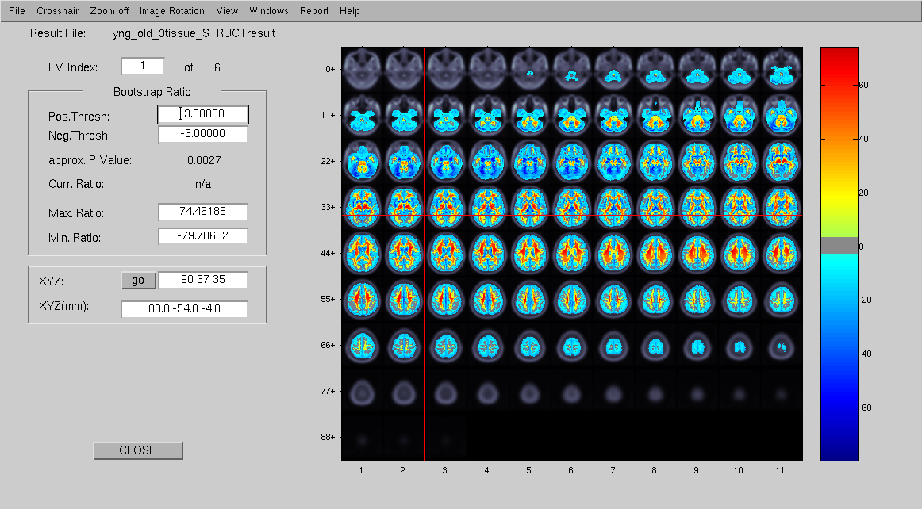

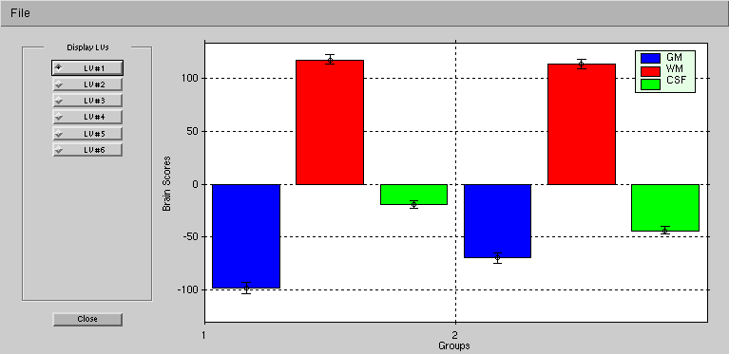

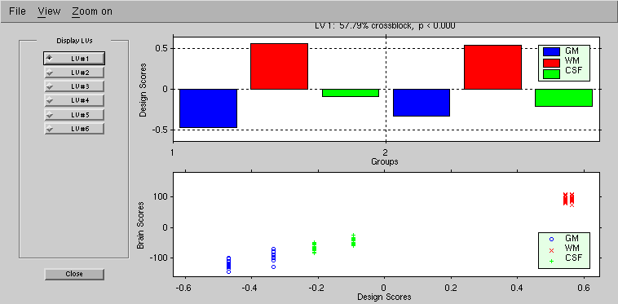For LV1, both groups show the same pattern, and this LV indicates areas where tissue is more likely to be classified as white matter (hot/yellow colours) than either grey matter or CSF (cool/blue colours).

LV2

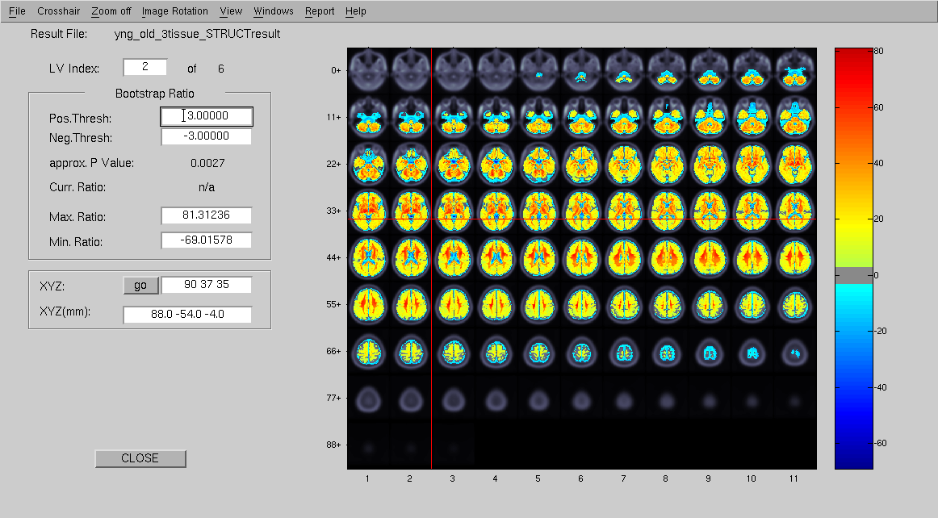
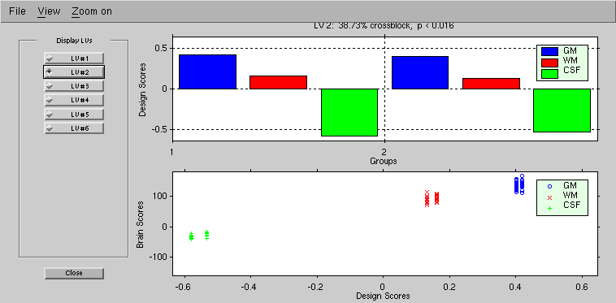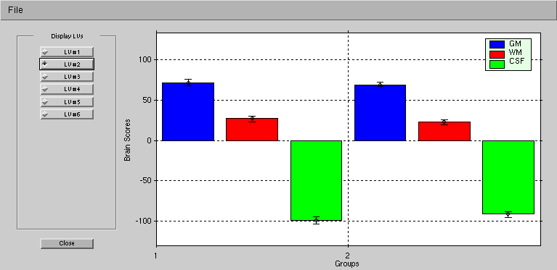

This LV demonstrates areas in both groups where tissue is more likely to be classified as CSF (cool/blue colours) than either grey or white matter (hot/yellow colours).

LV3 – NB this LV is not significant (p = .098)

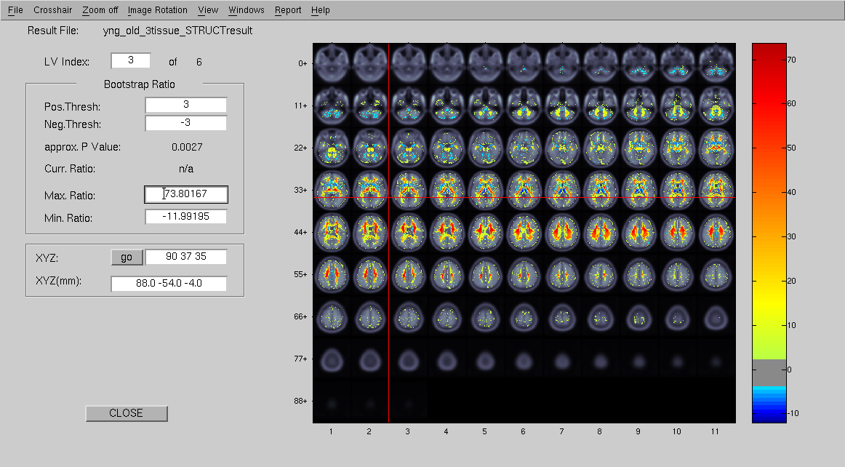
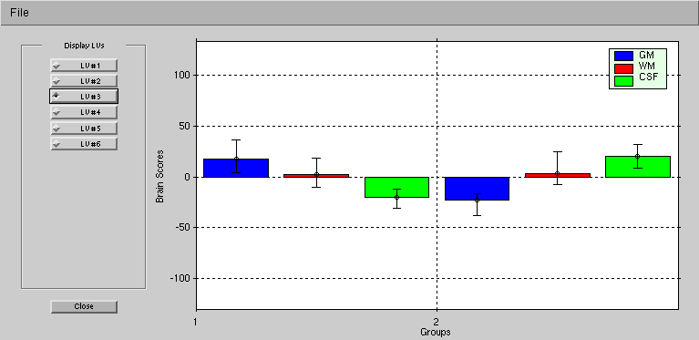
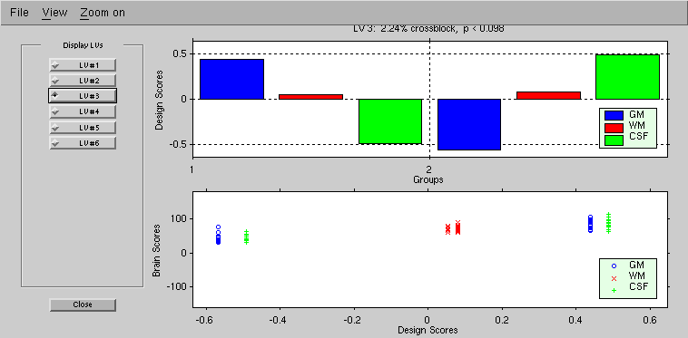LV3 indicates areas where tissue is more likely to be classified as either grey or white matter in young adults (hot.yellow colours) and more likely be classified as CSF in older adults. This is mostly around the ventricles.

LV4

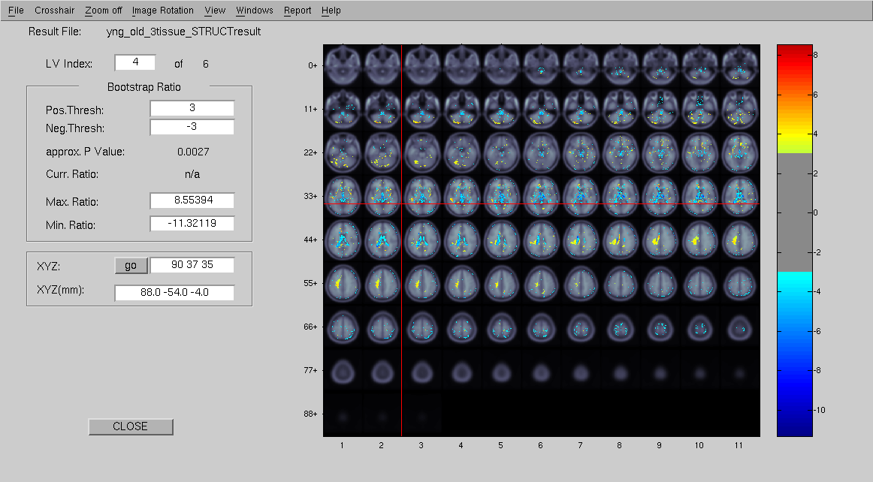
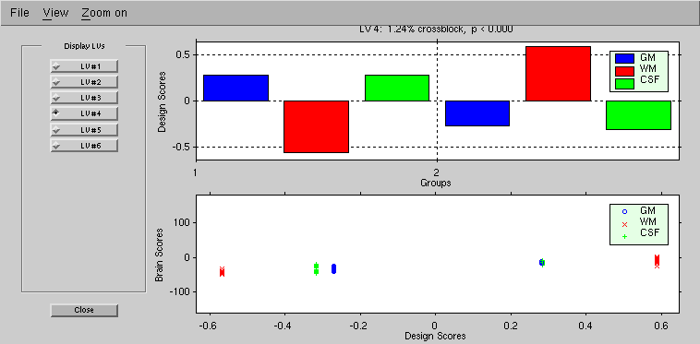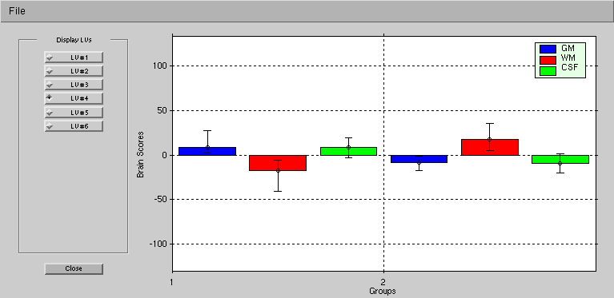

This LV demonstrates areas where there is an interaction, that is, areas where the young group are more likely to have tissue classified as white matter (cool/blue colours) are those areas where the older group are more likely to have areas classified as grey matter or CSF (hot/yellow colours). Areas where the young group are more likely to have tissue classified as grey matter or CSF (hot/yellow colours) are the areas where the old group are more likely to have tissue classified as grey matter (cool/blue colours).

Troubleshooting

I get an error message regarding "incompatible conditions"?

PLS is case sensitive –make sure that when you created the individual session/datamat files the conditions are labeled exactly the same way.

I am getting an error message regarding “Subscript indices must either be real positive integers or logicals”?

Make sure for each condition you have at least one valid onset (not -1) in one of your runs when creating the session/datamat files. That is, you must have at least one valid onset for each condition and so if you have don’t have any data for a specific condition in any of your runs for that subject; you most likely need to exclude this person.

I have a result file (bothgrps_4conditions_BfMRIresult.mat) and would like to know what parameters they used to run it. E.g. the datamat/session files, type of PLS, number of permutation, etc.

Open matlab and load the result file:
>matlab74
>load(‘bothgrps_4conditions_fMRIresult.mat’)
>whos
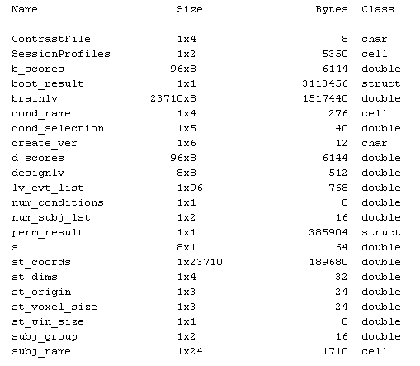

The whos command lists all variables in the currently active file. In order to see what is inside the variable, just type the variable name.

>cond_name

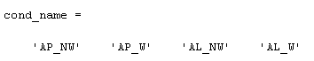

>perm_result

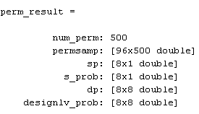

Sometimes a variable contains sub-variable. To access what is in a sub-directory, use period ‘.’ to indicate you want to go down a level.

>perm_result.s_prob

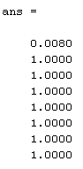

You can also load session/datamat files. Of course, you will get a separate set of variables but just type the variable name to see what is in it. Or, go to the ‘Workspace’ tap and double click on the variable names (this opens the ‘Array Editor’, similar to an excel worksheet).

Appendix

Batch Parameters for Creating Session Profiles (for MATLAB)

There are additional parameters options that you can change. Note that if the parameters are not specified in your batch text file, the default values are used.

For Blocked Design:

General Section
prefix
Specify the file name you would like the session and datamat files to be saved as. Note that PLS will automatically

brain_region
Specifies brain region –you can either enter threshold number (default 0.15) or the filename of the binary brain mask with path info

across_run (1 or 0),
where 1 is to merge data across runs and 0 merge data within runs.

single_subj (1 or 0)
(default is 0), where 1 is single subject analysis; 0 is not single subject

normalize (1 or 0)
(default is 0), where 1 is to normalize data to volume mean.

single_ref_scan (1 or 0),
If you would like to use a single reference scan, set it to 1. If you are using this feature, all scans in this datamat will use this reference scan. This feature will replace the ref_scan_onset and num_ref_scan.

single_ref_onset
refers to the onset value for the single reference scan. This keyword is the onset for the single_ref_scan above and starts at 0.

single_ref_number
refers to the number of onset for the single_ref_scan keyword above and starts at 1.

Condition Section

cond_name
Specify the name of the condition. Each condition requires its own cond_name keyword.

ref_scan_onset
Refers to the reference scan onset for a specific condition.

num_ref_scan
refer to the number of reference scan onsets for a specific condition.

Run Section
data_file
data files (in nifti or analyze format) with path information. Note that all selected image file names should be sorted in alphabetic ascend order. Wildcard (*) can be used for analyze files (*.img)

block_onsets
onset scans (starts from 0) for a specific condition in a specific run. The sequence should always be condition in run.

block_length
refers to the number of scan for each block after block_onsets

For Event-Related Design:
*Please refer to the previous section for explanation of keywords.

General Section
prefix*

brain_region*

win_size
(default is 8 assuming 1TR = 2 sec), indicates the number of scans in one hemodynamic response

across_run*

normalize*

single_subj*

single_ref_scan*

single_ref_onset*

single_ref_number*

Condition Section

cond_name*

ref_scan_onset*

num_ref_scan*

Run Section

data_file*

even_onsets
refers to the onset scans (starts from 0) for a specific condition in a specific run. The sequence should always be condition in run.

References

Chiew, K. (2007). Partial Least Squares the rough guide [pdf]. Retrieved from http://artsci.wustl.edu/~kschiew/PLS_guide.pdf

Krishnan, A., Williams, L. J., McIntosh, A. R., & Abdi, H. (in press). Partial least squares (PLS) methods for neuroimaging: A tutorial and review. NeuroImage.

McIntosh, A. R., Chau, W. K., & Protzner, A. B. (2004). Spatiotemporal analysis of event-related fMRI data using partial least squares. NeuroImage, 23, 764-775.

McIntosh, A. R., & Lobaugh, N. (2004). Partial least squares analysis of neuroimaging data: Applications and advances. NeuroImage, 23, S250-263.

McIntosh, A. R., Bookstein, F. L., Haxby, J. V., & Grady, C. L. (1996). Spatial pattern analysis of conational brain images using partial least squares. NeuroImage, 3, 143-157.

Shen, J. (2009). PLSgui User’s Guide. Retrieved from http://www.rotman-baycrest.on.ca/pls/UserGuide.htm

Assistance from Cheryl Grady, Lynne Williams, Omer Grigg, Gigi Luk, John Anderson, Rebecca Carlton, Ricky Tong, Jimmy Shen & Natasa Kovacevic.

